Aromatic Chemistry
Scaffolded Worksheets — ANSWER VERSION
OCR A Level Chemistry A (H432) · Module 6.1.1 Aromatic compounds
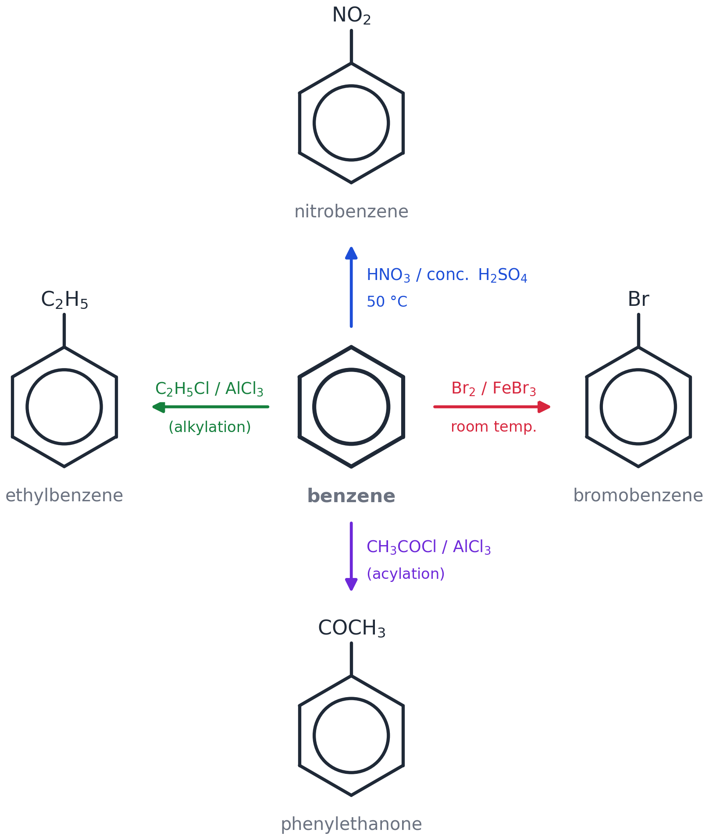

Contents
Worksheet 1 — Meet benzene: Kekulé vs delocalised (6.1.1 (a) (b))
Worksheet 2 — Naming aromatic compounds (6.1.1 (c))
Worksheet 3 — Electrophilic substitution: nitration (6.1.1 (d)(i) (e))
Worksheet 4 — Halogenation and halogen carriers (6.1.1 (d)(ii) (e) (f))
Worksheet 5 — Friedel–Crafts: alkylation and acylation (6.1.1 (d)(iii) (g))
Worksheet 6 — Phenol: a weak acid with an activated ring (6.1.1 (h) (i) (j))
Worksheet 7 — Directing groups and synthesis (6.1.1 (k) (l))
Worksheet 8 — Chapter practice questions (6.1.1 (a)–(l))

How each worksheet works
CORE — the questions for the lesson. When the slide says "NOW → Worksheet", this is where you go. They are the textbook summary questions for that section plus questions of the same kind: no gap-fills, you have to think.
HARDER — the same skills with more to think about. For when you have finished the core questions; they are meant to take time.
EXAM-STYLE — one question in exam wording, also done in class: in one go, in silence, then marked against the mark scheme.
Worksheet 8 is the whole set of chapter practice questions from the textbook (pages 451–453), to be done after the topic.
University-level work is NOT in this booklet: it is on the separate purple Uni worksheet, and beyond that in the Stretch Pack.
Self-check — tick the "I can" statements at the end of each worksheet.

Worksheet 1
Meet benzene: Kekulé vs delocalised
OCR A Level Chemistry A (H432) · Specification 6.1.1 (a) (b) · core questions about 20 min · ANSWER VERSION

Specification 6.1.1 says you must be able to demonstrate and apply knowledge and understanding of:
(a) the comparison of the Kekulé model of benzene with the subsequent delocalised models for benzene in terms of p-orbital overlap forming a delocalised π-system
(b) the experimental evidence for a delocalised, rather than Kekulé, model for benzene in terms of bond lengths, enthalpy change of hydrogenation and resistance to reaction
Examiner guidance: You may represent benzene in equations and mechanisms as the Kekulé structure OR as a hexagon with a circle. HSW1,7: development of the model for benzene over time. HSW11: acceptance of the delocalised model by the scientific community in the light of supporting experimental evidence.
Answers are shown in green. Mark points in brackets. Stretch answers are guidance, not a mark scheme.

CORE Core questions
Do these in the lesson when the slide says NOW → Worksheet.

1. State the empirical formula of benzene. [1 mark]
Answer: CH (1)
2. Draw the Kekulé structure of benzene and the delocalised structure of benzene. State one difference in what the two models predict about the C–C bond lengths. [3 marks]
Kekulé: hexagon with three alternating C=C and C–C bonds (1). Delocalised: hexagon with a circle (1). Kekulé predicts TWO bond lengths (C–C 0.153 nm and C=C 0.134 nm); the delocalised model predicts all six bonds the SAME length (1).
(Drawing boxes appear on the student copy: Kekulé structure | Delocalised structure)
3. Explain how X-ray diffraction helped scientists to develop the delocalised model of benzene. [3 marks]
Answer: X-ray diffraction (Lonsdale, 1929) measures bond lengths / gives an electron-density map (1). All six C–C bonds in benzene were found to be the SAME length, 0.139 nm (1). This is between a C–C single bond (0.153 nm) and a C=C double bond (0.134 nm), so there are no separate single and double bonds — the electrons must be delocalised (1).
4. The enthalpy change of hydrogenation of cyclohexene is −120 kJ mol⁻¹. [4 marks]
(a) Predict the enthalpy change of hydrogenation of the Kekulé structure of benzene (cyclohexa-1,3,5-triene). Show your working.
(b) The actual enthalpy change of hydrogenation of benzene is −208 kJ mol⁻¹. Calculate the difference between the two values and explain what it tells you about benzene.
Answer: (a) Three C=C bonds → 3 × (−120) = −360 kJ mol⁻¹ (1). (b) −208 − (−360) = 152 kJ mol⁻¹ less energy released (1); benzene is LOWER in energy / MORE stable than the Kekulé structure by 152 kJ mol⁻¹ (1); because its π electrons are delocalised round the ring (1).
5. Explain why the delocalised model of benzene accounts for the observed stability of benzene better than the Kekulé model. [3 marks]
Answer: Kekulé's structure has three localised C=C bonds, so it should have the enthalpy of hydrogenation of three alkene bonds (−360 kJ mol⁻¹) and react like an alkene (1). Delocalising the six π electrons over all six carbons lowers the energy of the molecule (1). The 152 kJ mol⁻¹ 'missing' from the hydrogenation is the delocalisation energy — exactly what the delocalised model predicts (1).
6. Cyclohexene decolourises bromine water at room temperature; benzene does not. Explain why this observation was a problem for Kekulé's model. [2 marks]
Answer: Kekulé's structure contains C=C double bonds, so benzene should undergo electrophilic addition and decolourise bromine like an alkene (1). It does not, so its 'double bonds' cannot be ordinary C=C bonds — the π electrons are delocalised, not localised (1).

HARDER Harder
Same ideas, more to think about. Start these when you have finished the core questions — they are meant to take time.

H1. The enthalpy change of hydrogenation of cyclohexa-1,3-diene (two C=C bonds next to each other) is −232 kJ mol⁻¹. [3 marks]
(a) Predict the value using the cyclohexene data in question 4.
(b) Calculate the difference and suggest why the diene is slightly more stable than predicted.
Answer: (a) 2 × (−120) = −240 kJ mol⁻¹ (1). (b) 8 kJ mol⁻¹ less energy released, so the diene is 8 kJ mol⁻¹ more stable than predicted (1). The two C=C bonds are adjacent (conjugated), so the π electrons are partly delocalised across all four carbons — a small version of what happens fully in benzene (1).
H2. A student says that every C–C bond in benzene is 'one-and-a-half bonds'. Explain what the student means and how the bond-length data (C–C 0.153 nm, C=C 0.134 nm, benzene 0.139 nm) support the idea. [2 marks]
Answer: Six π electrons are shared over six C–C bonds — one extra electron per bond on top of the σ bond, i.e. a bond order of 1.5 (1). A 1.5 bond should be shorter than a single bond and longer than a double bond; 0.139 nm lies between 0.153 nm and 0.134 nm, as expected (1).
H3. Kekulé's model was also criticised on these grounds: it predicts TWO different isomers of 1,2-dibromobenzene (the two Br atoms on a C=C, or on a C–C), but only ONE has ever been found. Explain how the delocalised model resolves this. [2 marks]
Answer: In the Kekulé structure the bond between C1 and C2 is either double or single, giving two distinguishable 1,2-isomers (1). In the delocalised model every C–C bond is identical, so there is only one 1,2-dibromobenzene — as observed (1).
H4. X-ray diffraction finds carbon atoms easily but hydrogen atoms only with great difficulty. Suggest why. [1 mark]
Answer: X-rays are scattered by electrons; a hydrogen atom has only one electron, so it scatters X-rays very weakly compared with carbon (1).

EXAM-STYLE Exam-style question
Exam wording, exam marks. Done in class: in silence, in one go, then marked against the mark scheme.

E1. In 1865 Kekulé proposed a model for benzene with alternating single and double bonds. Describe and explain TWO pieces of experimental evidence that led scientists to replace this model with a delocalised model. In your answer, refer to bond lengths and to enthalpy changes. [6 marks]
Answer: Bond lengths: X-ray diffraction shows all six C–C bonds are the same length, 0.139 nm (1); this is between the single (0.153 nm) and double (0.134 nm) bond lengths, so there are no alternating single/double bonds (1). Enthalpy of hydrogenation: Kekulé predicts 3 × (−120) = −360 kJ mol⁻¹ but the measured value is −208 kJ mol⁻¹ (1); 152 kJ mol⁻¹ less energy is released, so benzene is more stable than the Kekulé structure (1). Explanation: the p-orbital on each carbon overlaps sideways with both neighbours (1) so the π electrons are delocalised over all six carbons, lowering the energy (1). [Also creditworthy: benzene does not decolourise bromine water / resists addition.]
Self-check — I can…
☐ draw both models of benzene
☐ explain the bond-length evidence
☐ use hydrogenation data to calculate the 152 kJ mol⁻¹ stabilisation

Worksheet 2
Naming aromatic compounds
OCR A Level Chemistry A (H432) · Specification 6.1.1 (c) · core questions about 20 min · ANSWER VERSION

Specification 6.1.1 says you must be able to demonstrate and apply knowledge and understanding of:
(c) use of IUPAC rules of nomenclature for systematically naming substituted aromatic compounds
Examiner guidance: Use locant numbers to identify positions of substitution, e.g. 2,4-dinitromethylbenzene. HSW8: introduction of systematic nomenclature.
Answers are shown in green. Mark points in brackets. Stretch answers are guidance, not a mark scheme.

CORE Core questions
Do these in the lesson when the slide says NOW → Worksheet.

1. Draw the structures of the following aromatic compounds. [5 marks]
a Br on C1, C2 and C4 (1). b NO₂ on C1 and C3 (1). c CH₃ on C1, Cl on C2, C4 and C6 (1).
(Drawing boxes appear on the student copy: a 1,2,4-tribromobenzene | b 1,3-dinitrobenzene | c 2,4,6-trichloromethylbenzene)
d C₆H₅–CO–CH₂CH₃: a benzene ring joined to the C=O of propanone (1-phenylpropan-1-one) (1). e COOH on C1, Cl on C2 and C3 (1).
(Drawing boxes appear on the student copy: d phenylpropanone | e 2,3-dichlorobenzoic acid)
2. Name the following molecules. [3 marks]
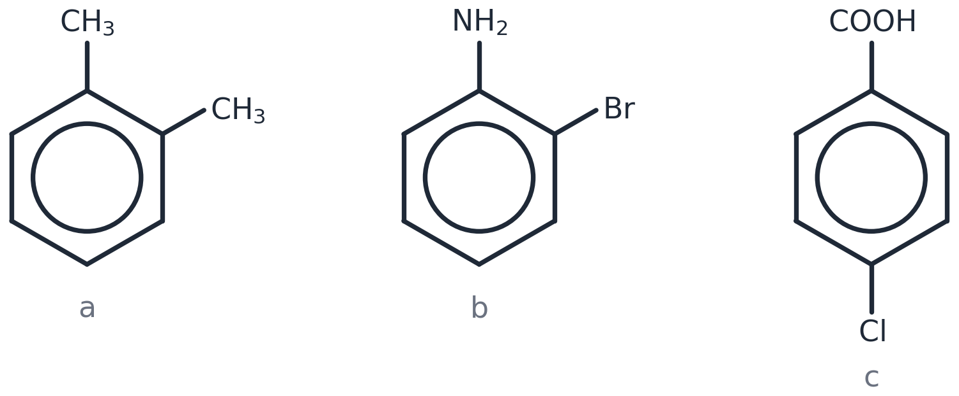
Answer: a 1,2-dimethylbenzene (1). b 2-bromophenylamine (1). c 4-chlorobenzoic acid (1).
3. Name compounds A–H. [8 marks]
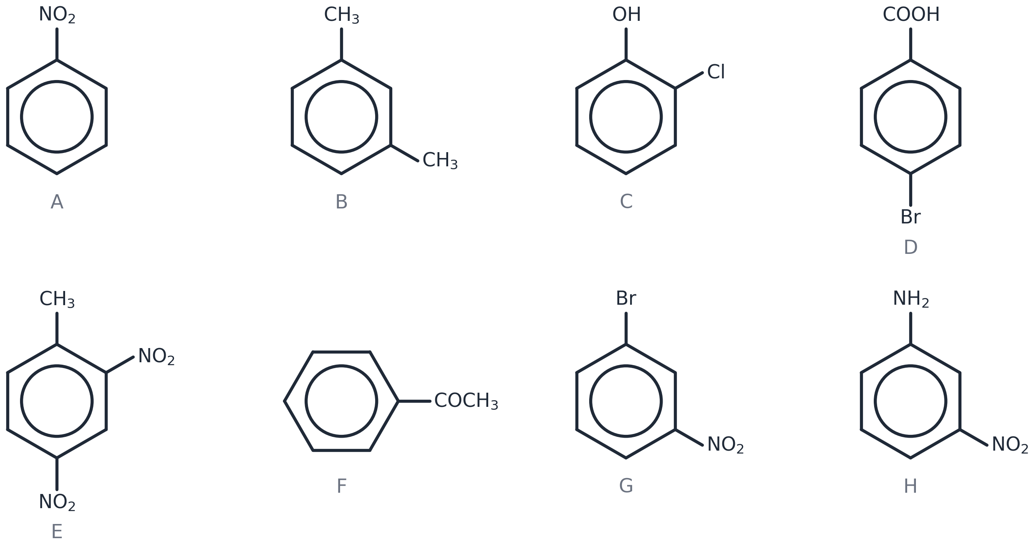
Answer: A nitrobenzene; B 1,3-dimethylbenzene; C 2-chlorophenol; D 4-bromobenzoic acid; E 2,4-dinitromethylbenzene; F phenylethanone; G 1-bromo-3-nitrobenzene; H 3-nitrophenylamine (1 each).
 | Name |  | Name
A |  | E
B |  | F
C |  | G
D |  | H

4. Each of these names is WRONG. Write the correct name and say what the mistake is. [5 marks]
(a) 4-nitro-1-methylbenzene (b) 3-chloro-5-bromophenol (c) 2,4,6-trinitrotoluene (d) 1,5-dichlorobenzene (e) hydroxybenzene
Answer: (a) 4-nitromethylbenzene — methylbenzene is the parent, so the CH₃ is carbon 1 and is not given a locant (1). (b) 3-bromo-5-chlorophenol — prefixes in alphabetical order (1). (c) 2,4,6-trinitromethylbenzene — 'toluene' is not a systematic name (1). (d) 1,3-dichlorobenzene — use the LOWEST possible locants (1). (e) phenol — the OH-on-ring compound has its own name (1).
5. Compound X has the molecular formula C₇H₇Cl and contains a benzene ring. Draw and name all FOUR possible structures. [4 marks]
(chloromethyl)benzene, C₆H₅CH₂Cl; 2-chloromethylbenzene; 3-chloromethylbenzene; 4-chloromethylbenzene (1 each). (1-chloro-2-methylbenzene etc. also accepted.)
(Drawing boxes appear on the student copy: 1 | 2 | 3 | 4)
6. Give the molecular formula of: (a) methylbenzene (b) phenol (c) nitrobenzene (d) benzoic acid (e) phenylamine. [5 marks]
Answer: (a) C₇H₈ (b) C₆H₆O (c) C₆H₅NO₂ (d) C₇H₆O₂ (e) C₆H₇N (1 each).

HARDER Harder
Same ideas, more to think about. Start these when you have finished the core questions — they are meant to take time.

H1. Name compounds P, Q and R. Each has THREE groups on the ring — use alphabetical order and the lowest locants. [3 marks]
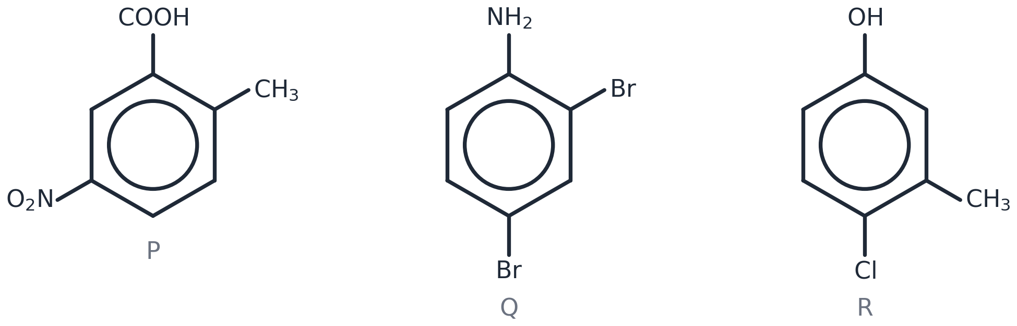
Answer: P 2-methyl-5-nitrobenzoic acid (1). Q 2,4-dibromophenylamine (1). R 4-chloro-3-methylphenol (1).
H2. There are SIX structural isomers of dinitromethylbenzene, CH₃C₆H₃(NO₂)₂. Draw and name all six. [6 marks]
Answer: 2,3-; 2,4-; 2,5-; 2,6-; 3,4- and 3,5-dinitromethylbenzene (1 each). Check: with CH₃ at C1 the two NO₂ groups can be at {2,3} {2,4} {2,5} {2,6} {3,4} {3,5} — {2,6} and {3,5} are the only ones with a mirror line through C1.
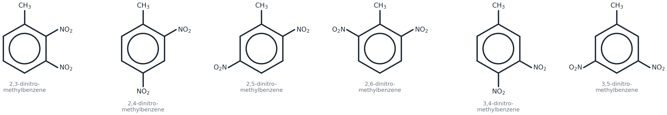
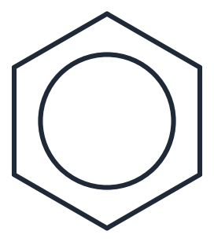

H3. A compound has the molecular formula C₈H₈O. It contains a benzene ring and a C=O group. Draw and name THREE possible structures. [3 marks]
phenylethanone, C₆H₅COCH₃; 2-, 3- or 4-methylbenzaldehyde, CH₃C₆H₄CHO; phenylethanal, C₆H₅CH₂CHO (any three, 1 each).
(Drawing boxes appear on the student copy: 1 | 2 | 3)

EXAM-STYLE Exam-style question
Exam wording, exam marks. Done in class: in silence, in one go, then marked against the mark scheme.

E1. Compound Y has the molecular formula C₆H₄Cl₂ and contains a benzene ring. [5 marks]
(a) Draw and name all the possible structural isomers of Y.
(b) In one of these isomers all four hydrogen atoms are in identical environments. Identify this isomer and explain your answer.
(a) 1,2-dichlorobenzene; 1,3-dichlorobenzene; 1,4-dichlorobenzene (1 each). (b) 1,4-dichlorobenzene (1): the molecule has two mirror lines / the ring is symmetrical so each H is the same distance from a Cl and there is only one hydrogen environment (1).
(Drawing boxes appear on the student copy: (a) | | )
Self-check — I can…
☐ draw a structure from a name
☐ name a ring with one, two or three groups
☐ spot a wrong name and fix it

Worksheet 3
Electrophilic substitution: nitration
OCR A Level Chemistry A (H432) · Specification 6.1.1 (d)(i) (e) · core questions about 25 min · ANSWER VERSION

Specification 6.1.1 says you must be able to demonstrate and apply knowledge and understanding of:
(d(i)) the electrophilic substitution of aromatic compounds with concentrated nitric acid in the presence of concentrated sulfuric acid
(e) the mechanism of electrophilic substitution in arenes for nitration and halogenation
Examiner guidance: For the nitration mechanism you should include the equation for the formation of NO₂⁺. For the halogenation mechanism the electrophile can be assumed to be X⁺. HSW1,2,8: using reaction mechanisms to explain organic reactions.
Answers are shown in green. Mark points in brackets. Stretch answers are guidance, not a mark scheme.

CORE Core questions
Do these in the lesson when the slide says NOW → Worksheet.

1. Benzene reacts by electrophilic substitution. Define the terms (a) electrophile (b) substitution. [2 marks]
Answer: (a) An electron-pair acceptor / a species attracted to a region of high electron density (1). (b) A reaction in which one atom or group is replaced by another atom or group (1).
2. Write the equation for the formation of the electrophile in the nitration of benzene, and name the electrophile. [2 marks]
Answer: HNO₃ + H₂SO₄ → NO₂⁺ + HSO₄⁻ + H₂O (1); the nitronium ion, NO₂⁺ (1).
3. Complete the mechanism for the nitration of benzene: add the two curly arrows and the positive charge on the intermediate. [3 marks]
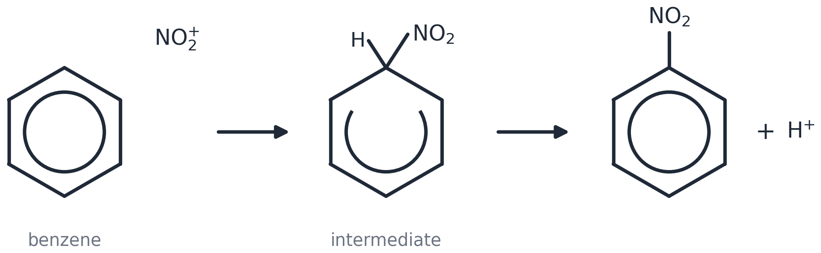
Answer: MARK 1 — Tail ON the circle — that is where the electron pair is — next to the carbon being attacked. Head touching the N atom of NO₂⁺ — the atom that carries the + (never an O). An arrow that starts on the hexagon edge (a σ bond), ends on the wrong atom, or points the other way scores nothing. MARK 2 — Open the circle into a HORSESHOE that stops at the two carbons either side of the carbon holding the H and the NO₂ — it must not reach that carbon. Write + INSIDE the horseshoe (the charge is spread over the other five carbons; never on the carbon with the H, never on the H itself). Draw H AND NO₂ on the SAME carbon. MARK 3 — Tail on the MIDDLE of the C–H bond (a bond is breaking — never on the H atom). Head pointing into the ring, towards the +, to re-form the circle. Products: nitrobenzene + H⁺.
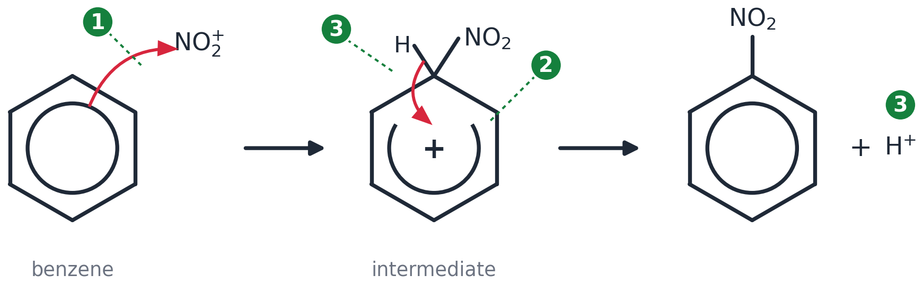
Where the marks are — exactly. Learn these three lines; they are what the examiner checks.
Mark | The examiner must see
1 · Curly arrow from the delocalised ring to N of NO₂⁺ | Tail ON the circle — that is where the electron pair is — next to the carbon being attacked. Head touching the N atom of NO₂⁺ — the atom that carries the + (never an O). An arrow that starts on the hexagon edge (a σ bond), ends on the wrong atom, or points the other way scores nothing.
2 · The intermediate, drawn exactly | Open the circle into a HORSESHOE that stops at the two carbons either side of the carbon holding the H and the NO₂ — it must not reach that carbon. Write + INSIDE the horseshoe (the charge is spread over the other five carbons; never on the carbon with the H, never on the H itself). Draw H AND NO₂ on the SAME carbon.
3 · Curly arrow from the C–H bond into the ring, and H⁺ leaves | Tail on the MIDDLE of the C–H bond (a bond is breaking — never on the H atom). Head pointing into the ring, towards the +, to re-form the circle. Products: nitrobenzene + H⁺.
Making the electrophile | HNO₃ + H₂SO₄ → NO₂⁺ + HSO₄⁻ + H₂O
Regenerating the catalyst (H₂SO₄) | H⁺ + HSO₄⁻ → H₂SO₄

4. Now mark your own mechanism. Tick every line you can see on YOUR drawing.
Mark point | ✓
Equation for making the electrophile (e.g. HNO₃ + H₂SO₄ → NO₂⁺ + HSO₄⁻ + H₂O)
Arrow 1: tail ON the circle, head TOUCHING the electrophilic atom (N of NO₂⁺ / Br⁺ / C of CH₃CO⁺)
Intermediate: horseshoe stops either side of the carbon holding H and the new group; + INSIDE the horseshoe
Intermediate: H AND the new group drawn on the SAME carbon
Arrow 2: tail on the MIDDLE of the C–H bond, head INTO the ring towards the +
Products: substituted benzene + H⁺ ; catalyst regenerated (H⁺ + HSO₄⁻ → H₂SO₄ or H⁺ + FeBr₄⁻ → FeBr₃ + HBr)

5. Write the equation that regenerates the catalyst, and use it to explain why sulfuric acid is described as a catalyst. [2 marks]
Answer: H⁺ + HSO₄⁻ → H₂SO₄ (1). H₂SO₄ is used up in the first step (making NO₂⁺) and re-formed in the last step, so it is not used up overall (1).
6. State the conditions for the mono-nitration of benzene and explain what happens if the mixture is heated more strongly. [2 marks]
Answer: Concentrated HNO₃ with concentrated H₂SO₄ at about 50 °C (water bath) (1). Above about 55 °C a second nitro group substitutes, giving 1,3-dinitrobenzene, so the product is impure / yield of nitrobenzene falls (1).
7. A student's mechanism is shown below. It contains THREE mistakes. Describe each mistake and how to correct it. [3 marks]
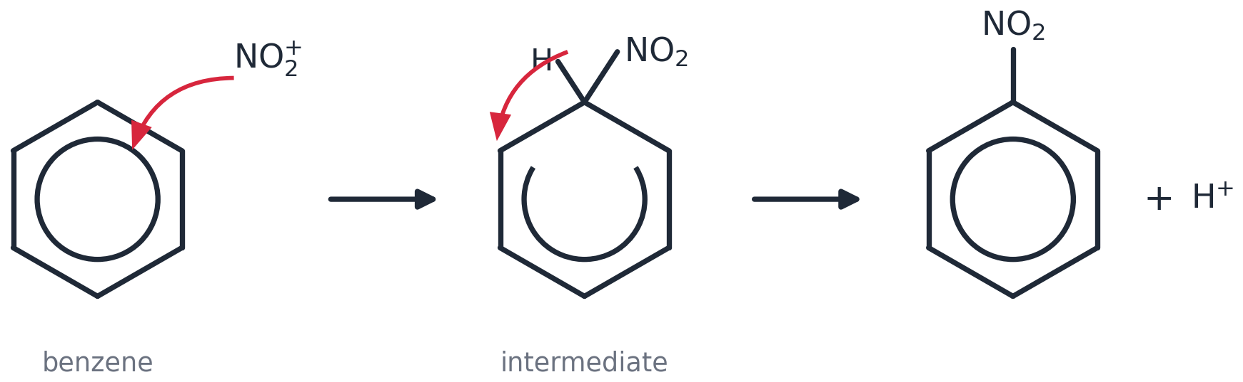
Answer: 1 The first arrow goes from NO₂⁺ to the ring — it must start ON the circle (the electron pair) with its head touching the N (1). 2 The intermediate has no + charge — it goes INSIDE the horseshoe (1). 3 The second arrow starts on the H atom — it must start on the MIDDLE of the C–H bond and point into the ring (1).
8. Six more mechanisms, each losing exactly ONE mark. Under each drawing write which mark (1, 2 or 3) is lost and how to fix it. [6 marks]
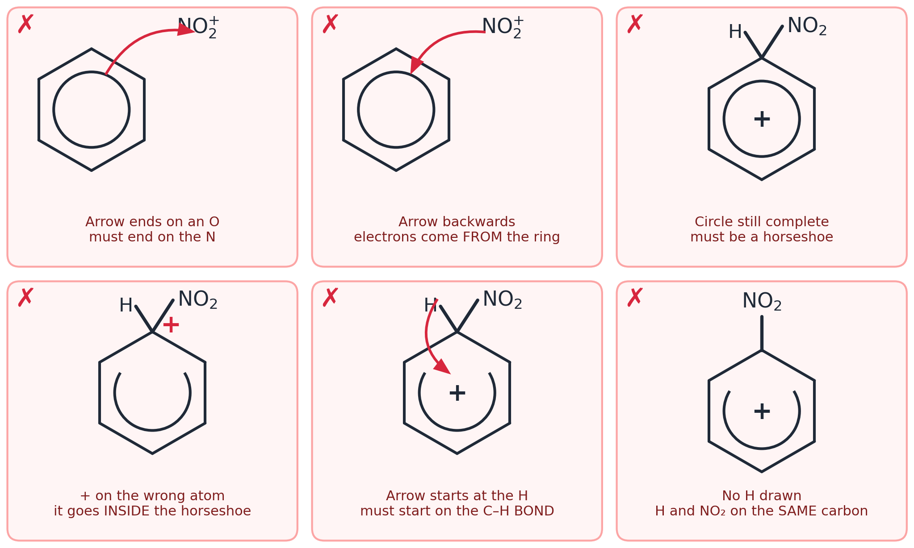
Answer: Top row: mark 1 — head must touch the N, not an O; mark 1 — arrow backwards, the electrons come FROM the ring; mark 2 — the circle must be opened into a horseshoe. Bottom row: mark 2 — the + goes INSIDE the horseshoe, not on the carbon with the H; mark 3 — arrow 2 must start on the C–H BOND, not the H; mark 2 — H must be drawn on the same carbon as NO₂. Kekulé structures are allowed throughout. Then arrow 1 starts on a C=C double bond, and the intermediate still needs the + and the H.

HARDER Harder
Same ideas, more to think about. Start these when you have finished the core questions — they are meant to take time.

H1. Methylbenzene is nitrated with concentrated nitric and sulfuric acids to form 4-nitromethylbenzene. Draw the mechanism, using NO₂⁺ as the electrophile. (The NO₂ goes to the carbon opposite the CH₃.) [4 marks]
Ring with CH₃ at C1; arrow with its tail on the circle beside C4 and head touching the N of NO₂⁺ (1); intermediate: horseshoe stopping either side of C4, + inside, H and NO₂ both on C4, CH₃ still on C1 (1); arrow from the middle of the C4–H bond into the ring (1); 4-nitromethylbenzene + H⁺ (1).
(Drawing boxes appear on the student copy: Draw the mechanism here (use the whole width))
H2. In a preparation, 15.6 g of benzene gave 19.7 g of nitrobenzene. Calculate the percentage yield. (Mr: benzene 78.0, nitrobenzene 123.0) [3 marks]
Answer: n(benzene) = 15.6/78.0 = 0.200 mol (1); theoretical mass of nitrobenzene = 0.200 × 123.0 = 24.6 g (1); yield = 19.7/24.6 × 100 = 80.1 % (1).
H3. In the same preparation the temperature is kept below 55 °C, and the crude product is washed with sodium carbonate solution before it is purified. Explain both precautions. [2 marks]
Answer: Below 55 °C to prevent a second nitration (1,3-dinitrobenzene) (1); sodium carbonate neutralises and removes the acids left in the product (1).
H4. Concentrated nitric acid on its own nitrates benzene only very slowly. Explain why, using the equation in question 2. [2 marks]
Answer: NO₂⁺ is formed when nitric acid is protonated by a STRONGER acid (1); without H₂SO₄ very little NO₂⁺ is present, so the electrophile concentration is tiny and the reaction is slow (1).

EXAM-STYLE Exam-style question
Exam wording, exam marks. Done in class: in silence, in one go, then marked against the mark scheme.

E1. Phenylethanone, C₆H₅COCH₃, reacts with a mixture of concentrated nitric acid and concentrated sulfuric acid to form 3-nitrophenylethanone. Outline the mechanism for this reaction. Your answer should include the formation of the electrophile and should show how sulfuric acid behaves as a catalyst. [6 marks]
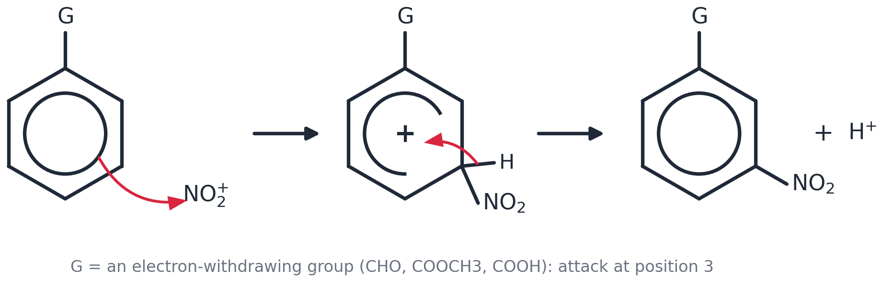
HNO₃ + H₂SO₄ → NO₂⁺ + HSO₄⁻ + H₂O (1); arrow with its tail ON the circle beside C3 and head TOUCHING the N of NO₂⁺ (1); intermediate: horseshoe stopping either side of C3, + INSIDE it, H and NO₂ both on C3, COCH₃ on C1 (1); arrow from the MIDDLE of the C–H bond into the ring (1); 3-nitrophenylethanone + H⁺ (1); H⁺ + HSO₄⁻ → H₂SO₄ (1). [In the figure G = COCH₃.]
(Drawing boxes appear on the student copy: Draw the mechanism here (use the whole width))
Self-check — I can…
☐ write the equation for forming NO₂⁺
☐ draw the nitration mechanism and say where each mark is
☐ explain how H₂SO₄ acts as a catalyst

Worksheet 4
Halogenation and halogen carriers
OCR A Level Chemistry A (H432) · Specification 6.1.1 (d)(ii) (e) (f) · core questions about 25 min · ANSWER VERSION

Specification 6.1.1 says you must be able to demonstrate and apply knowledge and understanding of:
(d(ii)) the electrophilic substitution of aromatic compounds with a halogen in the presence of a halogen carrier
(e) the mechanism of electrophilic substitution in arenes for nitration and halogenation
(f) the explanation of the relative resistance to bromination of benzene, compared with alkenes, in terms of the delocalised electron density of the π-system in benzene compared with the localised electron density of the π-bond in alkenes
Examiner guidance: Halogen carriers include iron, iron halides and aluminium halides. For the nitration mechanism you should include the equation for the formation of NO₂⁺. For the halogenation mechanism the electrophile can be assumed to be X⁺. HSW1,2,8: using reaction mechanisms to explain organic reactions. HSW2,5: use the delocalised benzene model to explain reactivity.
Answers are shown in green. Mark points in brackets. Stretch answers are guidance, not a mark scheme.

CORE Core questions
Do these in the lesson when the slide says NOW → Worksheet.

1. Benzene reacts with chlorine by an electrophilic substitution mechanism. Outline this mechanism on the skeleton below, including an equation to show how the electrophile is generated from Cl₂ and AlCl₃. [4 marks]
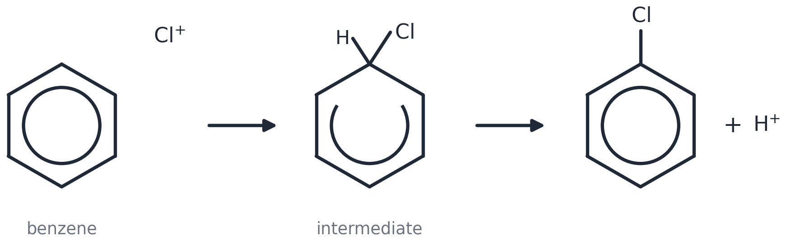
Answer: Cl₂ + AlCl₃ → Cl⁺ + AlCl₄⁻ (1); arrow with its tail ON the circle and head TOUCHING Cl⁺ (1); intermediate: horseshoe stopping either side of the carbon holding H and Cl, + INSIDE, H and Cl on the same carbon (1); arrow from the MIDDLE of the C–H bond into the ring; chlorobenzene + H⁺ (then H⁺ + AlCl₄⁻ → AlCl₃ + HCl) (1).
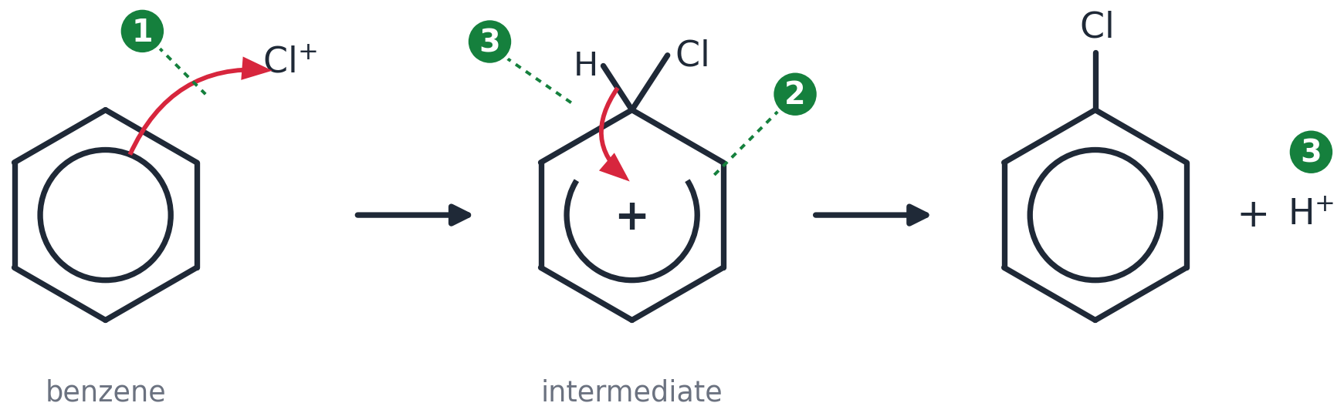
2. Write THREE equations for the bromination of benzene using bromine and iron(III) bromide: (a) formation of the electrophile (b) the overall reaction (c) regeneration of the catalyst. [3 marks]
Answer: (a) Br₂ + FeBr₃ → Br⁺ + FeBr₄⁻ (1). (b) C₆H₆ + Br₂ → C₆H₅Br + HBr (1). (c) H⁺ + FeBr₄⁻ → FeBr₃ + HBr (1).
3. Explain the role of the halogen carrier in the bromination of benzene. [2 marks]
Answer: Bromine alone is not polar enough to be attacked by benzene's delocalised ring (1). The halogen carrier accepts a bromide ion (a lone pair) from Br₂, generating the strong electrophile Br⁺ (1).
4. State what you would observe when bromine is added to (a) cyclohexene (b) benzene (c) benzene with iron filings. [3 marks]
Answer: (a) Orange/brown bromine is decolourised at room temperature (1). (b) No change — the bromine colour remains (1). (c) The bromine colour fades and steamy/acidic fumes of HBr are given off (1).
5. Explain why benzene is much less reactive towards bromine than an alkene such as cyclohexene. [4 marks]
Answer: Cyclohexene: the π electrons are LOCALISED between two carbon atoms, so the electron density is high (1); this polarises the Br–Br molecule / induces a dipole, so Br δ+ acts as an electrophile (1). Benzene: the π electrons are DELOCALISED over all six carbons, so the electron density between any two carbons is lower (1); benzene cannot polarise Br₂, so no electrophile forms and there is no reaction without a halogen carrier (1).
6. Complete the mechanism for the electrophilic ADDITION of bromine to cyclohexene: add the curly arrows, the + charge on the intermediate and the lone pair on Br⁻. [3 marks]
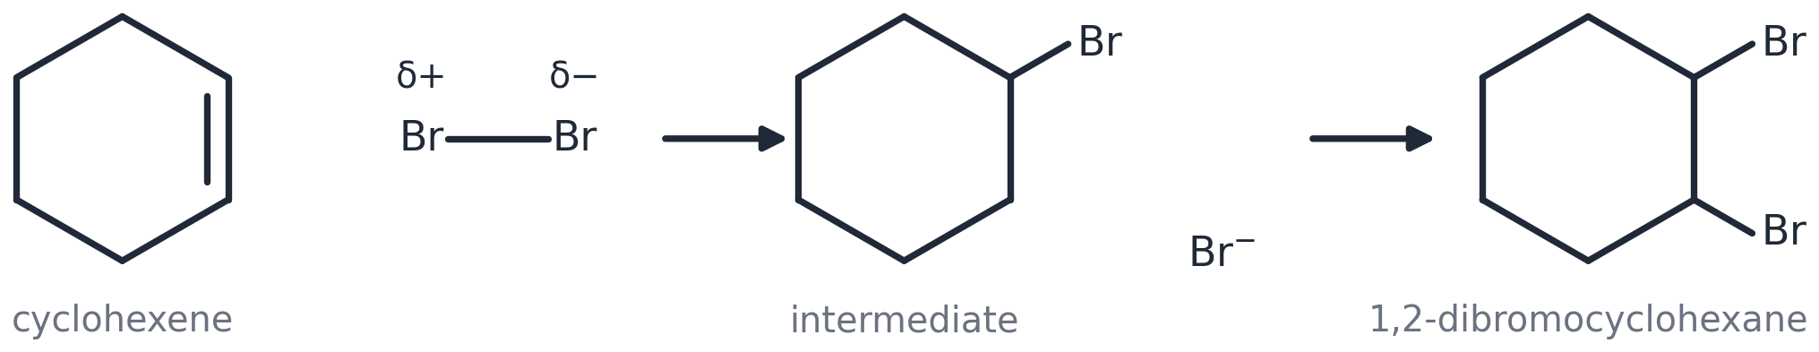
Answer: Arrow 1 with its tail ON the π bond (the second line of the C=C) and head touching the δ+ Br, dipole shown on Br–Br (1); arrow 2 from the MIDDLE of the Br–Br bond to the δ− Br, and the carbocation with + on the carbon that did not get the Br (1); lone pair drawn on Br⁻ (two dots) with an arrow from it to the C⁺ (1).
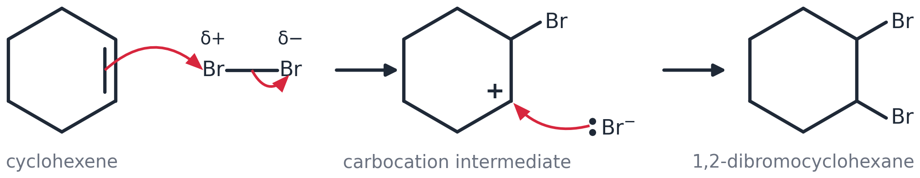

HARDER Harder
Same ideas, more to think about. Start these when you have finished the core questions — they are meant to take time.

H1. Some textbooks draw the electrophile in bromination as a polarised Br–Br molecule bonded to FeBr₃ (Br–Br···FeBr₃) instead of Br⁺. Draw the first step of the mechanism in this form, showing the dipole and BOTH curly arrows. [3 marks]
Br–Br drawn with δ+ on the Br nearer the ring and δ− on the Br bonded to Fe (1); arrow with its tail on the circle and head touching the δ+ Br (1); arrow from the middle of the Br–Br bond to the far Br (which leaves as part of FeBr₄⁻) (1).
(Drawing boxes appear on the student copy: Draw here)
H2. AlCl₃ and FeBr₃ can act as halogen carriers, but NaCl cannot. Suggest why. [2 marks]
Answer: Al in AlCl₃ (and Fe in FeBr₃) has an incomplete outer shell / an empty orbital, so it can accept a lone pair from the halogen molecule (1). Na⁺ in NaCl has a full outer shell and cannot accept an electron pair, so it cannot polarise the halogen (1).
H3. Chlorobenzene reacts with more chlorine, with AlCl₃, to give a mixture of dichlorobenzenes. Draw and name the three possible isomers, and suggest why a mixture is formed. [4 marks]
1,2-dichlorobenzene; 1,3-dichlorobenzene; 1,4-dichlorobenzene (1 each). A mixture forms because the electrophile can attack any of the ring's remaining positions (the Cl already on the ring directs mainly to 2 and 4) (1).
(Drawing boxes appear on the student copy: | | )
H4. Iodine does not react with benzene even in the presence of a halogen carrier. Suggest a reason. [1 mark]
Answer: Iodine forms the electrophile I⁺ much less readily than chlorine or bromine (iodine is the least electronegative halogen and I⁺ is a weak electrophile) (1).

EXAM-STYLE Exam-style question
Exam wording, exam marks. Done in class: in silence, in one go, then marked against the mark scheme.

E1. Bromobenzene is manufactured from benzene and bromine using iron filings. [6 marks]
(a) Explain how iron filings act as a catalyst in this reaction even though the halogen carrier is iron(III) bromide.
(b) Outline the mechanism for the formation of bromobenzene from benzene.
(c) State one hazard of the reaction and how it is controlled.
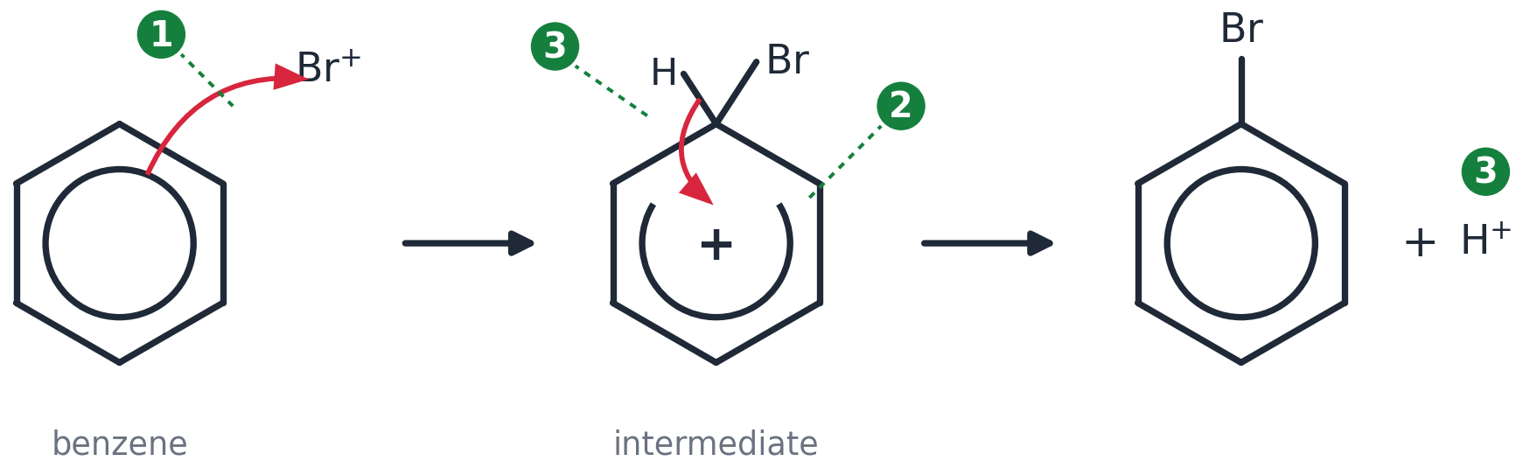
(a) Iron reacts with bromine to form FeBr₃ in the reaction mixture: 2Fe + 3Br₂ → 2FeBr₃ (1); FeBr₃ then generates Br⁺ from Br₂ and is regenerated, so the iron is not used up overall (1). (b) Arrow with tail on the circle, head touching Br⁺ (1); intermediate with horseshoe stopping either side of the carbon holding H and Br, + inside, H and Br on the same carbon (1); arrow from the middle of the C–H bond into the ring; bromobenzene + H⁺ (1). (c) Bromine is toxic and corrosive / HBr fumes are given off — use a fume cupboard and an absorber for the HBr (1).
(Drawing boxes appear on the student copy: (b) mechanism)
Self-check — I can…
☐ draw the halogenation mechanism with the electrophile-forming equation
☐ explain what a halogen carrier does
☐ give the 4-mark explanation of why benzene resists bromination

Worksheet 5
Friedel–Crafts: alkylation and acylation
OCR A Level Chemistry A (H432) · Specification 6.1.1 (d)(iii) (g) · core questions about 25 min · ANSWER VERSION

Specification 6.1.1 says you must be able to demonstrate and apply knowledge and understanding of:
(d(iii)) the electrophilic substitution of aromatic compounds with a haloalkane or acyl chloride in the presence of a halogen carrier (Friedel–Crafts reaction) and its importance to synthesis by formation of a C–C bond to an aromatic ring
(g) the interpretation of unfamiliar electrophilic substitution reactions of aromatic compounds, including prediction of mechanisms
Examiner guidance: See also 6.2.4(d) — carbon–carbon bond formation in synthesis. Extra information may be provided on exam papers.
Answers are shown in green. Mark points in brackets. Stretch answers are guidance, not a mark scheme.

CORE Core questions
Do these in the lesson when the slide says NOW → Worksheet.

1. Benzene reacts with 2-chloropropane, in the presence of an AlCl₃ catalyst, by electrophilic substitution. Construct the equation for this reaction, using structural formulae. [2 marks]
Answer: C₆H₆ + CH₃CHClCH₃ → C₆H₅CH(CH₃)₂ + HCl — correct organic product, (1-methylethyl)benzene (1); balanced with HCl (1).
2. Deduce the structure of the organic product expected from the reaction of each of the following compounds with benzene in the presence of AlCl₃: (i) (CH₃)₂CHCOCl (ii) C₆H₅COCl. [2 marks]
(i) C₆H₅–CO–CH(CH₃)₂ (2-methyl-1-phenylpropan-1-one) (1). (ii) C₆H₅–CO–C₆H₅ (diphenylmethanone) (1).
(Drawing boxes appear on the student copy: (i) | (ii))
3. Use curly arrows to show the mechanism for the reaction between (CH₃)₂CHCOCl and benzene, clearly showing the role of the catalyst. [4 marks]
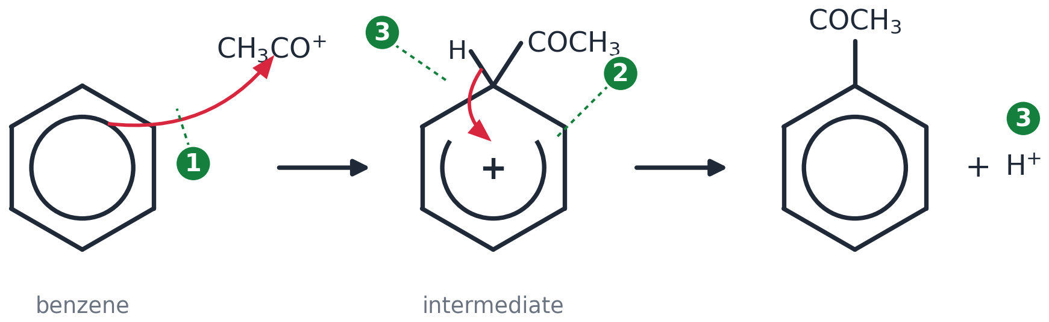
(CH₃)₂CHCOCl + AlCl₃ → (CH₃)₂CHCO⁺ + AlCl₄⁻ (1); arrow with its tail ON the circle and head TOUCHING the carbonyl C of the acylium ion — the carbon carrying the + (1); intermediate: horseshoe stopping either side of the carbon holding H and COCH(CH₃)₂, + INSIDE, both on the same carbon (1); arrow from the MIDDLE of the C–H bond into the ring; product + H⁺; H⁺ + AlCl₄⁻ → AlCl₃ + HCl (1). [The figure shows CH₃CO⁺ — replace CH₃ with (CH₃)₂CH.]
(Drawing boxes appear on the student copy: Draw the mechanism here (use the whole width))
4. Explain why Friedel–Crafts reactions are important in organic synthesis. [1 mark]
Answer: They form a new C–C bond to the benzene ring, so carbon atoms can be added / the carbon skeleton extended (1).
5. Write equations for the formation of the electrophile from (a) chloroethane (b) ethanoyl chloride, each with AlCl₃, and (c) the regeneration of the catalyst at the end of the reaction. [3 marks]
Answer: (a) CH₃CH₂Cl + AlCl₃ → CH₃CH₂⁺ + AlCl₄⁻ (1). (b) CH₃COCl + AlCl₃ → CH₃CO⁺ + AlCl₄⁻ (1). (c) H⁺ + AlCl₄⁻ → AlCl₃ + HCl (1).
6. Complete the table for reactions of benzene with AlCl₃ as the catalyst. [4 marks]
Reagent | Electrophile | Name of organic product
CH₃Cl | CH₃⁺ | methylbenzene
CH₃CH₂Cl | CH₃CH₂⁺ | ethylbenzene
CH₃COCl | CH₃CO⁺ | phenylethanone
C₆H₅COCl | C₆H₅CO⁺ | diphenylmethanone

HARDER Harder
Same ideas, more to think about. Start these when you have finished the core questions — they are meant to take time.

H1. Industrially, (1-methylethyl)benzene (cumene) is made by reacting benzene with propene using phosphoric acid, H₃PO₄, as the catalyst. Suggest the identity of the electrophile and how it forms, then draw the mechanism. [4 marks]
H⁺ from the acid adds to propene to give the secondary carbocation CH₃CH⁺CH₃ (more stable than the primary CH₃CH₂CH₂⁺) (1); arrow from the circle to the C⁺ (1); intermediate with horseshoe, + inside, H and CH(CH₃)₂ on the same carbon (1); arrow from the middle of the C–H bond into the ring; (1-methylethyl)benzene + H⁺, regenerating the catalyst (1).
(Drawing boxes appear on the student copy: Draw the mechanism here (use the whole width))
H2. Benzene reacts with 1-chloropropane and AlCl₃ to give mainly (1-methylethyl)benzene rather than propylbenzene. Suggest why. (Think back to carbocation stability in 4.1.3.) [2 marks]
Answer: The primary carbocation CH₃CH₂CH₂⁺ formed first rearranges by a hydride shift to the more stable secondary carbocation CH₃CH⁺CH₃ (1); this attacks the ring, so the product carries the CH(CH₃)₂ group (1).
H3. Draw the organic product formed when excess benzene reacts with ClCO–CH₂CH₂–COCl in the presence of AlCl₃. [1 mark]
C₆H₅CO–CH₂CH₂–COC₆H₅ (1,4-diphenylbutane-1,4-dione): both acyl chloride groups react with a benzene ring (1).
(Drawing boxes appear on the student copy: Product)
H4. In an acylation, more than one mole of AlCl₃ is needed for each mole of acyl chloride, whereas in an alkylation a small amount is enough. Suggest why. [1 mark]
Answer: The ketone product contains a C=O whose lone pair forms a complex with AlCl₃, tying up the catalyst; alkylbenzenes cannot do this (1).

EXAM-STYLE Exam-style question
Exam wording, exam marks. Done in class: in silence, in one go, then marked against the mark scheme.

E1. Phenylethanone, C₆H₅COCH₃, can be made by reacting benzene with ethanoyl chloride in the presence of aluminium chloride. [6 marks]
(a) Write an equation to show the formation of the electrophile.
(b) Outline the mechanism for the reaction of this electrophile with benzene.
(c) Write an equation to show how the catalyst is regenerated.
(d) Name the type of reaction.
(a) CH₃COCl + AlCl₃ → CH₃CO⁺ + AlCl₄⁻ (1). (b) Arrow with tail on the circle, head touching the carbonyl carbon of CH₃CO⁺ (1); intermediate with horseshoe, + inside, H and COCH₃ on the same carbon (1); arrow from the middle of the C–H bond into the ring; phenylethanone + H⁺ (1). (c) H⁺ + AlCl₄⁻ → AlCl₃ + HCl (1). (d) Electrophilic substitution (Friedel–Crafts acylation) (1).
(Drawing boxes appear on the student copy: (b) mechanism)
Self-check — I can…
☐ write equations for alkylation and acylation
☐ draw the acylation mechanism, arrow to the C=O carbon
☐ predict the product of an unfamiliar electrophile

Worksheet 6
Phenol: a weak acid with an activated ring
OCR A Level Chemistry A (H432) · Specification 6.1.1 (h) (i) (j) · core questions about 25 min · ANSWER VERSION

Specification 6.1.1 says you must be able to demonstrate and apply knowledge and understanding of:
(h) the weak acidity of phenols shown by the neutralisation reaction with NaOH but absence of reaction with carbonates
(i) the electrophilic substitution reactions of phenol: (i) with bromine to form 2,4,6-tribromophenol, (ii) with dilute nitric acid to form a mixture of 2-nitrophenol and 4-nitrophenol
(j) the relative ease of electrophilic substitution of phenol compared with benzene, in terms of electron pair donation to the π-system from an oxygen p-orbital in phenol
Examiner guidance: PAG7 (qualitative analysis); see also 6.3.1(c). Note that nitration of phenol does NOT require concentrated HNO₃ or the presence of a concentrated H₂SO₄ catalyst. Illustrated by the reactions with bromine and with nitric acid. The explanation is ONLY in terms of the susceptibility of the ring to attack — NOT the stability of the intermediate. HSW2,5.
Answers are shown in green. Mark points in brackets. Stretch answers are guidance, not a mark scheme.

CORE Core questions
Do these in the lesson when the slide says NOW → Worksheet.

1. (a) Name each of the molecules A–D. (b) Identify the molecules that are phenols. [5 marks]
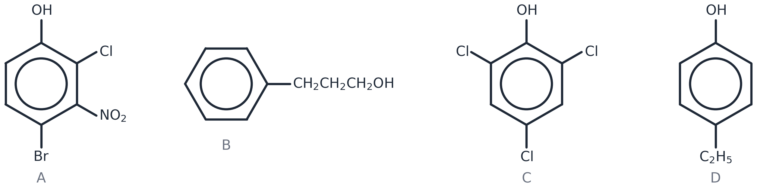
Answer: (a) A 4-bromo-2-chloro-3-nitrophenol; B 3-phenylpropan-1-ol; C 2,4,6-trichlorophenol; D 4-ethylphenol (1 each). (b) A, C and D — the OH is bonded directly to the ring. B is an alcohol: its OH is on the side chain (1).
2. Write an equation to show the reaction of 2-hydroxyphenol (benzene-1,2-diol) with an EXCESS of sodium hydroxide. [1 mark]
Answer: C₆H₄(OH)₂ + 2NaOH → C₆H₄(ONa)₂ + 2H₂O — both OH groups are phenolic, so both react (1).
3. Outline how you would carry out a test to distinguish between solutions of pent-1-ene and phenol. [1 mark]
Answer: Add bromine water to each: both decolourise it, but phenol also gives a WHITE PRECIPITATE (2,4,6-tribromophenol); pent-1-ene does not (1). [Alternative: add NaOH(aq) — phenol reacts and dissolves; pent-1-ene forms a separate layer.]
4. Explain why bromine reacts more readily with phenol than with benzene. [3 marks]
Answer: In phenol a lone pair on the oxygen is in a p-orbital (1) that is delocalised into the ring's π-system (1); this increases the electron density of the ring, so it is more susceptible to attack and can polarise Br₂ without a halogen carrier (1).
5. Phenol reacts with chloromethane to form 2-methylphenol. The reactivity of phenol means that a halogen carrier is not required. Complete the mechanism on the skeleton below. (Hint: the ring attacks the electron-deficient carbon atom of chloromethane.) [4 marks]
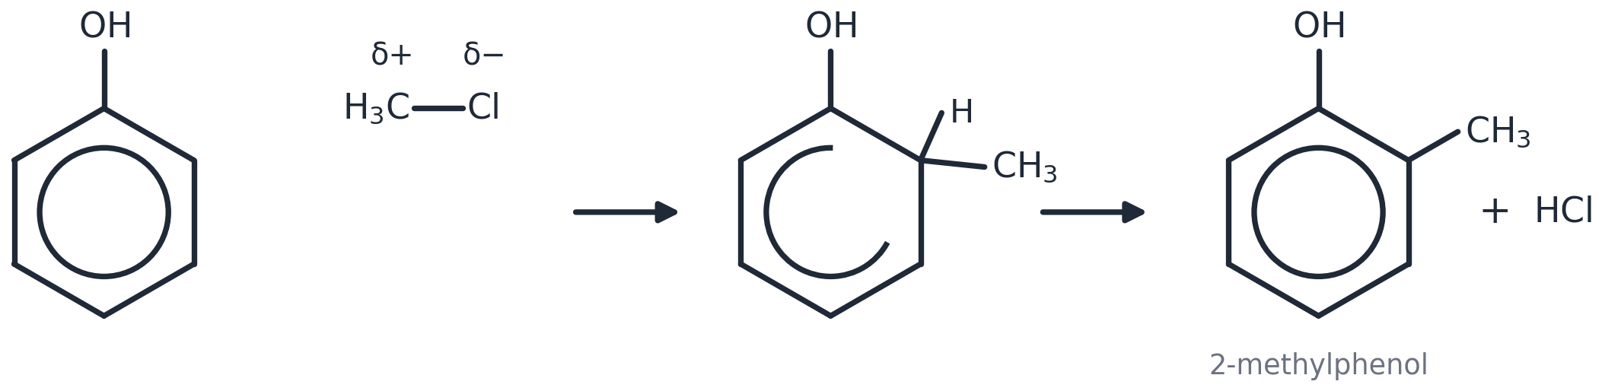
Answer: Dipole on CH₃–Cl (C δ+, Cl δ−); arrow with its tail on the circle beside C2 and head touching the δ+ carbon (1); arrow from the middle of the C–Cl bond to the Cl (1); intermediate: horseshoe stopping either side of C2, + inside, H and CH₃ both on C2 (1); arrow from the middle of the C–H bond into the ring; 2-methylphenol + HCl (1).
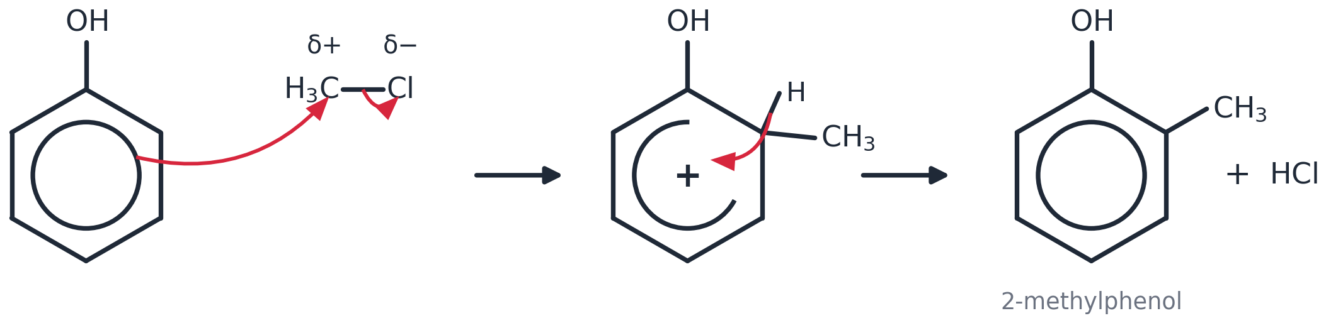
6. Write equations (structural formulae) for the reaction of phenol with (a) sodium hydroxide (b) sodium (c) excess bromine water (d) dilute nitric acid, and state what you would SEE in (c). [5 marks]
Answer: (a) C₆H₅OH + NaOH → C₆H₅O⁻Na⁺ + H₂O (1). (b) 2C₆H₅OH + 2Na → 2C₆H₅O⁻Na⁺ + H₂ (1). (c) C₆H₅OH + 3Br₂ → C₆H₂Br₃OH + 3HBr (1); bromine decolourised and a white precipitate forms (1). (d) C₆H₅OH + HNO₃ → C₆H₄(NO₂)OH + H₂O, giving 2-nitrophenol and 4-nitrophenol (1).
7. Phenol does not react with sodium carbonate solution, but ethanoic acid does. Explain what this tells you about phenol. [2 marks]
Answer: Phenol is a weak acid (1) — too weak to release CO₂ from a carbonate, whereas carboxylic acids are strong enough to do so (1).

HARDER Harder
Same ideas, more to think about. Start these when you have finished the core questions — they are meant to take time.

H1. Predict the organic product when 4-methylphenol reacts with excess bromine water, and explain your answer. [3 marks]
Answer: 2,6-dibromo-4-methylphenol (1). The OH group directs bromine to positions 2, 4 and 6 (1); position 4 is already occupied by CH₃, so only positions 2 and 6 are substituted (1).
H2. Kₐ values at 298 K: ethanol 1.0 × 10⁻¹⁶, phenol 1.3 × 10⁻¹⁰, ethanoic acid 1.7 × 10⁻⁵ mol dm⁻³. Put the three in order of increasing acid strength and explain the order in terms of the stability of the negative ion formed. [3 marks]
Answer: ethanol < phenol < ethanoic acid (1). Phenoxide: the negative charge on O is partly delocalised into the ring, stabilising the ion, so phenol loses H⁺ more readily than ethanol, whose ethoxide ion has no delocalisation (1). Ethanoate: the charge is shared equally between two oxygens — the most stable anion, so the strongest acid (1).
H3. 2-Hydroxybenzoic acid (salicylic acid) has a phenol group and a carboxylic acid group. Write equations for its reaction with (a) excess sodium hydroxide and (b) sodium carbonate, and state which group(s) react in each case. [3 marks]
Answer: (a) HOC₆H₄COOH + 2NaOH → NaOC₆H₄COONa + 2H₂O — both the OH and the COOH react (1). (b) 2HOC₆H₄COOH + Na₂CO₃ → 2HOC₆H₄COONa + H₂O + CO₂ — only the COOH reacts (1); the phenol group is too weak an acid to react with a carbonate (1).
H4. 4-Nitrophenol is a much stronger acid than phenol. Suggest why. [2 marks]
Answer: The NO₂ group is strongly electron-withdrawing (1); it pulls electron density away from the O–H bond / stabilises the negative charge on the phenoxide ion, so H⁺ is lost more easily (1).

EXAM-STYLE Exam-style question
Exam wording, exam marks. Done in class: in silence, in one go, then marked against the mark scheme.

E1. Compound Z is 4-methylphenol. [7 marks]
(a) Draw the structure of Z.
(b) Write an equation for the reaction of Z with sodium hydroxide.
(c) Z reacts with dilute nitric acid to give only ONE mono-nitro product. Draw its structure and explain why only one product forms.
(d) Z reacts with bromine water at room temperature; methylbenzene does not. Explain this difference.
(a) OH on C1, CH₃ on C4 (1). (b) CH₃C₆H₄OH + NaOH → CH₃C₆H₄O⁻Na⁺ + H₂O (1). (c) 4-methyl-2-nitrophenol (1); OH directs to 2, 4 and 6 — position 4 is blocked and positions 2 and 6 are equivalent, so only one isomer (1). (d) In Z the O lone pair in a p-orbital is delocalised into the ring (1), increasing the ring's electron density so it can polarise Br₂ (1); the CH₃ group in methylbenzene donates far less electron density, so the ring cannot polarise Br₂ — a halogen carrier is needed (1).
(Drawing boxes appear on the student copy: (a) Z | (c) product)
Self-check — I can…
☐ name phenols and tell them from alcohols
☐ write the equations for phenol + NaOH, Na, Br₂ and dilute HNO₃
☐ explain why phenol is activated

Worksheet 7
Directing groups and synthesis
OCR A Level Chemistry A (H432) · Specification 6.1.1 (k) (l) · core questions about 25 min · ANSWER VERSION

Specification 6.1.1 says you must be able to demonstrate and apply knowledge and understanding of:
(k) the 2- and 4-directing effect of electron-donating groups (OH, NH₂) and the 3-directing effect of electron-withdrawing groups (NO₂) in electrophilic substitution of aromatic compounds
(l) the prediction of substitution products of aromatic compounds by directing effects and the importance to organic synthesis
Examiner guidance: You will NOT be expected to know further electron-donating or electron-withdrawing groups; relevant additional data will be supplied in examinations. HSW5. See also 6.2.5 Organic synthesis.
Answers are shown in green. Mark points in brackets. Stretch answers are guidance, not a mark scheme.
Data for this worksheet. You must KNOW the first three rows; the rest would be given in an exam.
Group on the ring | Directs the next group to
–OH, –NH₂ (electron-donating, lone pair) | 2 and 4
–NO₂ (electron-withdrawing) | 3
–R (alkyl, e.g. –CH₃) | 2 and 4
–Cl, –Br | 2 and 4
–COOH, –COOR, –COR (–COCH₃), –CHO | 3
–N⁺(CH₃)₃ | 3

CORE Core questions
Do these in the lesson when the slide says NOW → Worksheet.

1. Identify each of the following compounds as containing a 2,4-directing or a 3-directing group: (a) C₆H₅CH₂CH₃ (b) C₆H₅Cl (c) C₆H₅COOH (d) C₆H₅N⁺(CH₃)₃. [4 marks]
Answer: (a) 2,4-directing (1). (b) 2,4-directing (1). (c) 3-directing (1). (d) 3-directing (1).
2. Identify and draw the structures of the product(s) of the following reactions: (a) C₆H₅Br + HNO₃ (with conc. H₂SO₄) (b) C₆H₅NO₂ + Br₂ + FeBr₃ (c) C₆H₅COOCH₂CH₃ + CH₃Cl + AlCl₃. [3 marks]
(a) 1-bromo-2-nitrobenzene and 1-bromo-4-nitrobenzene (1). (b) 1-bromo-3-nitrobenzene (1). (c) ethyl 3-methylbenzoate — the ester group is 3-directing (1). [Honest note for (c): in practice Friedel–Crafts reactions fail on rings deactivated by a C=O group; the question tests the directing rule.]
(Drawing boxes appear on the student copy: (a) | (b) | (c))
3. Starting from benzene, suggest a two-step synthesis of (a) 3-nitromethylbenzene (b) 2-nitromethylbenzene. Give reagents and conditions and explain the order of the steps. [4 marks]
Answer: (a) Step 1: conc. HNO₃ + conc. H₂SO₄, 50 °C → nitrobenzene; step 2: CH₃Cl + AlCl₃ → 3-nitromethylbenzene. Nitrate FIRST because NO₂ directs the methyl group to position 3 (2). (b) Step 1: CH₃Cl + AlCl₃ → methylbenzene; step 2: conc. HNO₃ + conc. H₂SO₄, 50 °C → 2-nitromethylbenzene (with the 4-isomer). Methylate FIRST because CH₃ directs NO₂ to 2 (and 4) (2). [Note: (a) is the textbook answer; in reality Friedel–Crafts reactions do not work on nitrobenzene — examiners credit the directing logic.]
4. Explain, in terms of electron density, why an –OH group directs a second substituent to positions 2 and 4 whereas an –NO₂ group directs it to position 3. [2 marks]
Answer: –OH donates electron density into the ring (lone pair delocalised), and the increase is greatest at positions 2 and 4, so electrophiles attack there (1). –NO₂ withdraws electron density from the ring; the decrease is greatest at 2 and 4, so position 3 is the least deactivated and is attacked (1).
5. Predict the major organic product(s) of (a) phenylethanone + Cl₂ with AlCl₃ (b) methylbenzene + chloroethane with AlCl₃. Draw and name them. [3 marks]
(a) 1-(3-chlorophenyl)ethanone — COCH₃ is 3-directing (1). (b) 1-ethyl-2-methylbenzene and 1-ethyl-4-methylbenzene — CH₃ is 2,4-directing (2).
(Drawing boxes appear on the student copy: (a) | (b) | )

HARDER Harder
Same ideas, more to think about. Start these when you have finished the core questions — they are meant to take time.

H1. When a ring already carries TWO groups, the more strongly activating group usually decides where the next one goes. Predict the major product(s) of (a) 4-methylphenol + dilute nitric acid (b) 3-nitromethylbenzene + Br₂/FeBr₃. Explain each prediction. [4 marks]
Answer: (a) 4-methyl-2-nitrophenol: OH is the stronger director (2,4); position 4 is blocked so NO₂ goes to 2 (=6) (2). (b) Mainly 4-bromo-3-nitromethylbenzene and 2-bromo-5-nitromethylbenzene: the activating CH₃ directs to 2, 4 and 6; the position between the two groups (2) is crowded, so 4 and 6 dominate (2).
H2. Nitro groups can be reduced to amino groups using tin and concentrated hydrochloric acid. Use this to plan a synthesis from benzene of (a) 4-bromophenylamine (b) 3-bromophenylamine. Give reagents and conditions for every step. [4 marks]
Answer: (a) Benzene → bromobenzene (Br₂/FeBr₃) → 1-bromo-4-nitrobenzene (conc. HNO₃/H₂SO₄, 50 °C; Br directs to 4) → 4-bromophenylamine (Sn/conc. HCl, then NaOH) (2). (b) Benzene → nitrobenzene (conc. HNO₃/H₂SO₄) → 1-bromo-3-nitrobenzene (Br₂/FeBr₃; NO₂ directs to 3) → 3-bromophenylamine (Sn/conc. HCl, then NaOH) (2).
H3. Methylbenzene is converted to 2,4,6-trinitromethylbenzene (TNT) by prolonged nitration. Write the overall equation and explain why the three nitro groups take up positions 2, 4 and 6. [3 marks]
Answer: C₆H₅CH₃ + 3HNO₃ → CH₃C₆H₂(NO₂)₃ + 3H₂O (1). CH₃ is 2,4-directing, so the first NO₂ goes to 2 or 4 (1); each NO₂ already on the ring is 3-directing, which points to the same positions (e.g. NO₂ at 4 directs to 2 and 6), so all three end up at 2, 4 and 6 (1).
H4. A student plans to make 4-nitrophenylethanone by nitrating phenylethanone. Explain why the plan fails, and why simply reversing the two steps (nitrate, then acylate) does not work either. [3 marks]
Answer: COCH₃ is 3-directing, so nitration of phenylethanone gives 3-nitrophenylethanone, not the 4-isomer (1). Nitrating first gives nitrobenzene, and NO₂ is also 3-directing, so acylation would again give the 3-isomer (1) — and Friedel–Crafts reactions fail on the strongly deactivated nitrobenzene ring anyway (1).

EXAM-STYLE Exam-style question
Exam wording, exam marks. Done in class: in silence, in one go, then marked against the mark scheme.

E1. 1-Bromo-4-nitrobenzene can be made from benzene in two steps. [8 marks]
(a) Give the reagents and conditions for each step and explain why the steps must be carried out in this order.
(b) Outline the mechanism for the second step.
(c) Explain why carrying out the steps in the reverse order would give a different product.
(a) Step 1: Br₂ with FeBr₃ (or AlBr₃ / iron), room temperature → bromobenzene (1). Step 2: conc. HNO₃ + conc. H₂SO₄, 50 °C → 1-bromo-4-nitrobenzene (1). Br is 2,4-directing, so it must be on the ring BEFORE the nitro group is added (1). (b) Ring with Br at C1; arrow with tail on the circle beside C4, head touching the N of NO₂⁺ (1); intermediate: horseshoe stopping either side of C4, + inside, H and NO₂ both on C4 (1); arrow from the middle of the C–H bond into the ring; product + H⁺ (1). (c) Nitrating first gives nitrobenzene; NO₂ is 3-directing (1), so bromination would then give 1-bromo-3-nitrobenzene (1).
(Drawing boxes appear on the student copy: (b) mechanism)
Self-check — I can…
☐ classify a group as 2,4- or 3-directing
☐ predict the product of a substitution on a substituted ring
☐ plan a two-step synthesis and justify the order

Worksheet 8
Chapter practice questions
OCR A Level Chemistry A (H432) · Specification 6.1.1 (a)–(l) · core questions about 80 min · ANSWER VERSION

Specification 6.1.1 says you must be able to demonstrate and apply knowledge and understanding of:
(a) Kekulé model vs delocalised model: p-orbital overlap → delocalised π-system
(b) evidence for delocalisation: bond lengths, enthalpy change of hydrogenation, resistance to reaction
(c) IUPAC rules for naming substituted aromatic compounds
(d) electrophilic substitution: nitration, halogenation, Friedel–Crafts
(e) the mechanism of electrophilic substitution for nitration and halogenation
(f) why benzene resists bromination compared with alkenes: delocalised vs localised π electron density
(g) interpreting unfamiliar electrophilic substitution reactions, including predicting mechanisms
(h) weak acidity of phenols: reacts with NaOH, no reaction with carbonates
(i) phenol + bromine → 2,4,6-tribromophenol; phenol + dilute nitric acid → 2-nitrophenol and 4-nitrophenol
(j) phenol is more easily substituted than benzene: electron pair donated from an oxygen p-orbital into the π-system
(k) OH and NH₂ (electron-donating) direct to 2- and 4-; NO₂ (electron-withdrawing) directs to 3-
(l) predicting substitution products from directing effects; importance to organic synthesis
Answers are shown in green. Mark points in brackets. Stretch answers are guidance, not a mark scheme.
The Chapter 25 practice questions (textbook pages 451–453), complete. 72 marks, about 80 minutes. Done in class, in one sitting, in silence, then marked against the mark scheme.

EXAM-STYLE Practice questions
Past-paper questions from OCR F324 — the same style as your H432 papers.

1. Salicylic acid is a naturally occurring carboxylic acid, widely used in organic synthesis. The flowchart shows some of its reactions. [12 marks]
(a)(i) In the box, draw the structure of the organic compound formed by reaction 1.
(ii) Write a chemical equation to represent reaction 2.
(iii) State the reagents and conditions in reaction 3.
(b)(i) Outline the mechanism for the bromination of salicylic acid in reaction 2. A halogen carrier is not required; the electrophile is Br₂.
(ii) Explain why bromine reacts more readily with salicylic acid than with benzene. Use appropriate technical terms, spelled correctly.
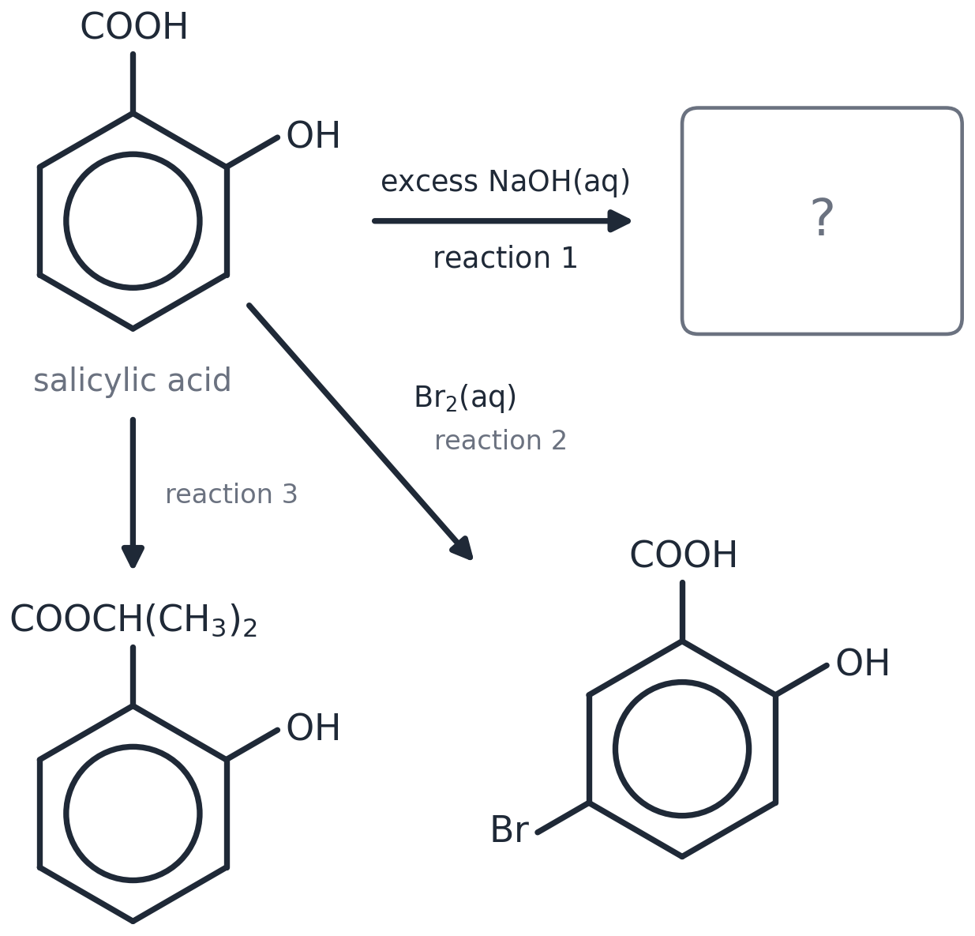
Answer: (a)(i) Both acidic H atoms removed: –COO⁻Na⁺ and –O⁻Na⁺ on the ring (1). (ii) HOC₆H₄COOH + Br₂ → HOC₆H₃(Br)COOH + HBr (1). (iii) Propan-2-ol with concentrated H₂SO₄ catalyst, heat under reflux (1). (b)(i) Dipole on Br–Br; arrow with its tail on the circle and head touching the δ+ Br, AND an arrow from the middle of the Br–Br bond to the far Br (1); intermediate: horseshoe stopping either side of C5, + inside, H and Br both on C5 (1); arrow from the middle of the C–H bond into the ring (1); product + HBr (or H⁺ + Br⁻) (1). (ii) Lone pair on the O in a p-orbital (1) delocalised into the ring's π-system (1) → increased electron density, so the ring polarises Br₂ / is more susceptible to attack (1).
(b)(i) mechanism

2. In the first stage of the synthesis of a dye, methyl 3-nitrobenzoate is formed. In this stage, methyl benzoate is nitrated by concentrated nitric acid, in the presence of concentrated sulfuric acid as a catalyst. [6 marks]
(i) Outline the mechanism for this nitration of methyl benzoate. Show how H₂SO₄ behaves as a catalyst.
(ii) State the name for this type of mechanism.
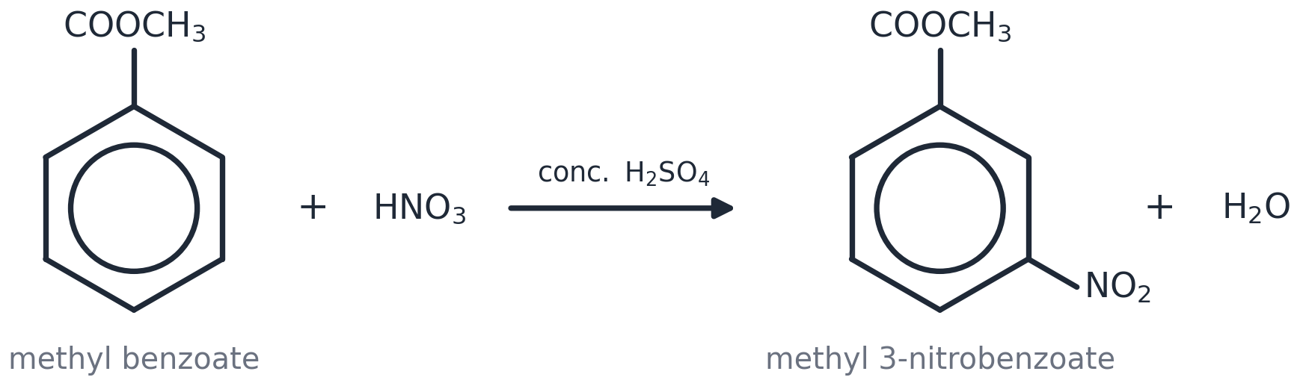
Answer: (i) HNO₃ + H₂SO₄ → NO₂⁺ + HSO₄⁻ + H₂O (1); arrow with its tail ON the circle and head TOUCHING the N of NO₂⁺ (1); intermediate: horseshoe stopping either side of C3, + INSIDE it, H and NO₂ both on C3 (1); arrow from the MIDDLE of the C–H bond into the ring, product + H⁺ (1); H⁺ + HSO₄⁻ → H₂SO₄ (1). (ii) Electrophilic substitution (1). [In the figure G = COOCH₃.]
Draw the mechanism here (use the whole width)

3. Benzaldehyde, C₆H₅CHO, is the simplest aromatic aldehyde and has a characteristic smell of almonds. Benzaldehyde can be nitrated with a mixture of concentrated nitric acid and concentrated sulfuric acid to form 3-nitrobenzaldehyde. [6 marks]
Explain, with the aid of curly arrows, the mechanism for the formation of 3-nitrobenzaldehyde. Your answer should clearly show the role of sulfuric acid as a catalyst.
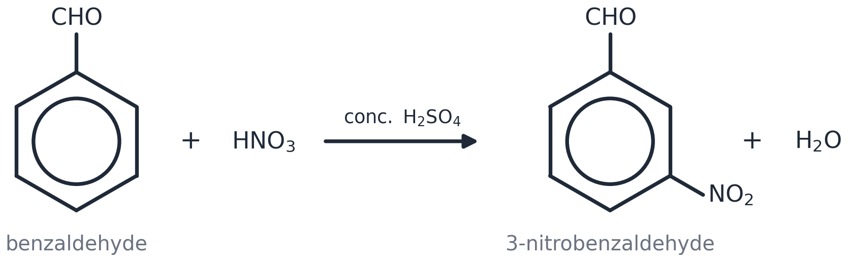
Answer: HNO₃ + H₂SO₄ → NO₂⁺ + HSO₄⁻ + H₂O (1); arrow with its tail ON the circle and head TOUCHING the N of NO₂⁺ (1); intermediate: horseshoe stopping either side of C3, + INSIDE it, H and NO₂ both on C3 (1); arrow from the MIDDLE of the C–H bond into the ring (1); 3-nitrobenzaldehyde + H⁺ (1); H⁺ + HSO₄⁻ → H₂SO₄ (1). [In the figure G = CHO.]
mechanism

4. Benzene and other arenes can be chlorinated to produce chloroarenes which are used in the manufacture of pesticides, drugs and dyes. [15 marks]
(a) In 1865, Kekulé proposed a model for the structure and bonding of benzene, but there is considerable evidence to suggest that Kekulé's model may not be correct. Scientists have proposed alternative models for the structure and bonding of benzene. Explain the evidence that led scientists to doubt the model proposed by Kekulé.
(b) Chlorobenzene, C₆H₅Cl, is formed by the reaction of benzene and chlorine in the presence of a suitable catalyst, such as AlCl₃: C₆H₆ + Cl₂ → C₆H₅Cl + HCl. Outline the mechanism for the formation of chlorobenzene from benzene. Show how AlCl₃ behaves as a catalyst.
(c) Chlorobenzene reacts with trichloroethanal, Cl₃CCHO, to produce the pesticide DDT (shown below). Construct an equation for the reaction of chlorobenzene with trichloroethanal to form DDT.
(d) Chlorobenzene can be nitrated to form a mixture of products. Suggest why the reaction forms a mixture of products.
(e) Explain why phenol reacts more readily with chlorine than benzene reacts with chlorine. In your answer, you should use appropriate technical terms, spelled correctly.
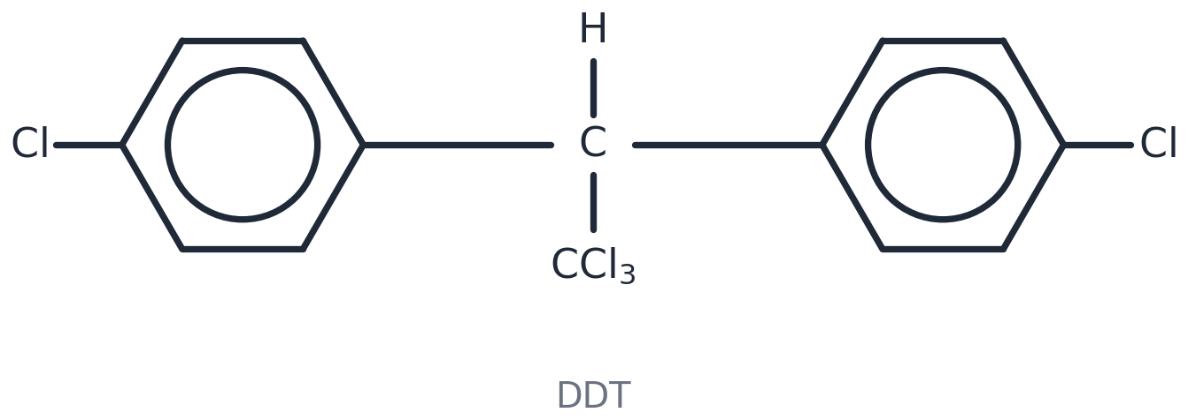
Answer: (a) Any three: all C–C bonds the same length (0.139 nm), between single and double (1); enthalpy of hydrogenation −208 not −360 kJ mol⁻¹, so benzene is more stable than expected (1); benzene does not readily undergo addition / does not decolourise bromine water (1). (b) Cl₂ + AlCl₃ → Cl⁺ + AlCl₄⁻ (1); arrow with tail on the circle, head touching Cl⁺ (1); intermediate: horseshoe stopping either side of the carbon holding H and Cl, + inside, H and Cl on the same carbon (1); arrow from the middle of the C–H bond into the ring (1); chlorobenzene + H⁺ (1); H⁺ + AlCl₄⁻ → AlCl₃ + HCl (1). (c) 2C₆H₅Cl + Cl₃CCHO → (ClC₆H₄)₂CHCCl₃ + H₂O — DDT structure correct (1), balanced with water (1). (d) The Cl group directs to positions 2 and 4, so 2- and 4-nitro isomers form / the electrophile can attack more than one position (1). (e) A lone pair on the O in a p-orbital (1) is delocalised into the π-system (1), increasing the electron density of the ring so it is more susceptible to attack / can polarise Cl₂ (1).
(b) mechanism

5. (a) Benzene can be converted into benzenesulfonic acid, C₆H₅SO₃H, which is used in the manufacture of many detergents. The reaction between benzene and sulfur trioxide is an electrophilic substitution reaction. Sulfur trioxide, SO₃, is the electrophile. Part of the mechanism for this reaction is shown below. Complete the mechanism by drawing the intermediate and by adding curly arrows to show the movement of electron pairs in steps 1 and 2. [6 marks]
(b) The painkiller paracetamol has the structure shown below. Separate samples of paracetamol are reacted with bromine, Br₂, and with cold sodium hydroxide, NaOH. Draw the structures of possible organic products formed in each reaction.
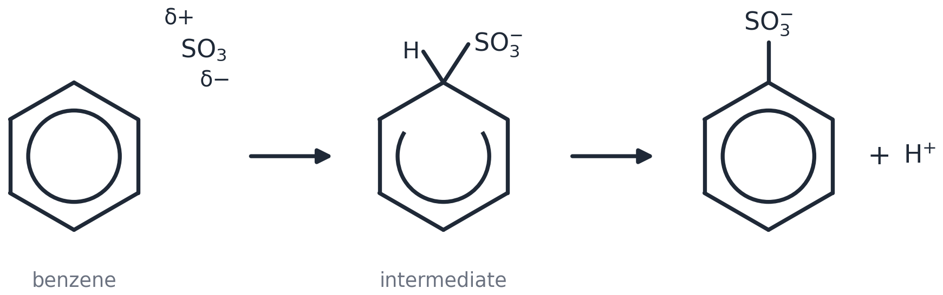
Answer: (a) Step 1: arrow with its tail ON the circle and head TOUCHING the δ+ S of SO₃ (1); intermediate: horseshoe stopping either side of the carbon holding H and SO₃⁻, + INSIDE it, –SO₃⁻ and H on the SAME carbon (1); step 2: arrow from the MIDDLE of the C–H bond into the ring (1); loss of H⁺ / H⁺ picked up by the SO₃⁻ oxygen to give C₆H₅SO₃H (1). (b) With Br₂: bromine substitutes on the ring next to the OH (e.g. 2-bromo-4-(acetylamino)phenol) (1); with cold NaOH: the phenol OH is deprotonated to –O⁻Na⁺ (sodium salt) (1).
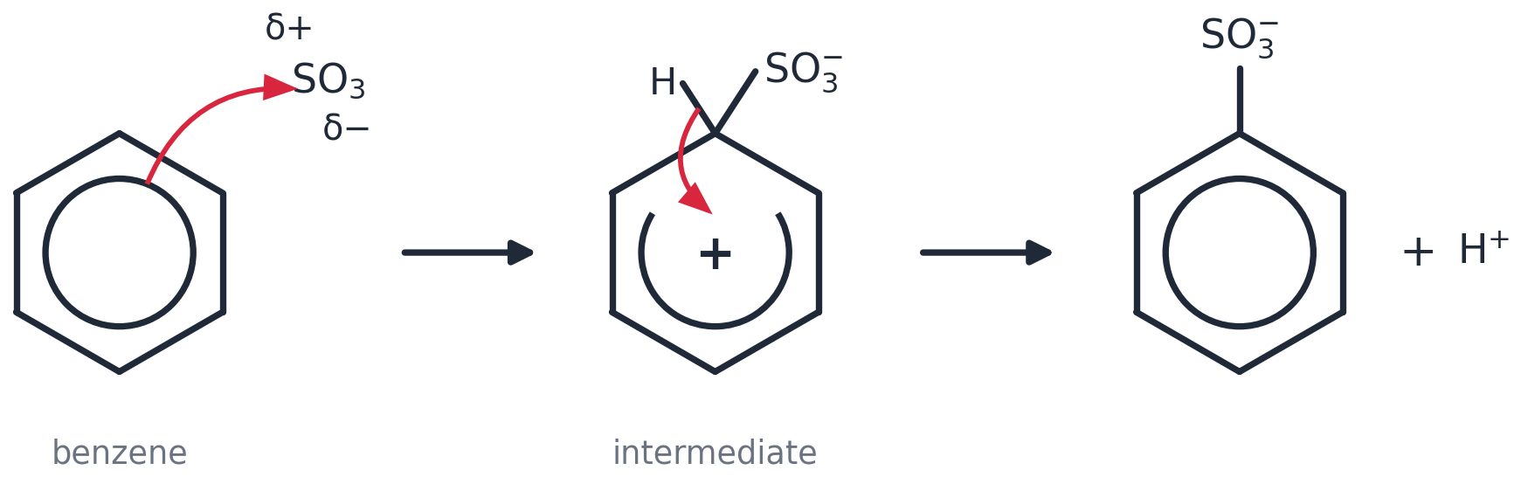
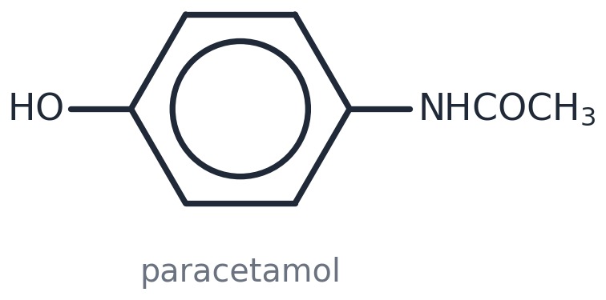
(a) intermediate and arrows — draw on the printed scheme above | (b) with Br₂ | (b) with NaOH

6. The mass spectrum of an aromatic hydrocarbon is found to have a molecular ion peak at m/z value of 106. Elemental analysis showed that the compound had the following composition by mass, C, 90.56% and H, 9.44%. [8 marks]
(a) Use the data to find the molecular formula of the aromatic compound.
(b) A student realised that the calculated molecular formula could have a number of different structural isomers. Draw all the possible structural isomers that contain a benzene ring.
(c) In the presence of concentrated nitric acid and concentrated sulfuric acid, one of the isomers, A, reacts to give one mono-nitrated compound, B. Identify A and B.
Answer: (a) C: 90.56/12.0 = 7.55; H: 9.44/1.0 = 9.44; ratio 1 : 1.25 = 4 : 5 → empirical formula C₄H₅ (1); Mr(C₄H₅) = 53, 106/53 = 2 → C₈H₁₀ (1). (b) Ethylbenzene; 1,2-dimethylbenzene; 1,3-dimethylbenzene; 1,4-dimethylbenzene (4). (c) A = 1,4-dimethylbenzene — all four ring hydrogens are equivalent, so only one mono-nitro product is possible (1); B = 1,4-dimethyl-2-nitrobenzene (1).
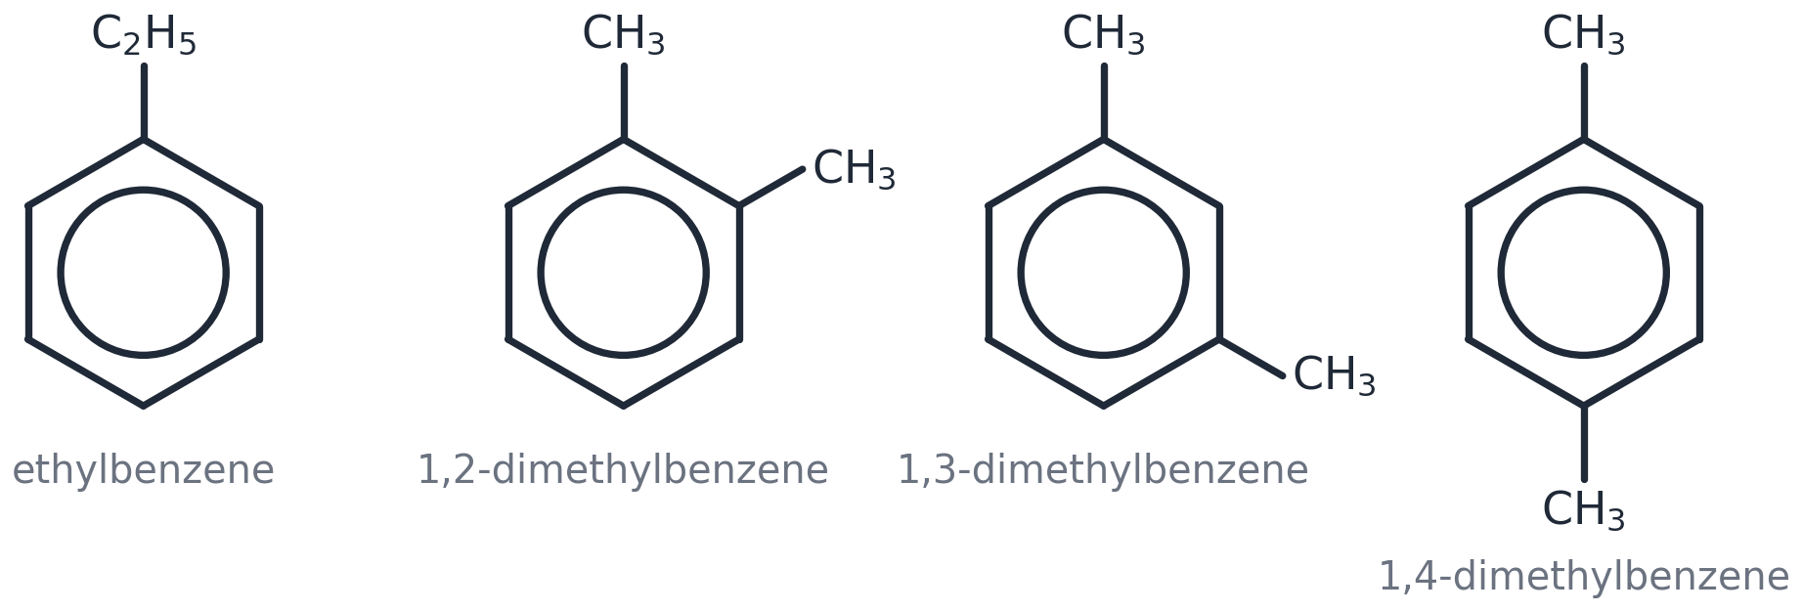
(b) isomers | (c) A and B

7. When monosubstituted aromatic compounds undergo further substitution, the position at which the new substituent attaches to the ring is directed by the original substituent. Use the table to answer the questions which follow. [8 marks]
(a)(i) Draw the structure of the major monosubstituted product formed when phenylethanone, C₆H₅COCH₃, reacts with chlorine in the presence of AlCl₃.
(ii) Show the mechanism for this reaction using curly arrows and illustrating the role of AlCl₃ in the reaction.
(b) Identify the two monosubstituted isomers formed when methylbenzene reacts with chloroethane in the presence of AlCl₃.
Answer: (a)(i) 1-(3-chlorophenyl)ethanone — Cl at position 3 (1). (ii) Cl₂ + AlCl₃ → Cl⁺ + AlCl₄⁻ (1); arrow with tail on the circle beside C3, head touching Cl⁺ (1); intermediate: horseshoe stopping either side of C3, + inside, H and Cl both on C3 (1); arrow from the middle of the C–H bond into the ring, product + H⁺ (1); H⁺ + AlCl₄⁻ → AlCl₃ + HCl (1). (b) 1-ethyl-2-methylbenzene and 1-ethyl-4-methylbenzene (2).
Original substituent | Position to which new substituent is directed
–COOH | 3
–CH₃ (or any alkyl group) | 2, 4
–NO₂ | 3
–Cl | 2, 4
–COCH₃ | 3

(a)(i) product | (a)(ii) mechanism (use the whole width)

8. Phenol is much more susceptible to electrophilic attack than benzene. [5 marks]
(a) Explain why phenol reacts more readily than benzene with electrophiles.
(b) Phenol reacts with dilute nitric acid to form a mixture of two monosubstituted isomers. Draw the structures of these two isomers and write an equation for the formation of one of these isomers.
Answer: (a) A lone pair on the oxygen in a p-orbital (1) is delocalised into the ring / π-system (1), increasing the electron density so the ring is more susceptible to attack by electrophiles (1). (b) 2-nitrophenol and 4-nitrophenol (1); C₆H₅OH + HNO₃ → O₂NC₆H₄OH + H₂O (1).
(b) 2-isomer | (b) 4-isomer

9. Methylbenzene, C₆H₅CH₃, is an aromatic hydrocarbon, used widely as a solvent. It is readily nitrated and can form mono-, di-, or tri-nitromethylbenzenes. [6 marks]
(a) 4-Nitromethylbenzene can be formed by the nitration of methylbenzene. Outline the mechanism for the formation of 4-nitromethylbenzene from methylbenzene using NO₂⁺ as the electrophile.
(b) There are six possible structural isomers of CH₃C₆H₃(NO₂)₂ that are dinitromethylbenzenes. Four of the isomers are shown below. Draw the structures of the other two isomers.
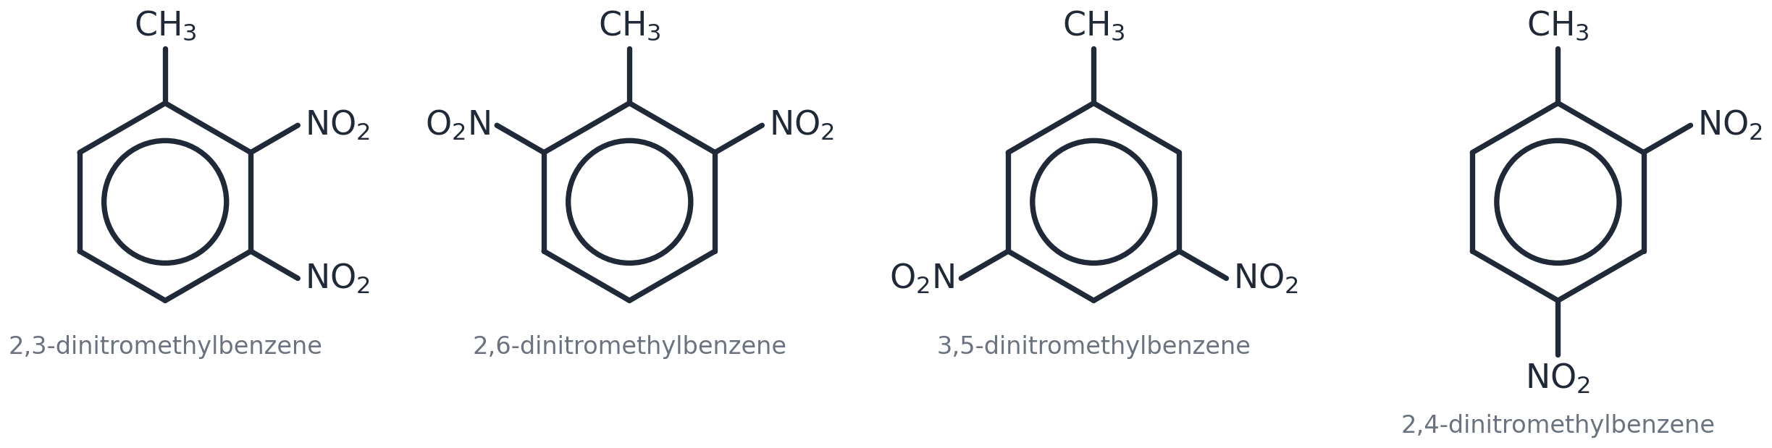
Answer: (a) Arrow with its tail ON the circle beside C4 and head TOUCHING the N of NO₂⁺ (1); intermediate: horseshoe stopping either side of C4, + INSIDE it, H and NO₂ both on C4, CH₃ on C1 (1); arrow from the MIDDLE of the C–H bond into the ring (1); 4-nitromethylbenzene + H⁺ (1). (b) 2,5-dinitromethylbenzene and 3,4-dinitromethylbenzene (1 each).
(a) mechanism (use the whole width)

(b) isomer 5 | (b) isomer 6

Self-check — I can…
☐ do a 6-mark mechanism question in exam conditions
☐ use a directing table I have never seen before
☐ explain phenol's reactivity in three technical sentences

