University-level worksheet
Aromatic Chemistry
the island
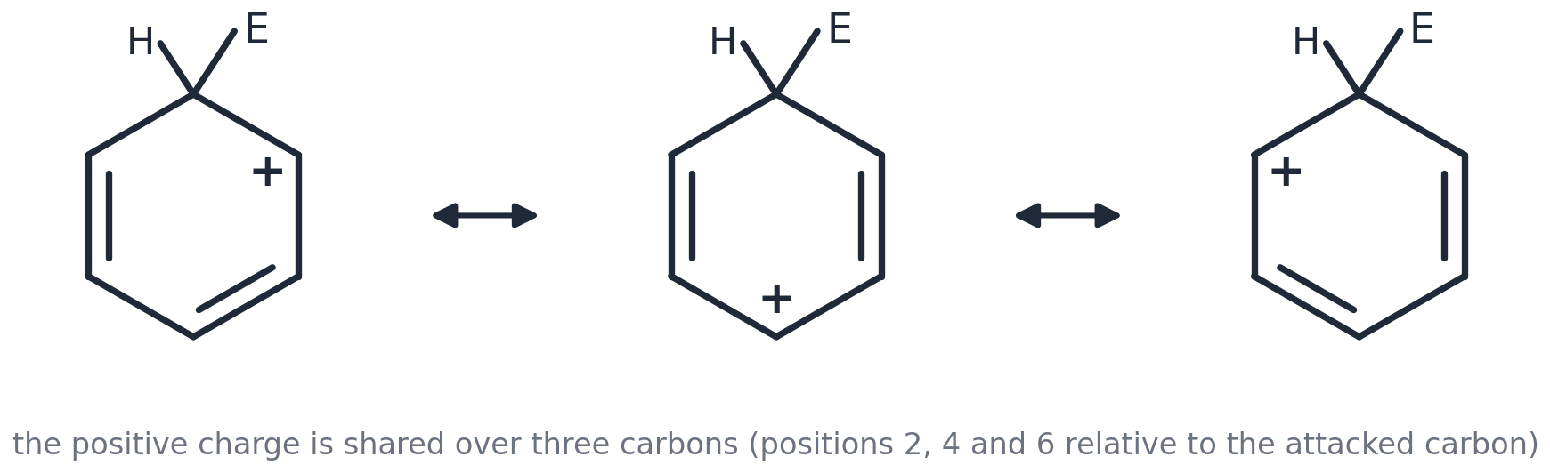

What this is
Seven short sections, one for each lesson of 6.1.1, containing the first-year university explanation of what the lesson taught: why 4n + 2, what the horseshoe really stands for, why phenol is acidic, why groups direct where they do. None of it is examined at A level, and none of it appears on the ordinary worksheets — it lives here so that nobody meets it by accident.
Who it is for
Anyone who has finished the Core and Harder questions and wants to know why. If you enjoy this, the Stretch Pack (63 pages, first- and second-year level) is the next step; each section here says where to go in it.
Contents
U1 Aromaticity: why 4n + 2? (lesson 1)
U2 How chemists really name rings: ortho, meta, para and trivial names (lesson 2)
U3 The Wheland intermediate (lesson 3)
U4 Halogen carriers are Lewis acids (lesson 4)
U5 Friedel–Crafts: the fine print (lesson 5)
U6 Phenol: acidity explained properly (lesson 6)
U7 Directing effects: the real reason (lesson 7)
Worked answers at the back

U1 GOES WITH LESSON 1 · UNIVERSITY LEVEL · NOT EXAMINED
Aromaticity: why 4n + 2?
Benzene is not the only aromatic ring — and some rings with alternating double bonds are spectacularly UNstable.

Key facts
• Hückel's rule: a planar, fully conjugated ring is aromatic if it holds 4n + 2 π electrons (2, 6, 10, 14 …).
• 4n π electrons in a planar ring is ANTIaromatic — far less stable than the open-chain version. Cyclobutadiene (4 π) survives only in an argon matrix at 8 K.
• A ring that escapes planarity is merely non-aromatic: cyclooctatetraene (8 π) puckers into a tub and behaves like an alkene.
• Lone pairs count only if they sit in a p-orbital that is part of the ring: pyrrole's N lone pair does; pyridine's does not.
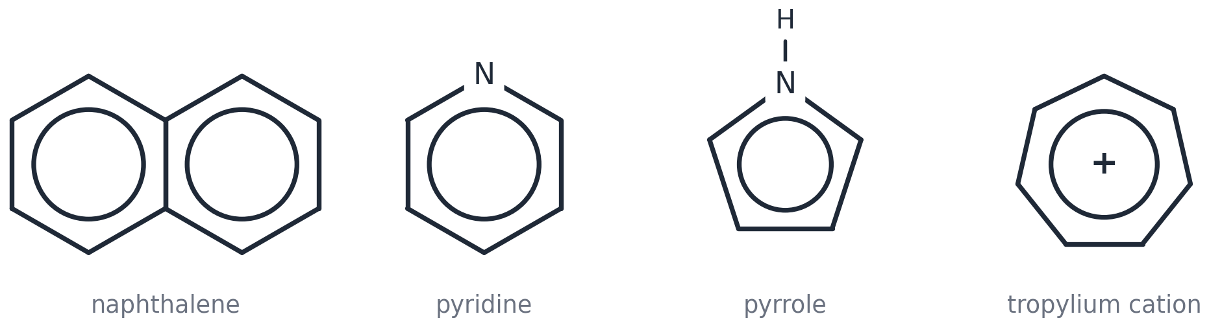
Aromatic rings that are not benzene: naphthalene (10 π), pyridine (6 π), pyrrole (6 π including the N lone pair), tropylium cation (6 π).
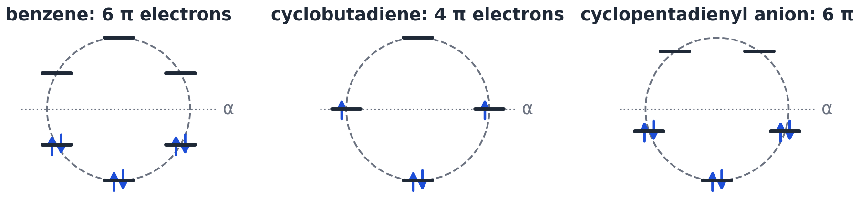
Frost circles: the π orbital energies of a ring sit at the corners of the polygon inscribed vertex-down in a circle. 4n + 2 electrons fill a closed shell.
U1.1 Classify as aromatic, antiaromatic or non-aromatic, giving the π-electron count: (a) the cyclopropenyl cation C₃H₃⁺ (b) cyclobutadiene C₄H₄ (c) cyclooctatetraene C₈H₈ (d) the cyclopentadienyl anion C₅H₅⁻ (e) naphthalene.

U1.2 Naphthalene's C–C bonds are NOT all the same length (0.136–0.142 nm). Explain why it is still aromatic, and why its bonds differ when benzene's do not.

U1.3 Use a Frost circle (square, vertex down) to explain why planar cyclobutadiene would be a diradical.

Go further: Stretch Pack Part A §1 (aromaticity) and Part B §8 (Hückel molecular orbital theory with numbers).

U2 GOES WITH LESSON 2 · UNIVERSITY LEVEL · NOT EXAMINED
How chemists really name rings: ortho, meta, para and trivial names
The names you will meet in every university textbook and paper, and why the exam board avoids them.

Key facts
• ortho (o-) = positions 1,2; meta (m-) = 1,3; para (p-) = 1,4. Only meaningful for TWO groups.
• Trivial names still in daily use: toluene (methylbenzene), aniline (phenylamine), xylene (dimethylbenzene), cresol (methylphenol), anisole (methoxybenzene), benzaldehyde and benzoic acid (also IUPAC), styrene (phenylethene).
• IUPAC lowest-locant and alphabetical rules still apply underneath: p-xylene is 1,4-dimethylbenzene.
U2.1 Give the IUPAC names of: p-xylene, m-cresol, o-nitrotoluene, p-chloroaniline, anisole.

U2.2 Explain why 1,2,4-trichlorobenzene cannot be named with ortho/meta/para, and why 'o-dichlorobenzene' is unambiguous.

U2.3 'Aryl' (Ar–) is used the way 'alkyl' (R–) is. Write the general formula for an aryl chloride and for Friedel–Crafts acylation of an arene, using Ar.

Go further: Stretch Pack Part B §11 (regioselectivity and synthesis) uses o/m/p throughout.

U3 GOES WITH LESSON 3 · UNIVERSITY LEVEL · NOT EXAMINED
The Wheland intermediate
The horseshoe is a shorthand. Here is what it stands for, and why the intermediate loses H⁺ rather than adding a nucleophile.

The three resonance forms of the intermediate (arenium ion, σ-complex): the positive charge is shared over the carbons ortho and para to the attacked carbon.
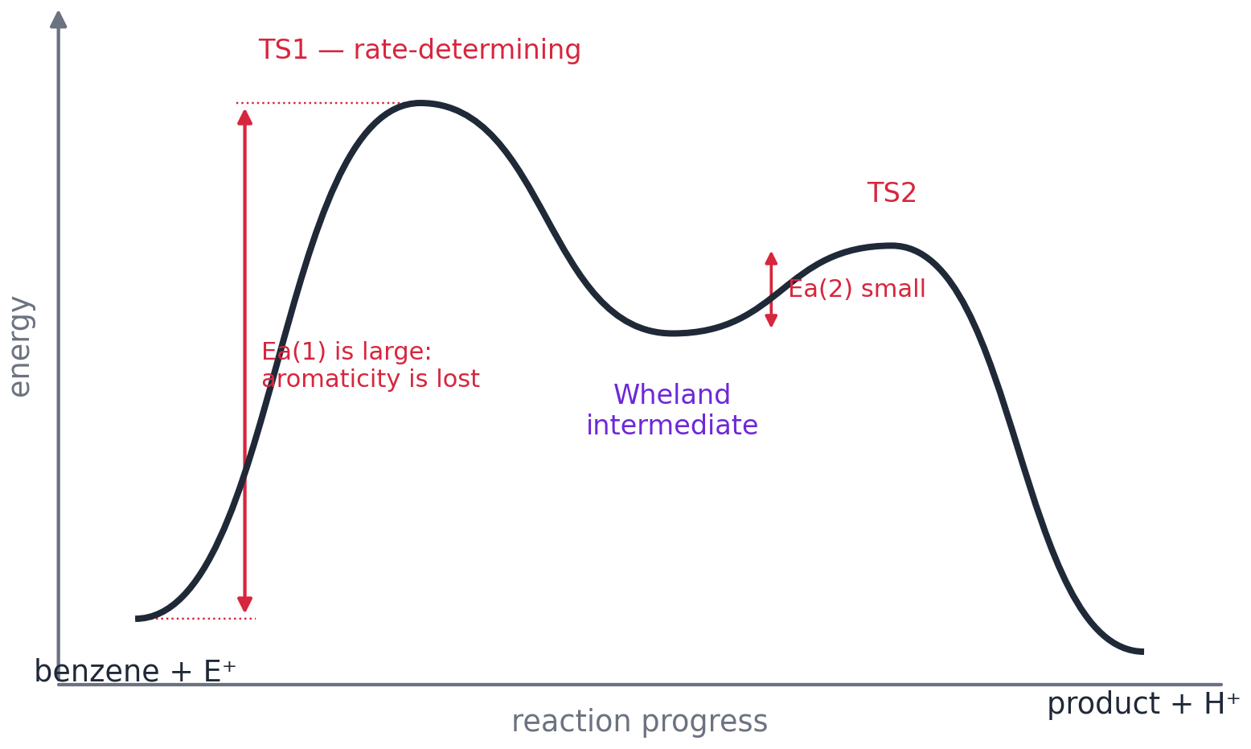
Energy profile: step 1 (attack, aromaticity lost) is slow and rate-determining; step 2 (loss of H⁺, aromaticity regained) is fast.
Key facts
• The intermediate is real: heptamethylbenzenium salts have been isolated and characterised by NMR (Doering 1958; Olah in superacids).
• Nitration of C₆D₆ is as fast as C₆H₆ — no kinetic isotope effect — so the C–H bond is not broken in the rate-determining step (Melander 1950).
• Substitution beats addition because losing H⁺ regains ~150 kJ mol⁻¹ of delocalisation energy; addition would give a non-aromatic diene.
U3.1 Draw the three resonance forms of the intermediate formed when Br⁺ attacks benzene. Mark the carbon that carries H and Br, and state on which carbons the positive charge is found.

U3.2 Use the energy profile to explain why the intermediate loses H⁺ rather than picking up HSO₄⁻ (which would give an addition product, as happens with an alkene).

U3.3 Sulfonation (SO₃) shows a kinetic isotope effect and is reversible; nitration shows neither. Sketch the two energy profiles and explain the difference.

U3.4 NO₂⁺ is linear. Which common molecule is it isoelectronic with, and what does linearity tell you about the N atom's orbitals?

Go further: Stretch Pack Part A §3 (the Wheland intermediate) and Part B §10 (electrophilic substitution at research depth).

U4 GOES WITH LESSON 4 · UNIVERSITY LEVEL · NOT EXAMINED
Halogen carriers are Lewis acids
What AlCl₃ and FeBr₃ actually do, and why iodination is hard.

Key facts
• A Lewis acid is an electron-pair acceptor. AlCl₃ has only six electrons around Al; FeBr₃ has empty d/p orbitals on Fe.
• The real electrophile is often a polarised complex Br–Br···FeBr₃ (Brδ+) rather than free Br⁺; the exam board lets you write Br⁺ because the arrow-pushing is identical.
• Iron filings work because 2Fe + 3Br₂ → 2FeBr₃ forms the carrier in situ.
U4.1 Draw a curly-arrow mechanism for the formation of the electrophile from Br₂ and FeBr₃, showing (a) the Br–Br bond pair moving to Fe and (b) the resulting FeBr₄⁻ and Br⁺.

U4.2 Iodobenzene cannot be made efficiently from benzene, I₂ and FeI₃. Give two reasons, and suggest why adding nitric acid helps.

U4.3 Fluorination of benzene with F₂ is violently exothermic and gives a tar. Explain why direct fluorination is useless for making fluorobenzene, and name the general strategy chemists use instead.

Go further: Stretch Pack Part A §5 (Friedel–Crafts fine print) and Part B §11 (diazonium chemistry).

U5 GOES WITH LESSON 5 · UNIVERSITY LEVEL · NOT EXAMINED
Friedel–Crafts: the fine print
Four things the A-level story leaves out — and the standard fix for all of them.

Key facts
• Primary carbocations rearrange to more stable secondary/tertiary ones by hydride or methyl shifts before they attack the ring.
• Alkyl groups activate the ring, so alkylation often goes further (polyalkylation) unless benzene is in large excess.
• Strongly deactivated rings (–NO₂, –COR, –CN) do not undergo Friedel–Crafts reactions at all; –NH₂ and –OH poison the catalyst by complexing AlCl₃.
• Acylation avoids all of this: the acylium ion is resonance-stabilised and does not rearrange, and the ketone product is deactivated so the reaction stops after one substitution.
U5.1 Benzene + 1-chloropropane/AlCl₃ gives mainly (1-methylethyl)benzene. Draw the carbocation rearrangement responsible and explain the driving force.

U5.2 Design a two-step synthesis of propylbenzene from benzene that avoids rearrangement, naming the reagents for each step.

U5.3 Draw the two resonance forms of the ethanoyl cation and explain why it does not rearrange.

U5.4 Why is nitrobenzene a good SOLVENT for Friedel–Crafts acylations, whereas methoxybenzene is not?

Go further: Stretch Pack Part A §5 and Part B §12 (named reactions and rearrangements).

U6 GOES WITH LESSON 6 · UNIVERSITY LEVEL · NOT EXAMINED
Phenol: acidity explained properly
Why phenol is 10⁶ times more acidic than ethanol yet 10⁵ times less than ethanoic acid — and what a nitro group does.

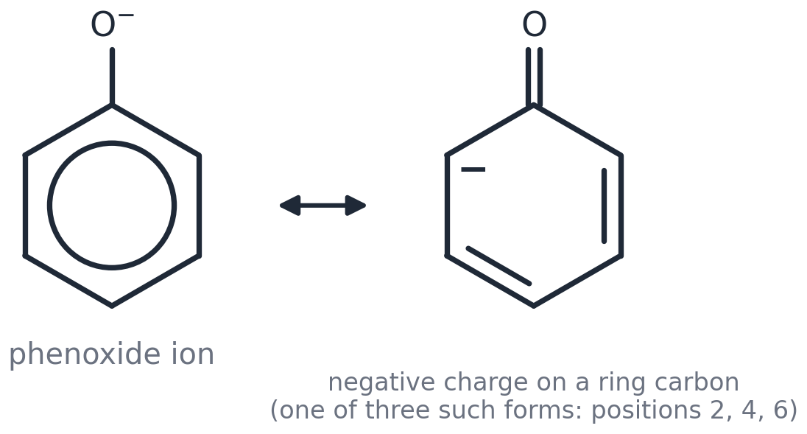
The phenoxide ion: the negative charge on oxygen is delocalised onto C2, C4 and C6 (three extra resonance forms).
Key facts
• pKₐ: ethanol ≈ 16; phenol 10.0; 4-nitrophenol 7.2; 2,4-dinitrophenol 4.1; 2,4,6-trinitrophenol (picric acid) 0.4; ethanoic acid 4.8.
• An acid is stronger when its conjugate base is more stable: delocalisation of the negative charge stabilises the phenoxide but not the ethoxide ion.
• Nitro groups withdraw electron density inductively (−I) AND accept the negative charge by resonance when para or ortho (−M), so each one strengthens the acid dramatically.
U6.1 Explain, using the resonance forms above, why phenol is a much stronger acid than ethanol.

U6.2 Explain the trend phenol (10.0) → 4-nitrophenol (7.2) → picric acid (0.4). Why is 3-nitrophenol (8.4) a weaker acid than 4-nitrophenol?

U6.3 Aspirin is made from 2-hydroxybenzoic acid, itself made from phenol by the Kolbe–Schmitt reaction (sodium phenoxide + CO₂ at 125 °C and 100 atm, then acid). Suggest why the phenoxide ion, not phenol, is used, and why the CO₂ goes to the 2-position.

Go further: Stretch Pack Part A §6 (phenol acidity, Kolbe–Schmitt, aspirin).

U7 GOES WITH LESSON 7 · UNIVERSITY LEVEL · NOT EXAMINED
Directing effects: the real reason
Count the resonance forms of the intermediate and the 2,4- versus 3- rule explains itself — and partial rate factors let you predict the isomer ratio.

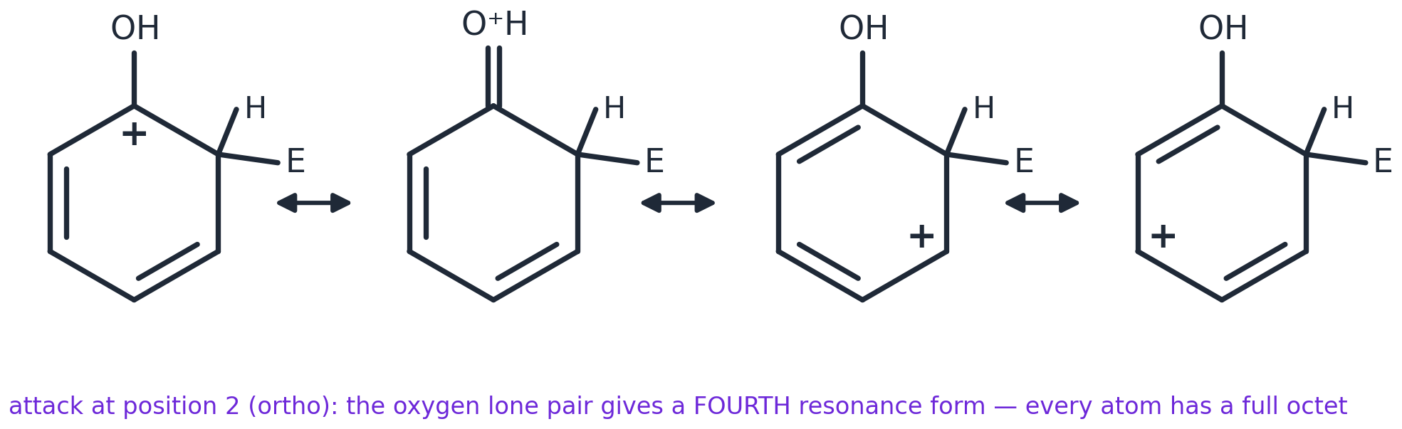
Attack at the 2-position of phenol: the fourth resonance form, in which the oxygen lone pair makes a C=O⁺ bond, gives every atom a full octet — attack at 3 cannot do this.
Key facts
• For –OH, –NH₂, –OR, –Cl: attack at 2 or 4 gives an EXTRA resonance form stabilised by the heteroatom lone pair; attack at 3 does not.
• For –NO₂, –COR: attack at 2 or 4 puts the positive charge next to the δ+ atom of the group (very unfavourable); attack at 3 avoids this — so every position is deactivated, but 3 least.
• Partial rate factors compare ONE position of the substituted ring with ONE position of benzene. Nitration of methylbenzene: ortho 42, meta 2.5, para 58. Chlorobenzene: 0.030, 0.0009, 0.14.
U7.1 Use the methylbenzene partial rate factors to calculate the expected percentages of 2-, 3- and 4-nitromethylbenzene, and the overall rate relative to benzene.

U7.2 Every partial rate factor for methylbenzene is greater than 1, even the meta one. What does this tell you about the –CH₃ group?

U7.3 Explain why –Cl deactivates the ring (all partial rate factors below 1) yet directs to 2 and 4.

U7.4 Draw the three resonance forms for attack of NO₂⁺ at the 4-position of nitrobenzene and identify the one that makes 4-attack unfavourable.

Go further: Stretch Pack Part A §4 (directing effects) and Part B §9 (the Hammett equation — putting numbers on 'electron-withdrawing').

Worked answers
Argue with these. If your answer is different and you can defend it, bring it to Dr Fennell.
U1 — Aromaticity: why 4n + 2?
U1.1 Classify as aromatic, antiaromatic or non-aromatic, giving the π-electron count: (a) the cyclopropenyl cation C₃H₃⁺ (b) cyclobutad…
(a) 2 π (n = 0): aromatic — the smallest aromatic ring. (b) 4 π = 4n: antiaromatic if planar; it distorts to a rectangle and is extremely reactive. (c) 8 π: would be antiaromatic if planar, so it adopts a tub shape — non-aromatic, alkene-like. (d) 6 π (4 from C=C + the lone pair): aromatic — which is why cyclopentadiene (pKₐ ≈ 16) is a remarkably strong acid for a hydrocarbon. (e) 10 π (n = 2): aromatic.
U1.2 Naphthalene's C–C bonds are NOT all the same length (0.136–0.142 nm). Explain why it is still aromatic, and why its bonds differ w…
Aromaticity needs a closed shell of 4n + 2 delocalised π electrons, which naphthalene has (10). Bond lengths depend on how often each bond is double in the resonance structures: naphthalene has three Kekulé structures and C1–C2 is double in two of them (bond order 1.67, 0.136 nm) while C2–C3 is double in only one (1.33, 0.142 nm). In benzene every bond is double in one of the two structures, so all are identical (order 1.5).
U1.3 Use a Frost circle (square, vertex down) to explain why planar cyclobutadiene would be a diradical.
The four orbital energies sit at the corners of the square: one bonding (bottom), two degenerate non-bonding (middle), one antibonding (top). Four electrons: two fill the bonding orbital and the remaining two go one each into the degenerate pair (Hund's rule) — two unpaired electrons, no closed shell, no aromatic stabilisation.
U2 — How chemists really name rings: ortho, meta, para and trivial names
U2.1 Give the IUPAC names of: p-xylene, m-cresol, o-nitrotoluene, p-chloroaniline, anisole.
1,4-dimethylbenzene; 3-methylphenol; 2-nitromethylbenzene; 4-chlorophenylamine; methoxybenzene.
U2.2 Explain why 1,2,4-trichlorobenzene cannot be named with ortho/meta/para, and why 'o-dichlorobenzene' is unambiguous.
o/m/p describe the relationship between exactly two substituents; with three groups every pair has its own relationship (1,2 ortho; 1,4 para; 2,4 meta) so the description is ambiguous — locants are required. With two identical groups, 'ortho' fixes the 1,2 relationship completely.
U2.3 'Aryl' (Ar–) is used the way 'alkyl' (R–) is. Write the general formula for an aryl chloride and for Friedel–Crafts acylation of a…
Aryl chloride: ArCl. Acylation: ArH + RCOCl → ArCOR + HCl (AlCl₃ catalyst).
U3 — The Wheland intermediate
U3.1 Draw the three resonance forms of the intermediate formed when Br⁺ attacks benzene. Mark the carbon that carries H and Br, and sta…
Ring with H and Br on the same carbon (C1). Positive charge on C2 with C=C at C3–C4 and C5–C6; on C4 with C=C at C2–C3 and C5–C6; on C6 with C=C at C2–C3 and C4–C5. The charge is on the carbons ortho and para to C1 — never on C1 itself and never on C3 or C5. The horseshoe with + is the average of these three drawings.
U3.2 Use the energy profile to explain why the intermediate loses H⁺ rather than picking up HSO₄⁻ (which would give an addition product…
Loss of H⁺ restores the aromatic π-system and releases the delocalisation energy (~150 kJ mol⁻¹) — a very favourable, low-barrier step. Addition of HSO₄⁻ would give a non-aromatic cyclohexadiene far higher in energy. An alkene carbocation has no aromaticity to regain, so addition is its only option.
U3.3 Sulfonation (SO₃) shows a kinetic isotope effect and is reversible; nitration shows neither. Sketch the two energy profiles and ex…
Sulfonation: the two transition states are of similar height because SO₃ is a weaker electrophile and the intermediate can revert to reactants; C–H (C–D) cleavage is partly rate-determining, so C₆D₆ reacts more slowly, and the shallow well makes the reaction reversible (steam removes –SO₃H). Nitration: the first transition state is much higher than the second, so the C–H step never limits the rate and the reaction is effectively irreversible.
U3.4 NO₂⁺ is linear. Which common molecule is it isoelectronic with, and what does linearity tell you about the N atom's orbitals?
CO₂ (16 valence electrons, O=N⁺=O). Linear → the N is sp hybridised with two π bonds; the empty p-orbital character at N is what makes it such a powerful electrophile.
U4 — Halogen carriers are Lewis acids
U4.1 Draw a curly-arrow mechanism for the formation of the electrophile from Br₂ and FeBr₃, showing (a) the Br–Br bond pair moving to F…
Arrow from a lone pair on one Br to the empty orbital on Fe gives Br–Br→FeBr₃; then an arrow from the Br–Br bond onto the Fe-bound Br gives FeBr₄⁻ and Br⁺ (in practice the ring attacks the polarised complex directly).
U4.2 Iodobenzene cannot be made efficiently from benzene, I₂ and FeI₃. Give two reasons, and suggest why adding nitric acid helps.
I⁺ is a poor electrophile (large, polarisable, low charge density), and the reaction is close to thermoneutral/reversible: the HI produced reduces iodobenzene back to benzene. Nitric acid oxidises the HI (and I₂ to a better electrophile, I⁺/IO⁺ species), driving the reaction forward.
U4.3 Fluorination of benzene with F₂ is violently exothermic and gives a tar. Explain why direct fluorination is useless for making flu…
F₂ is such a strong oxidant and the C–F bond so strong that the reaction is uncontrolled (radical pathways, polysubstitution, ring destruction). Fluoroarenes are made indirectly — e.g. from the amine via a diazonium salt (Balz–Schiemann: ArN₂⁺BF₄⁻ → ArF + N₂ + BF₃).
U5 — Friedel–Crafts: the fine print
U5.1 Benzene + 1-chloropropane/AlCl₃ gives mainly (1-methylethyl)benzene. Draw the carbocation rearrangement responsible and explain th…
CH₃CH₂CH₂⁺ (primary) undergoes a 1,2-hydride shift: a hydrogen with its bonding pair moves from C2 to C1, giving CH₃CH⁺CH₃ (secondary). Secondary cations are more stable because two alkyl groups donate electron density inductively and by hyperconjugation.
U5.2 Design a two-step synthesis of propylbenzene from benzene that avoids rearrangement, naming the reagents for each step.
1 Acylate with CH₃CH₂COCl/AlCl₃ → 1-phenylpropan-1-one (acylium ions do not rearrange; the product is deactivated so no second acylation). 2 Reduce the C=O to CH₂: Clemmensen (Zn(Hg), conc. HCl, heat) or Wolff–Kishner (N₂H₄, KOH, heat).
U5.3 Draw the two resonance forms of the ethanoyl cation and explain why it does not rearrange.
CH₃–C≡O⁺ ↔ CH₃–C⁺=O. The positive charge is delocalised onto oxygen (every atom keeps an octet in the first form), so the cation is far more stable than an alkyl cation and has no driving force to rearrange.
U5.4 Why is nitrobenzene a good SOLVENT for Friedel–Crafts acylations, whereas methoxybenzene is not?
Nitrobenzene is so deactivated by –NO₂ that it does not react with acylium ions, yet it dissolves AlCl₃ complexes well. Methoxybenzene is activated (+M) and would be acylated itself, at the para position, faster than benzene.
U6 — Phenol: acidity explained properly
U6.1 Explain, using the resonance forms above, why phenol is a much stronger acid than ethanol.
In the phenoxide ion the negative charge is delocalised from O onto the ring carbons (three resonance forms with the charge on C2, C4 and C6), which stabilises the anion and shifts the dissociation equilibrium to the right. The ethoxide ion has no delocalisation — the full charge stays on one oxygen.
U6.2 Explain the trend phenol (10.0) → 4-nitrophenol (7.2) → picric acid (0.4). Why is 3-nitrophenol (8.4) a weaker acid than 4-nitroph…
Each –NO₂ withdraws electron density (−I) and, from the 2- or 4-position, accepts the negative charge by resonance (an extra form with the charge on a nitro oxygen), stabilising the anion further; three nitro groups make picric acid as strong as a mineral acid. From the 3-position the charge cannot be pushed onto the nitro group (no resonance form reaches it), so only the weaker inductive effect operates.
U6.3 Aspirin is made from 2-hydroxybenzoic acid, itself made from phenol by the Kolbe–Schmitt reaction (sodium phenoxide + CO₂ at 125 °…
O⁻ donates far more electron density into the ring than OH, activating it enough to attack the weak electrophile CO₂. The Na⁺ ion coordinates both the phenoxide oxygen and CO₂, delivering the electrophile to the adjacent (2-) carbon.
U7 — Directing effects: the real reason
U7.1 Use the methylbenzene partial rate factors to calculate the expected percentages of 2-, 3- and 4-nitromethylbenzene, and the overa…
Weight each position by the number of equivalent positions: ortho 2 × 42 = 84; meta 2 × 2.5 = 5; para 58; total 147. 2-: 84/147 = 57 %; 3-: 3.4 %; 4-: 39 % (experiment ≈ 58 : 4 : 38). Overall rate = 147/6 ≈ 25 times faster than benzene.
U7.2 Every partial rate factor for methylbenzene is greater than 1, even the meta one. What does this tell you about the –CH₃ group?
–CH₃ activates ALL positions (inductive electron donation raises the electron density everywhere) but ortho/para far more, because hyperconjugation stabilises the intermediates for attack at those positions.
U7.3 Explain why –Cl deactivates the ring (all partial rate factors below 1) yet directs to 2 and 4.
Inductive withdrawal (Cl is electronegative) lowers the electron density at every position, so chlorobenzene reacts more slowly than benzene. But a Cl lone pair can donate by resonance into the intermediates for ortho/para attack (an extra resonance form), so those positions are deactivated less than meta → 2,4-directing.
U7.4 Draw the three resonance forms for attack of NO₂⁺ at the 4-position of nitrobenzene and identify the one that makes 4-attack unfav…
One of the three forms puts the positive charge on the carbon bearing –NO₂, directly next to the δ+ nitrogen — like charges adjacent, and no lone pair to help. This form contributes little, so the intermediate is less stabilised than for 3-attack, where the charge never reaches that carbon.

