Aromatic Chemistry
Support Guide
small steps · big print · pictures · recipes
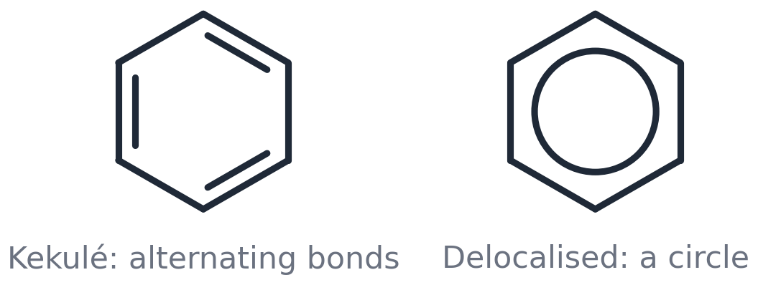

This guide is for you if…
• the slides go too fast
• you like to see one thing at a time
• you want a recipe to follow for mechanisms and explanations
• you revise best with pictures and short sentences

Name: ______________________________________
OCR A Level Chemistry A (H432) · Module 6.1.1 Aromatic compounds

Support pages
How to use this guide

This guide goes with the Aromatic Chemistry lessons. It says the same things as the slides, but in smaller steps, with fewer words and more pictures.
The 5 things you must know
1 | Read ONE box at a time. Cover it. Say it out loud. Check.
2 | Every lesson has: 5 must-know facts → a step-by-step recipe → a worked example → your turn → check yourself.
3 | Words in bold are key words. They are all in the word mat at the back.
4 | The recipe cards (page 'Mechanism recipe') work for EVERY mechanism in this topic. Cut them out and keep them.
5 | If you are stuck in an exam question, use the 'Which recipe do I need?' page.

Colour | What it means
Blue box | a question to answer
Green box | an answer to check against
Amber box | a key word or a memory hook
Pink box | a common mistake — watch out!
Grey box | steps to follow in order

Which recipe do I need?
If the question says… | Use… | Page
'Draw the mechanism' | the 4-move recipe card | Mechanism recipe
'Name this compound' | the 3-step naming recipe | Lesson 2
'Explain why benzene does not react with bromine' | the writing frame: benzene vs alkene | Writing frames
'Explain why phenol reacts more readily' | the writing frame: phenol | Writing frames
'Explain the role of the catalyst' | the writing frame: catalyst | Writing frames
'Suggest a two-step synthesis' | the 3-step planning recipe | Lesson 7
'Give the reagents and conditions' | the knowledge organiser table | Knowledge organiser

Lesson 1
Meet benzene
Spec 6.1.1 (a) (b) (f): Kekulé model vs delocalised model: p-orbital overlap → delocalised π-system · evidence for delocalisation: bond lengths, enthalpy change of hydrogenation, resistance to reaction · why benzene resists bromination compared with alkenes: delocalised vs localised π electron density

The 5 things you must know
1 | Benzene is C₆H₆: six carbon atoms in a flat, six-sided ring.
2 | Kekulé drew alternating double bonds. The REAL ring has a circle: the electrons are delocalised (shared round the whole ring).
3 | All six C–C bonds are the SAME length: 0.139 nm.
 | 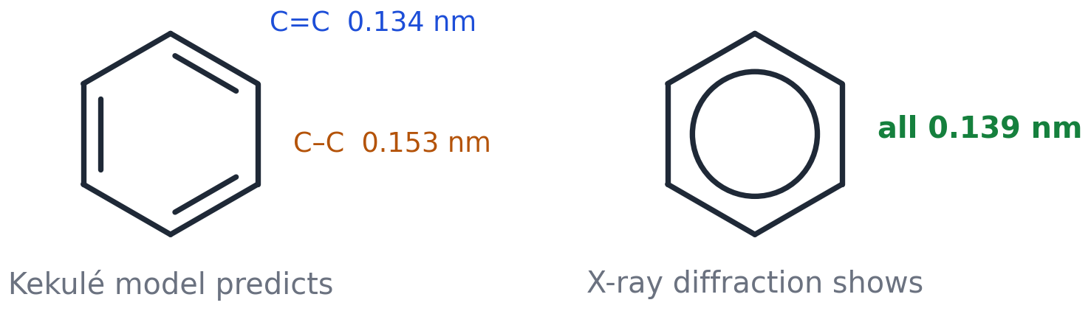
4 | Benzene is MORE stable than Kekulé expected — by 152 kJ mol⁻¹.
 | 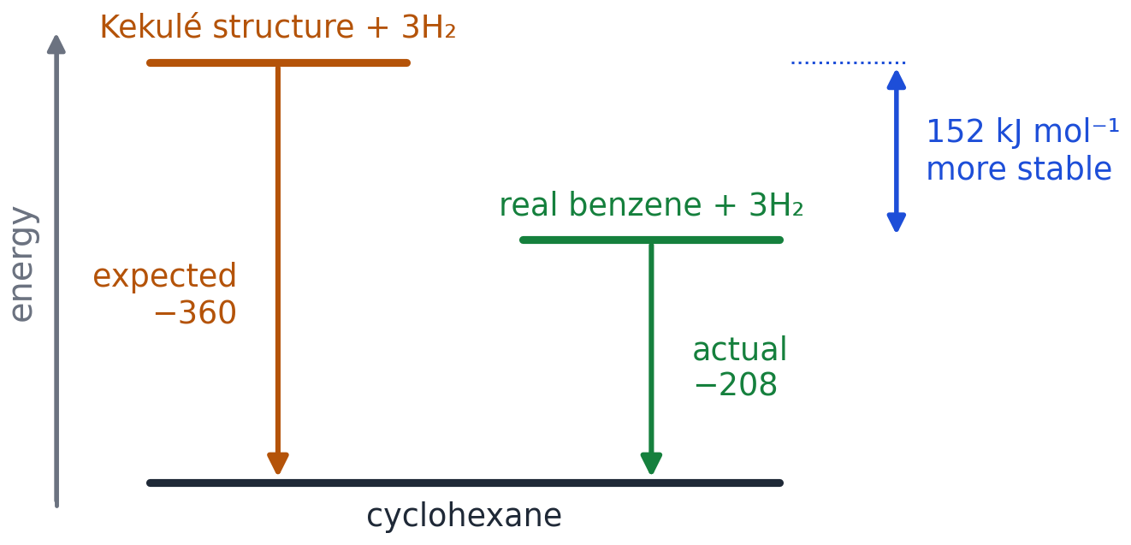
5 | Benzene does NOT react with bromine water. Alkenes DO.
 | 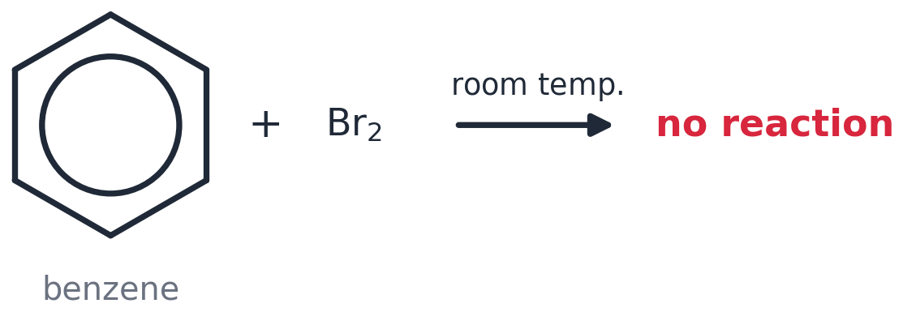

How to explain the hydrogenation evidence (3 steps)
1 | Step 1: Cyclohexene has ONE double bond. Adding H₂ gives −120 kJ mol⁻¹.
 | 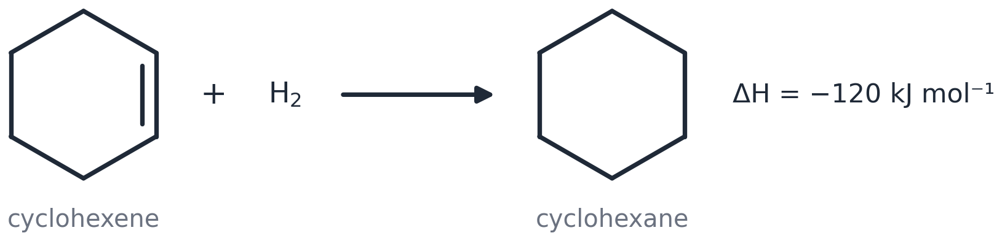
2 | Step 2: Kekulé's benzene has THREE double bonds, so it SHOULD give 3 × (−120) = −360 kJ mol⁻¹.
 | 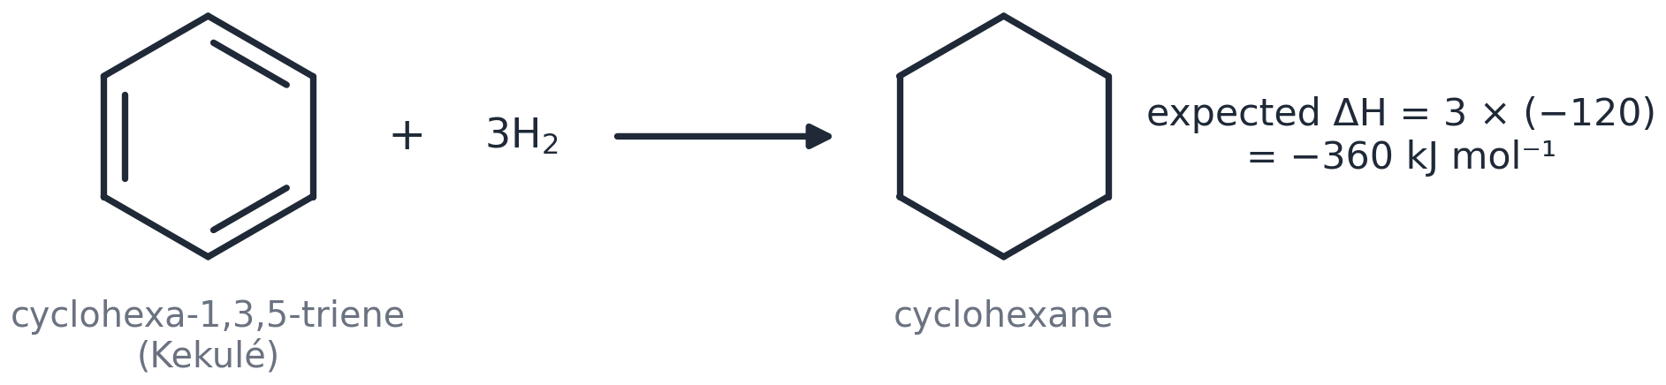
3 | Step 3: Real benzene gives only −208 kJ mol⁻¹. That is 152 kJ mol⁻¹ LESS. So benzene is 152 kJ mol⁻¹ MORE stable → the electrons are delocalised.
 | 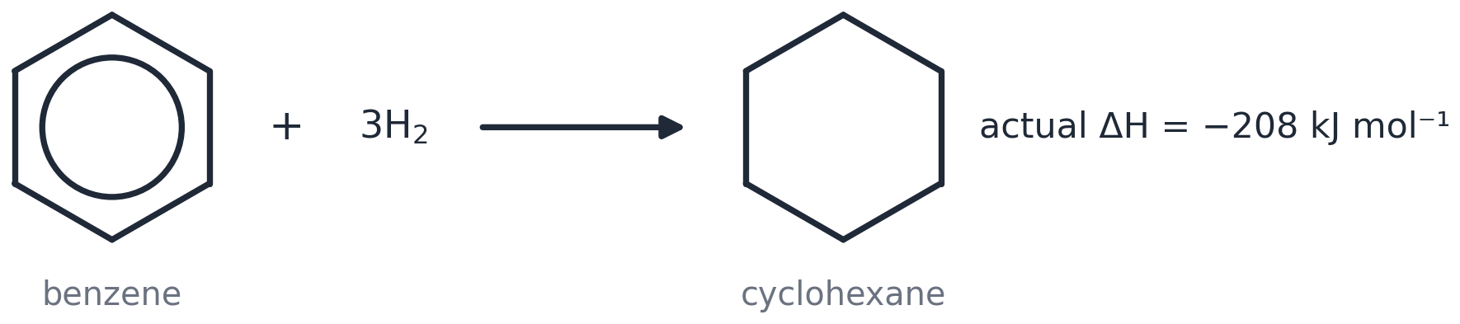

Why does benzene not decolourise bromine water?
I DO — read this worked example
In benzene the π electrons are delocalised over six carbons.
So the electron density between any two carbons is low.
Benzene cannot polarise the Br₂ molecule, so no electrophile forms and there is no reaction.

WE DO — fill in the gaps
In benzene the π electrons are ______________ over six carbons.
So the electron density between any two carbons is ______.
Benzene cannot ______________ the Br₂ molecule, so no ______________ forms and there is no reaction.

YOU DO — your turn
Now YOU explain why cyclohexene DOES decolourise bromine water. Use: localised, high electron density, polarise, electrophile, addition.

Words to use: delocalised • low • polarise • electrophile

Watch out! Common mistakes
✗ People often write… | ✓ What you should write
Benzene has three double bonds. | Benzene has NO separate double bonds — six delocalised electrons in a ring.
Benzene gives out more energy, so it is more stable. | Benzene gives out LESS energy. It is LOWER in energy, so MORE stable.
The circle is a bond. | The circle means six shared (delocalised) electrons.

Memory hook: Kekulé = alternate. Circle = share. • One-three-nine: every bond is 0.139!

Check yourself
1. What is the formula of benzene? | C₆H₆
2. How long is each C–C bond? | 0.139 nm (all the same)
3. Does benzene decolourise bromine water? | No — it has no localised C=C bond to polarise Br₂
Cover the green column with your hand. Say the answer. Then check.

Lesson 2
Naming aromatic compounds
Spec 6.1.1 (c): IUPAC rules for naming substituted aromatic compounds

The 5 things you must know
1 | ONE group on the ring → group + benzene: chlorobenzene, nitrobenzene, methylbenzene.
 | 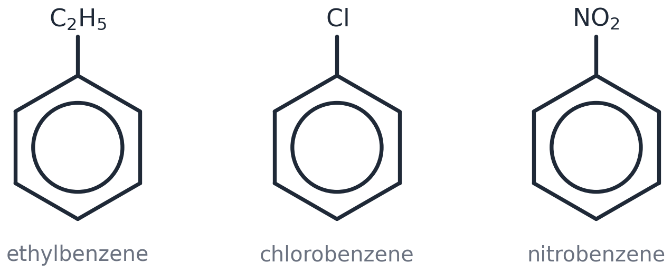
2 | FOUR special names to learn: phenol (OH), phenylamine (NH₂), benzoic acid (COOH), benzaldehyde (CHO).
 | 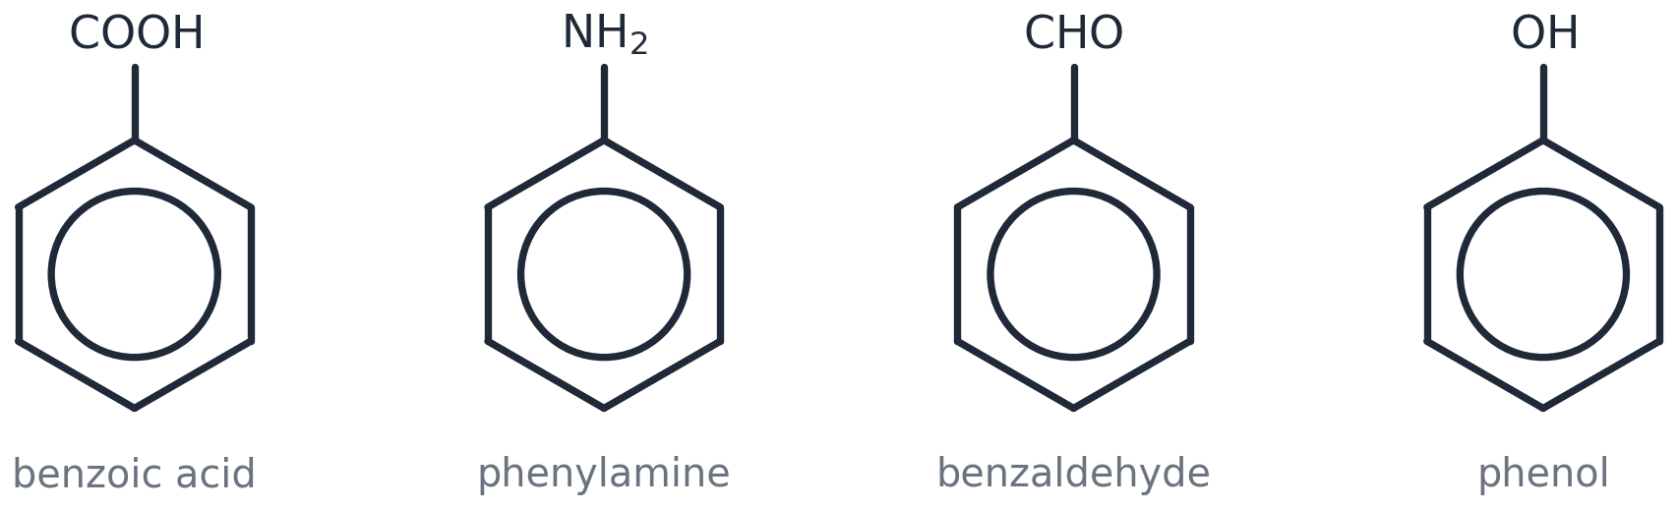
3 | TWO or more groups → number the ring, 1 to 6. | 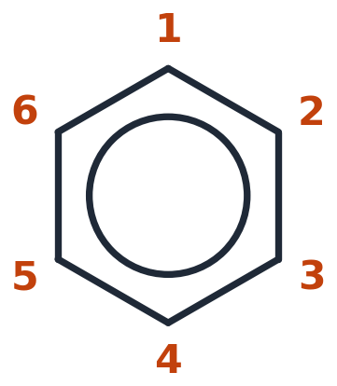
4 | Use the LOWEST numbers you can.
5 | Write the groups in ALPHABETICAL order: bromo, chloro, methyl, nitro.

How to name a ring with two groups (3 steps)
1 | Step 1: Find the parent (methylbenzene, phenol, phenylamine, benzoic acid). Its group is on carbon 1. | 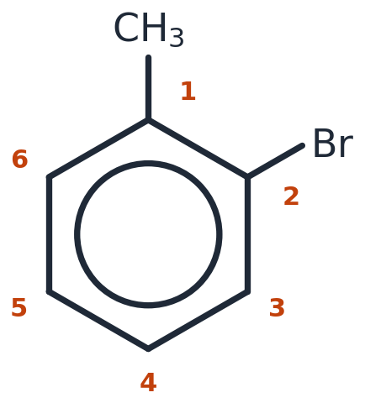
2 | Step 2: Count round to the other group. Go the way that gives the SMALLEST number. Here bromine is on carbon 2 (not 6).
3 | Step 3: Write it: number – group – parent → 2-bromomethylbenzene.

Naming: worked example
I DO — read this worked example
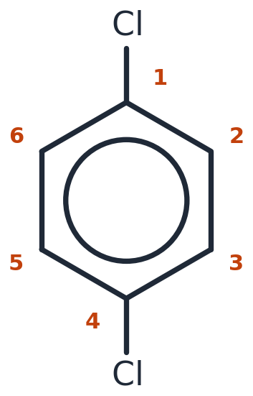
Two Cl groups, opposite each other. Same group twice → 'di'. Numbers 1 and 4. Name: 1,4-dichlorobenzene.

WE DO — fill in the gaps
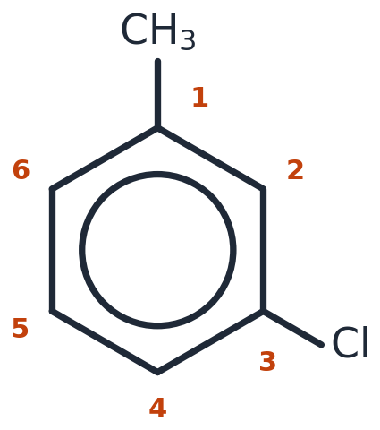
CH₃ on carbon ___ (methylbenzene is the parent). Cl on carbon ___. Name: ___-chloromethylbenzene.

YOU DO — your turn
Name compounds A, B, C and D in the picture below. (Answers in the check box.)

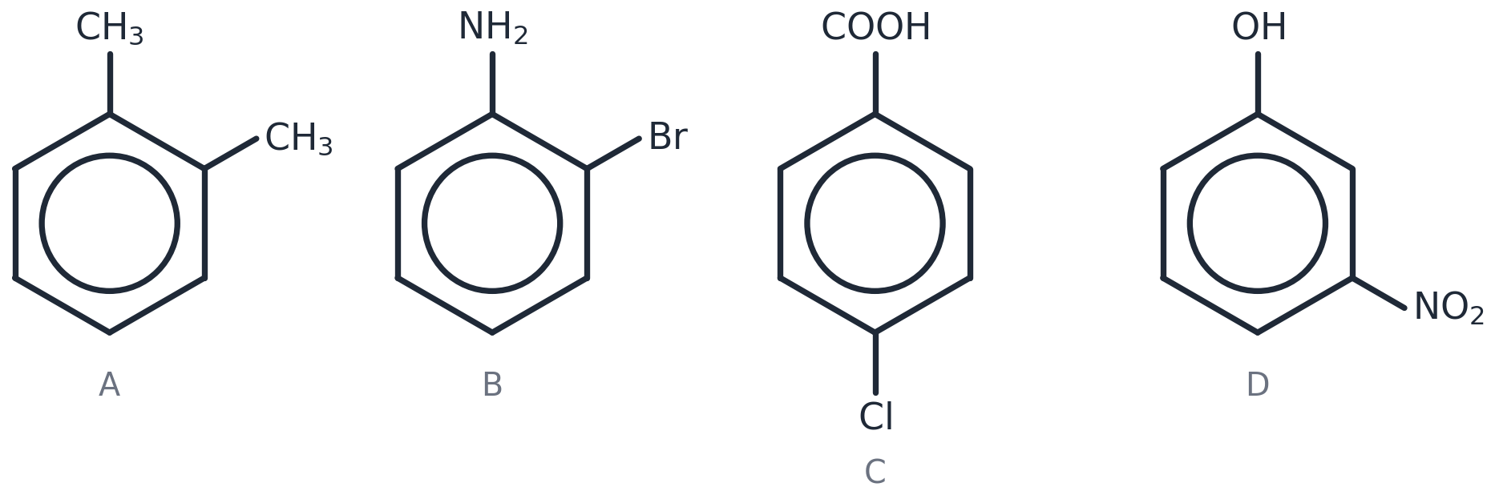
Watch out! Common mistakes
✗ People often write… | ✓ What you should write
6-bromomethylbenzene | 2-bromomethylbenzene — count the other way for the lowest number.
chloronitrobenzene | 1-chloro-2-nitrobenzene — numbers AND alphabetical order.
benzylamine for C₆H₅NH₂ | phenylamine.

Memory hook: Lowest numbers. Alphabetical letters. • PhenOL has the OH.

Check yourself
1. Name C₆H₅Cl. | chlorobenzene
2. Name C₆H₅OH. | phenol
3. Name the picture: A, B, C, D. | A 1,2-dimethylbenzene; B 2-bromophenylamine; C 4-chlorobenzoic acid; D 3-nitrophenol
Cover the green column with your hand. Say the answer. Then check.

Lesson 3
Nitration
Spec 6.1.1 (d)(i) (e): electrophilic substitution with conc. nitric acid + conc. sulfuric acid (nitration) · the mechanism of electrophilic substitution for nitration and halogenation

The 5 things you must know
1 | Reagents: concentrated nitric acid + concentrated sulfuric acid (the catalyst).
 | 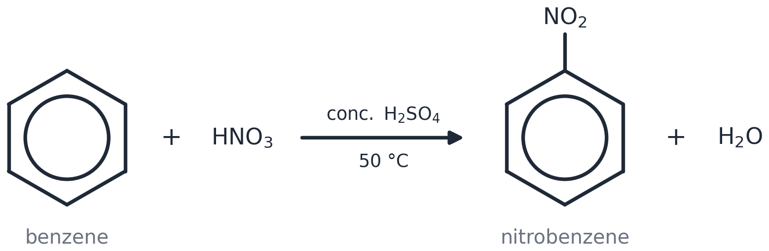
2 | Temperature: 50 °C in a water bath. Hotter → a second NO₂ goes on.
3 | The electrophile is NO₂⁺, the nitronium ion.
 | 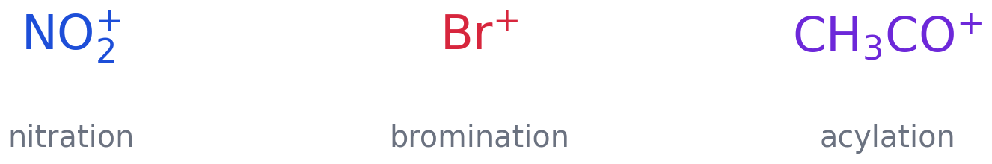
4 | Make it: HNO₃ + H₂SO₄ → NO₂⁺ + HSO₄⁻ + H₂O
5 | Product: nitrobenzene + water. Catalyst back: H⁺ + HSO₄⁻ → H₂SO₄

The mechanism in 4 moves
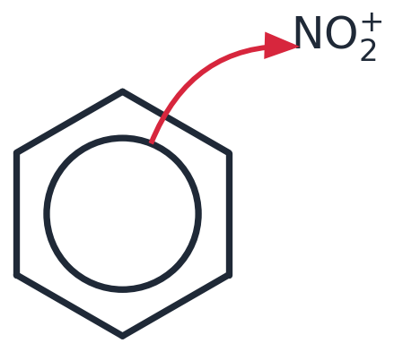  MOVE 1: Curly arrow. Tail ON the circle. Head TOUCHING the N of NO₂⁺ (not an O). | 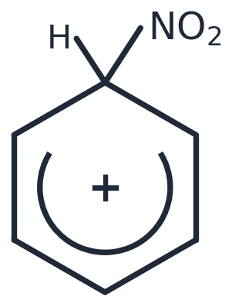  MOVE 2: The intermediate. Open the circle into a horseshoe that stops at the two carbons next to the top carbon. Write + INSIDE it. H and NO₂ on the SAME carbon.
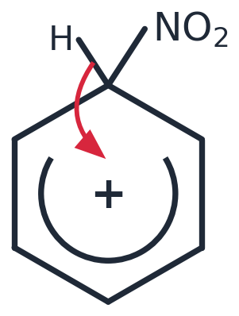  MOVE 3: Curly arrow. Tail on the MIDDLE of the C–H bond (not on the H). Head INTO the ring, towards the +. | 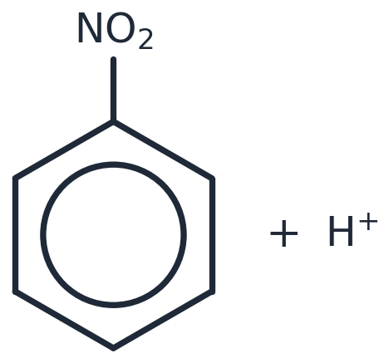  MOVE 4: Draw the product (nitrobenzene) + H⁺.
Then write the catalyst step: H⁺ + HSO₄⁻ → H₂SO₄
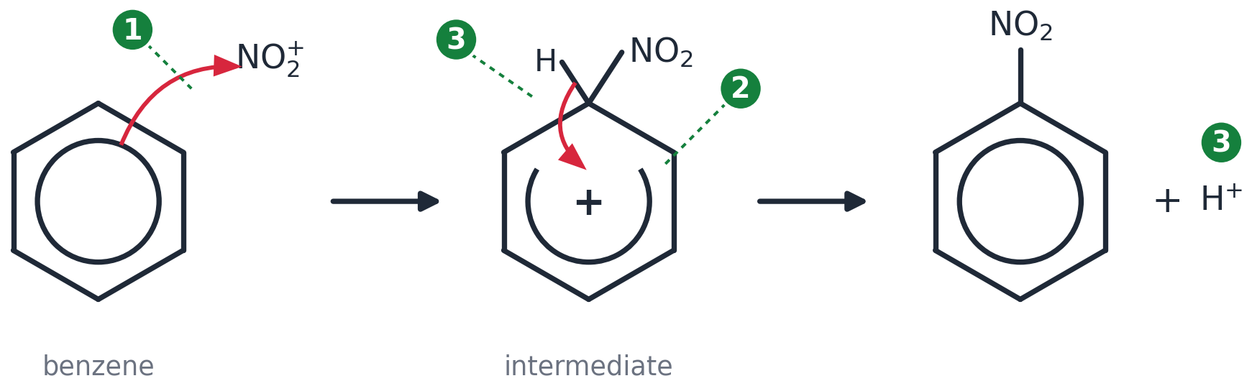
Where the 3 marks are: ① arrow tail on the circle, head on the N · ② horseshoe + plus + H and NO₂ on the same carbon · ③ arrow from the C–H bond into the ring, and H⁺.
Mark | What the examiner must SEE | Loses the mark if…
1 | Arrow tail ON the circle; head TOUCHING the N of NO₂⁺ | the head is on an O; the arrow points the other way; the tail is on the hexagon edge
2 | Horseshoe stops at the carbons next to the top carbon; + INSIDE it; H and NO₂ on the SAME carbon | the circle is still complete; the + is missing or on the wrong atom; no H drawn
3 | Arrow tail on the MIDDLE of the C–H bond; head INTO the ring; nitrobenzene + H⁺ written | the arrow starts at the H; no H⁺ in the products

The mechanism: I do → we do → you do
I DO — read this worked example
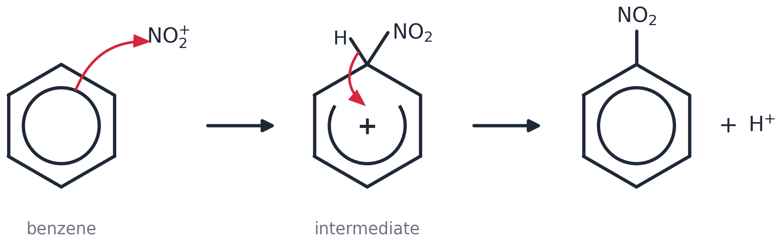
Here is the full mechanism. Look at where each arrow STARTS and ENDS.

WE DO — fill in the gaps
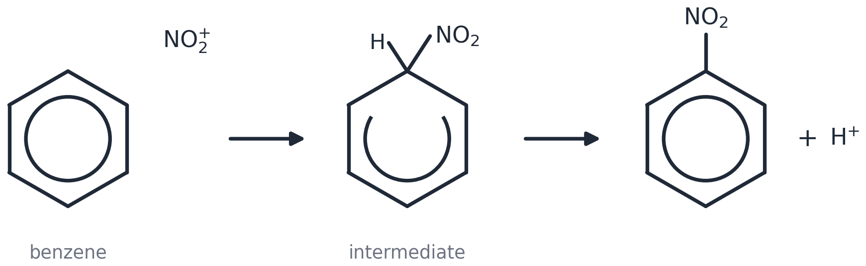
Add the two curly arrows and the + charge to this skeleton.

YOU DO — your turn
Draw the whole mechanism from memory on paper. Use the 4-move recipe card. Then check it with the checklist below.

Checklist — tick each one on YOUR mechanism | ✓
Equation for making the electrophile (e.g. HNO₃ + H₂SO₄ → NO₂⁺ + HSO₄⁻ + H₂O)
Arrow 1: tail ON the circle, head TOUCHING the electrophilic atom (N of NO₂⁺ / Br⁺ / C of CH₃CO⁺)
Intermediate: horseshoe stops either side of the carbon holding H and the new group; + INSIDE the horseshoe
Intermediate: H AND the new group drawn on the SAME carbon
Arrow 2: tail on the MIDDLE of the C–H bond, head INTO the ring towards the +
Products: substituted benzene + H⁺ ; catalyst regenerated (H⁺ + HSO₄⁻ → H₂SO₄ or H⁺ + FeBr₄⁻ → FeBr₃ + HBr)

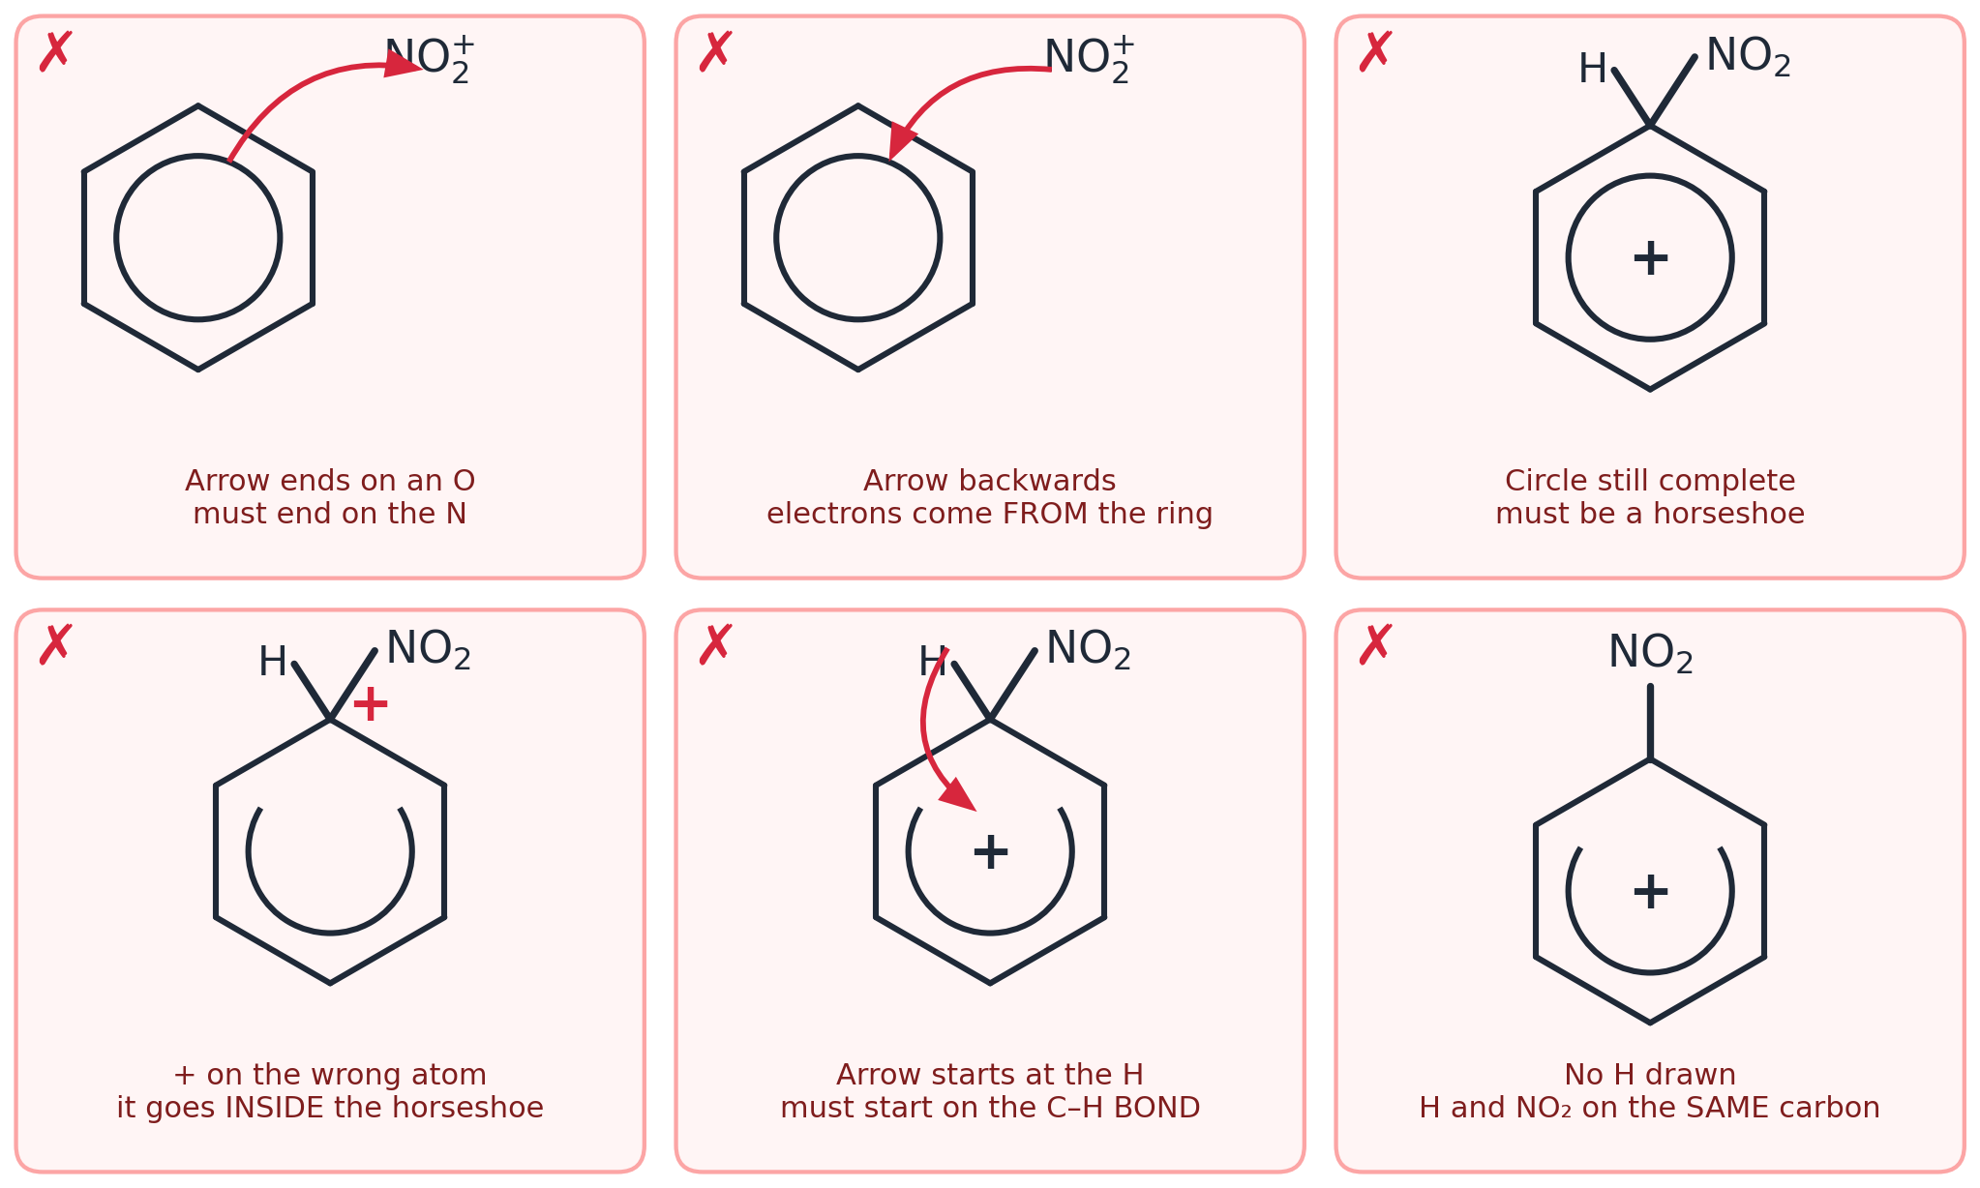
Six ways to lose a mark. Cover the captions and say what is wrong with each one.
Role of the catalyst (2 marks)
H₂SO₄ is a catalyst because it is ________ in step 1, where it makes ________.
It is ________________ at the end: H⁺ + HSO₄⁻ → H₂SO₄.
Word bank: used up • NO₂⁺ • regenerated

Watch out! Common mistakes
✗ People often write… | ✓ What you should write
Arrow from NO₂⁺ to the ring. | Arrow from the RING to the N.
Intermediate with no + charge. | Horseshoe AND a + charge.
Arrow starting on the H atom. | Arrow starting on the C–H BOND.

Memory hook: Ring gives, ring gets back. • Fifty for one NO₂, seventy for two.

Check yourself
1. What is the electrophile in nitration? | NO₂⁺ (nitronium ion)
2. What are the conditions? | conc. HNO₃ + conc. H₂SO₄, 50 °C
3. Which acid is the catalyst? | sulfuric acid, H₂SO₄
Cover the green column with your hand. Say the answer. Then check.

Lesson 4
Halogenation
Spec 6.1.1 (d)(ii) (e) (f): electrophilic substitution with a halogen + a halogen carrier · the mechanism of electrophilic substitution for nitration and halogenation · why benzene resists bromination compared with alkenes: delocalised vs localised π electron density

The 5 things you must know
1 | Benzene + Br₂ needs a halogen carrier: FeBr₃, AlCl₃ or iron filings.
 | 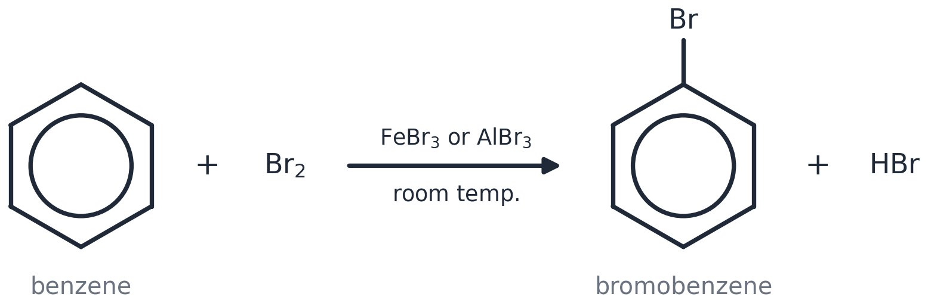
2 | The carrier makes the electrophile Br⁺: Br₂ + FeBr₃ → Br⁺ + FeBr₄⁻
3 | Then the SAME 4-move mechanism — just swap NO₂⁺ for Br⁺.
 | 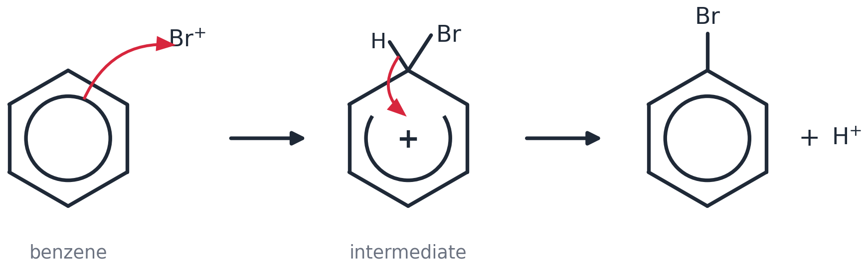
4 | Catalyst back: H⁺ + FeBr₄⁻ → FeBr₃ + HBr
5 | Alkenes react with Br₂ with NO catalyst (addition). Benzene does not (needs a carrier; substitution).
 | 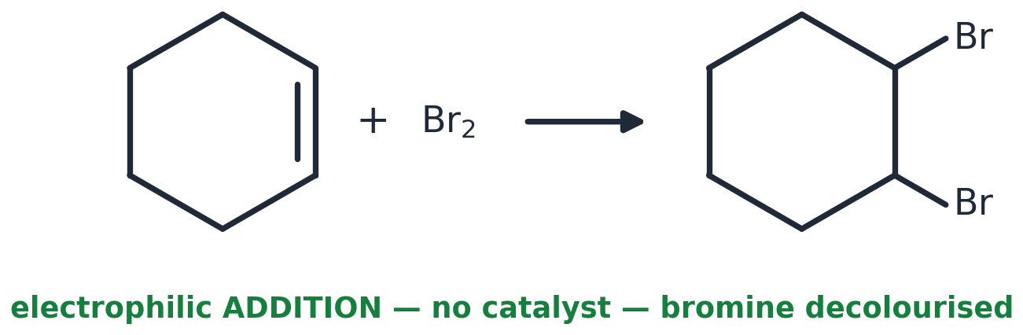

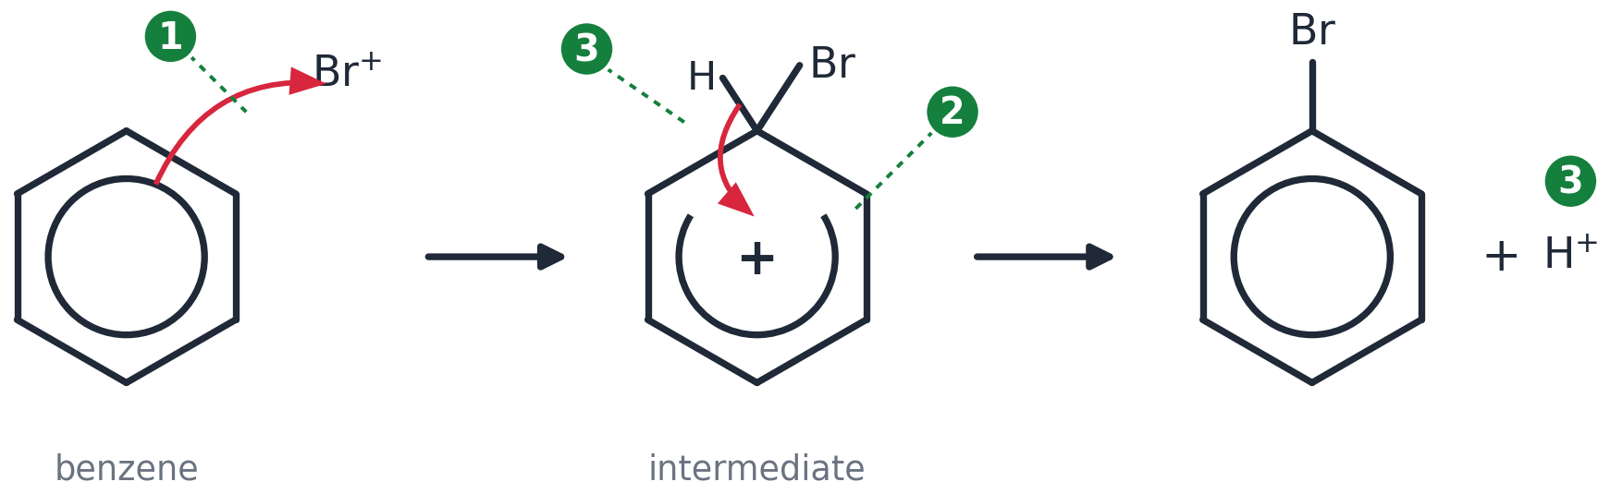
Same 3 marks: ① tail on the circle, head touching Br⁺ · ② horseshoe, + inside, H and Br on the same carbon · ③ arrow from the C–H bond into the ring, + H⁺.
The three steps EVERY halogenation needs
1 | Step 1: Make the electrophile: Br₂ + FeBr₃ → Br⁺ + FeBr₄⁻
2 | Step 2: Substitution: the 4-move recipe (arrow in, horseshoe +, arrow back, product + H⁺).
3 | Step 3: Catalyst back: H⁺ + FeBr₄⁻ → FeBr₃ + HBr

Chlorination with AlCl₃
I DO — read this worked example
Step 1: Cl₂ + AlCl₃ → Cl⁺ + AlCl₄⁻. Step 2: 4-move recipe with Cl⁺ → chlorobenzene + H⁺. Step 3: H⁺ + AlCl₄⁻ → AlCl₃ + HCl.

WE DO — fill in the gaps
Step 1: Cl₂ + AlCl₃ → ____ + ______. Step 2: recipe → ____________ + H⁺. Step 3: H⁺ + ______ → AlCl₃ + ____.

YOU DO — your turn
Write all three steps for chlorination using FeCl₃ instead of AlCl₃.

Alkene vs benzene with bromine (4 marks)
1. In an alkene the π electrons are __________ between two carbons, so the electron density is ______.
2. This __________ the Br₂ molecule: Br δ+ is the ____________.
3. In benzene the π electrons are ____________ over six carbons, so the electron density is ______.
4. Benzene cannot __________ Br₂, so a ______________ is needed to make Br⁺.
Word bank: localised • high • polarises • electrophile • delocalised • lower • polarise • halogen carrier

Watch out! Common mistakes
✗ People often write… | ✓ What you should write
Benzene decolourises bromine water. | It does NOT — unless a halogen carrier is used.
FeBr₃ is the electrophile. | Br⁺ is the electrophile. FeBr₃ is the catalyst that MAKES it.
Bromine ADDS to benzene. | Bromine SUBSTITUTES for an H (the ring stays).

Memory hook: The CARRIER makes the PLUS. • Alkene: adds. Arene: swaps.

Check yourself
1. Name three halogen carriers. | FeBr₃, AlCl₃, iron (also AlBr₃, FeCl₃)
2. Write the equation that makes Br⁺. | Br₂ + FeBr₃ → Br⁺ + FeBr₄⁻
3. What do you SEE when bromine water is added to benzene? | No change — stays orange
Cover the green column with your hand. Say the answer. Then check.

Lesson 5
Friedel–Crafts
Spec 6.1.1 (d)(iii) (g): Friedel–Crafts: haloalkane or acyl chloride + halogen carrier; C–C bond formation for synthesis · interpreting unfamiliar electrophilic substitution reactions, including predicting mechanisms

The 5 things you must know
1 | Friedel–Crafts reactions ADD CARBON to the ring: a new C–C bond.
2 | Alkylation: haloalkane + AlCl₃ → alkylbenzene. Example: benzene + C₂H₅Cl → ethylbenzene + HCl.
 | 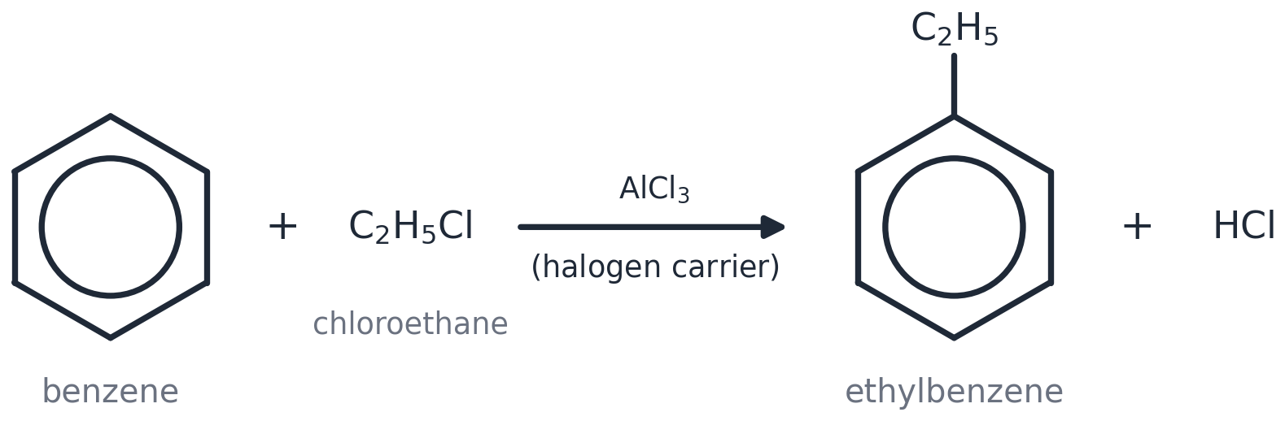
3 | Acylation: acyl chloride + AlCl₃ → a ketone. Example: benzene + CH₃COCl → phenylethanone + HCl.
 | 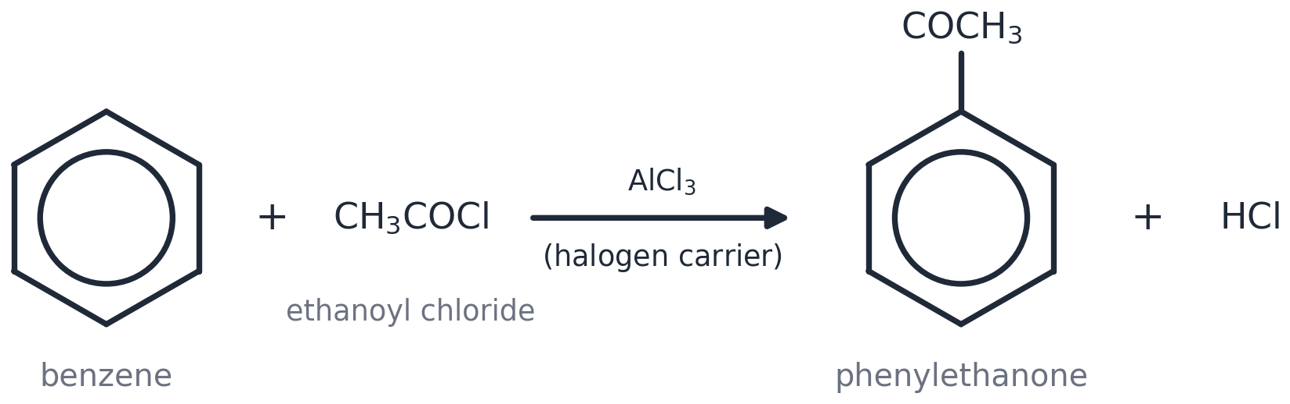
4 | Electrophiles: C₂H₅⁺ (alkylation) and CH₃CO⁺ (acylation). AlCl₃ makes them: C₂H₅Cl + AlCl₃ → C₂H₅⁺ + AlCl₄⁻
5 | Same 4-move mechanism. Catalyst back: H⁺ + AlCl₄⁻ → AlCl₃ + HCl
 | 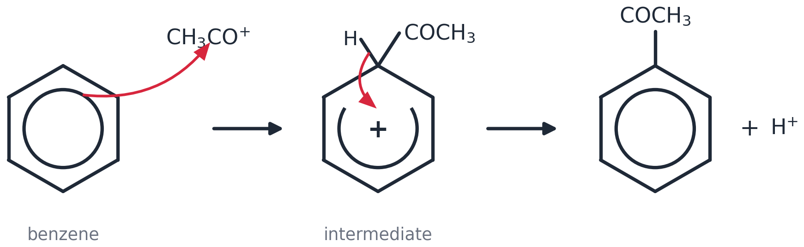

How to predict the product (3 steps)
1 | Step 1: Cross out the Cl on the reagent (CH₃CO–Cl → CH₃CO).
2 | Step 2: Join what is left onto the ring where an H was.
3 | Step 3: Write HCl as the other product.

Predict the product
I DO — read this worked example
benzene + CH₃Cl (AlCl₃) → methylbenzene + HCl

WE DO — fill in the gaps
benzene + CH₃COCl (AlCl₃) → ______________ + HCl

YOU DO — your turn
benzene + C₂H₅Cl (AlCl₃) → ? and benzene + C₆H₅COCl (AlCl₃) → ?

Watch out! Common mistakes
✗ People often write… | ✓ What you should write
The product of acylation is an alcohol. | It is a KETONE (C=O next to the ring).
AlCl₃ ends up in the product. | AlCl₃ is regenerated — it is a catalyst.
Friedel–Crafts uses a halogen (Br₂). | It uses a HALOALKANE or an ACYL CHLORIDE (+ AlCl₃).

Memory hook: Alkyl = a chain. Acyl = C=O. • Cross out the Cl, join the rest.

Check yourself
1. What type of bond does Friedel–Crafts make? | a C–C bond to the ring
2. Name the product of benzene + CH₃COCl. | phenylethanone
3. What is the electrophile in acylation with CH₃COCl? | CH₃CO⁺
Cover the green column with your hand. Say the answer. Then check.

Lesson 6
Phenol
Spec 6.1.1 (h) (i) (j): weak acidity of phenols: reacts with NaOH, no reaction with carbonates · phenol + bromine → 2,4,6-tribromophenol; phenol + dilute nitric acid → 2-nitrophenol and 4-nitrophenol · phenol is more easily substituted than benzene: electron pair donated from an oxygen p-orbital into the π-system

The 5 things you must know
1 | Phenol = an OH group DIRECTLY on the ring. (OH on a side chain = an alcohol.)
 | 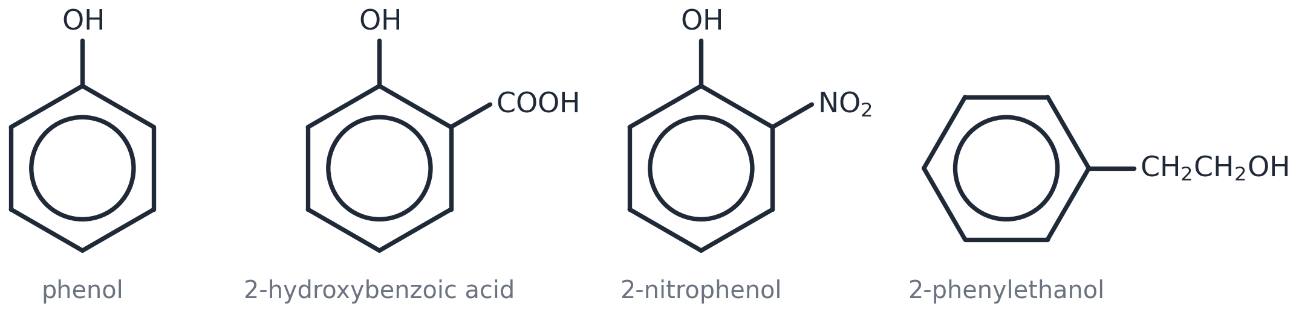
2 | Phenol is a WEAK acid: it reacts with NaOH (yes) but NOT with Na₂CO₃ (no fizz).
 | 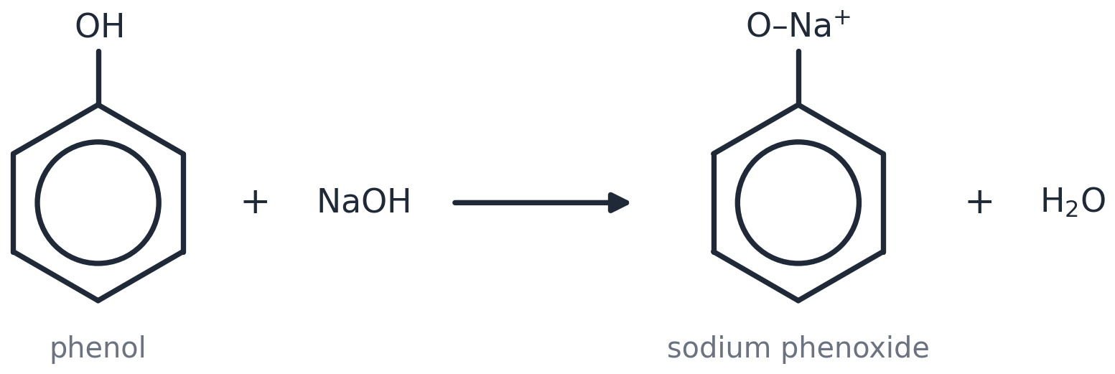
3 | Phenol + bromine water → white precipitate of 2,4,6-tribromophenol. NO catalyst needed.
 | 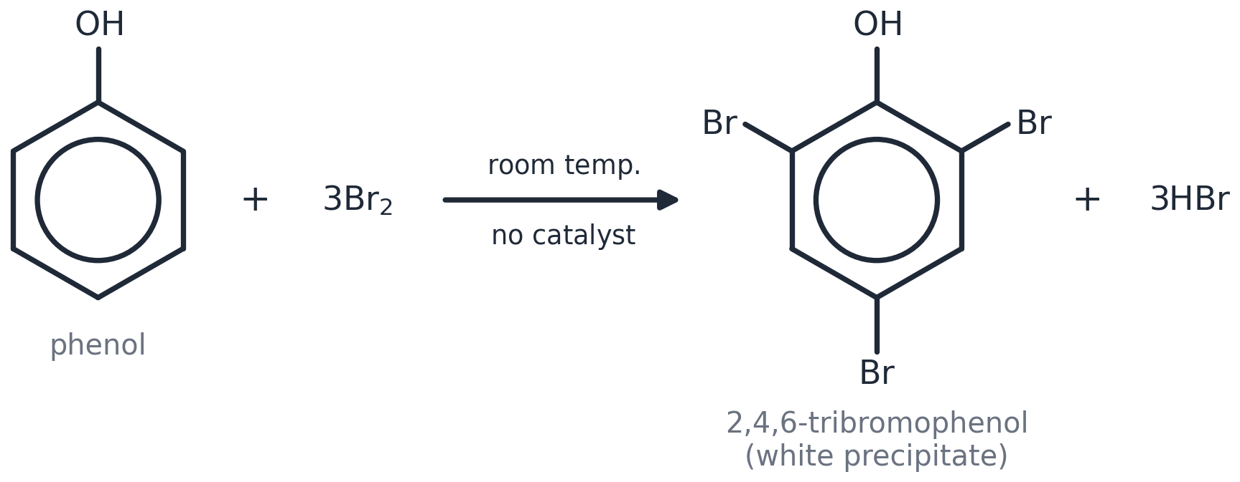
4 | Phenol + DILUTE nitric acid → 2-nitrophenol and 4-nitrophenol.
 | 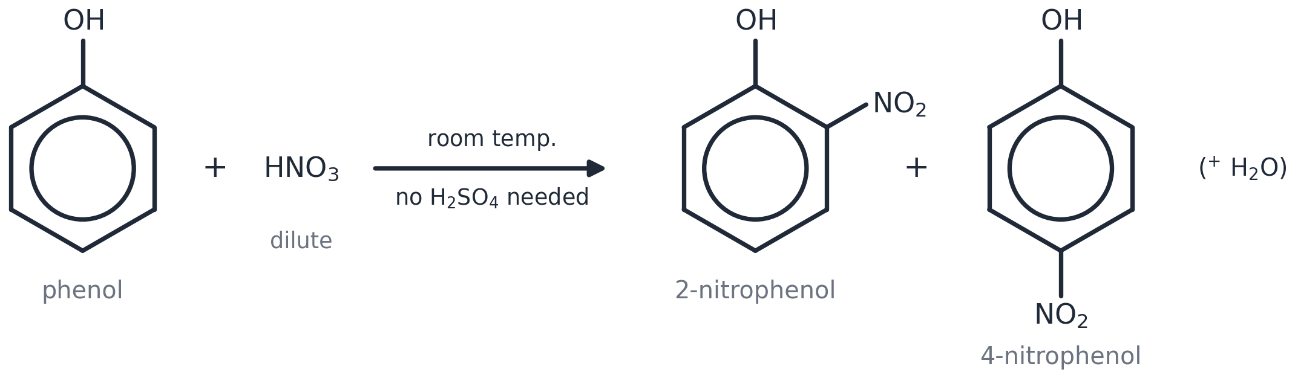
5 | Why more reactive than benzene? A lone pair on the O goes into the ring → more electron density.
 | 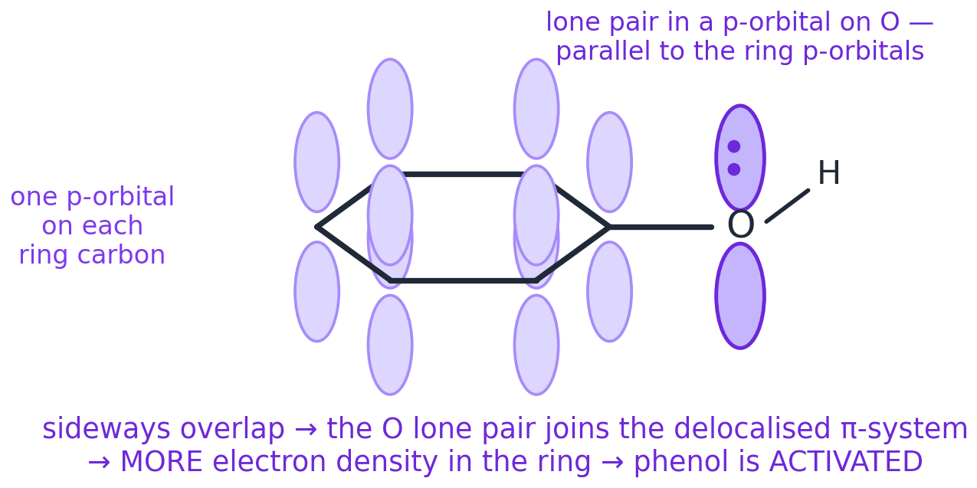

How to explain why phenol is MORE reactive (3 steps)
1 | Step 1: A lone pair on the oxygen is in a p-orbital.
2 | Step 2: It is delocalised into the ring, so the ring's electron density goes UP.
3 | Step 3: The ring can now polarise Br₂, so it reacts with NO catalyst.

Phenol vs benzene
I DO — read this worked example
Phenol reacts with bromine water without a catalyst because an oxygen lone pair is delocalised into the ring. This increases the electron density, so the ring polarises Br₂.

WE DO — fill in the gaps
Phenol reacts with bromine water without a catalyst because an oxygen __________ is ____________ into the ring. This __________ the electron density, so the ring __________ Br₂.

YOU DO — your turn
Now explain why phenol reacts with DILUTE nitric acid but benzene needs CONCENTRATED nitric AND sulfuric acid.

Words to use: lone pair • delocalised • increases • polarises

 | Benzene + Br₂ | Phenol + Br₂
Catalyst? | YES — halogen carrier | NO
What you see | nothing | orange → colourless + white solid
How many Br? | one | three (2, 4, 6)
Product | bromobenzene | 2,4,6-tribromophenol

Watch out! Common mistakes
✗ People often write… | ✓ What you should write
Phenol fizzes with sodium carbonate. | NO reaction — phenol is too weak an acid.
One Br goes on phenol. | THREE Br go on: positions 2, 4 and 6.
C₆H₅CH₂OH is a phenol. | The OH is on a side chain → it is an ALCOHOL.

Memory hook: Phenol: NaOH yes, carbonate no. • Phenol + Br₂: no catalyst, three Br, white solid.

Check yourself
1. Does phenol react with Na₂CO₃? | No
2. Name the product of phenol + excess bromine water. | 2,4,6-tribromophenol (white precipitate)
3. Which acid nitrates phenol? | DILUTE nitric acid (no H₂SO₄ needed)
Cover the green column with your hand. Say the answer. Then check.

Lesson 7
Directing groups
Spec 6.1.1 (k) (l): OH and NH₂ (electron-donating) direct to 2- and 4-; NO₂ (electron-withdrawing) directs to 3- · predicting substitution products from directing effects; importance to organic synthesis

The 5 things you must know
1 | A group already on the ring decides WHERE the next group goes.
 | 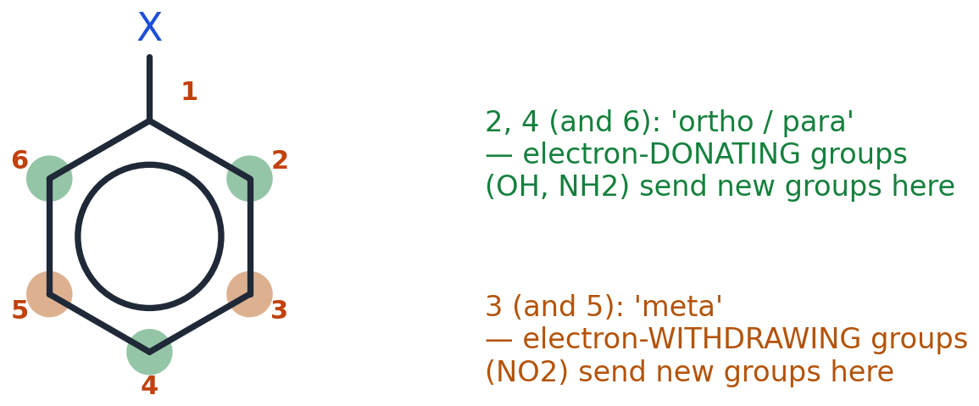
2 | OH and NH₂ GIVE electrons → the new group goes to position 2 or 4.
3 | NO₂ TAKES electrons → the new group goes to position 3.
4 | OH and NH₂ make the ring MORE reactive. NO₂ makes it LESS reactive.
 | 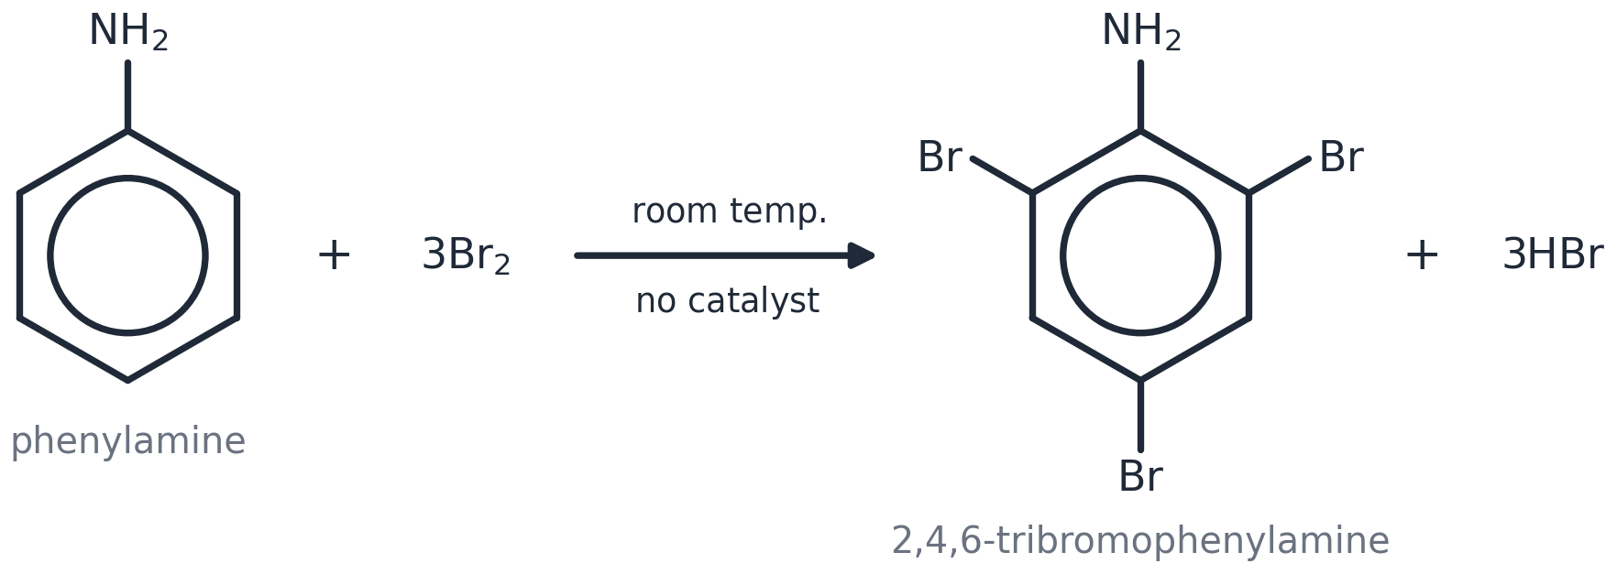
5 | In a two-step synthesis, put on FIRST the group that sends the second one to the right place.
 | 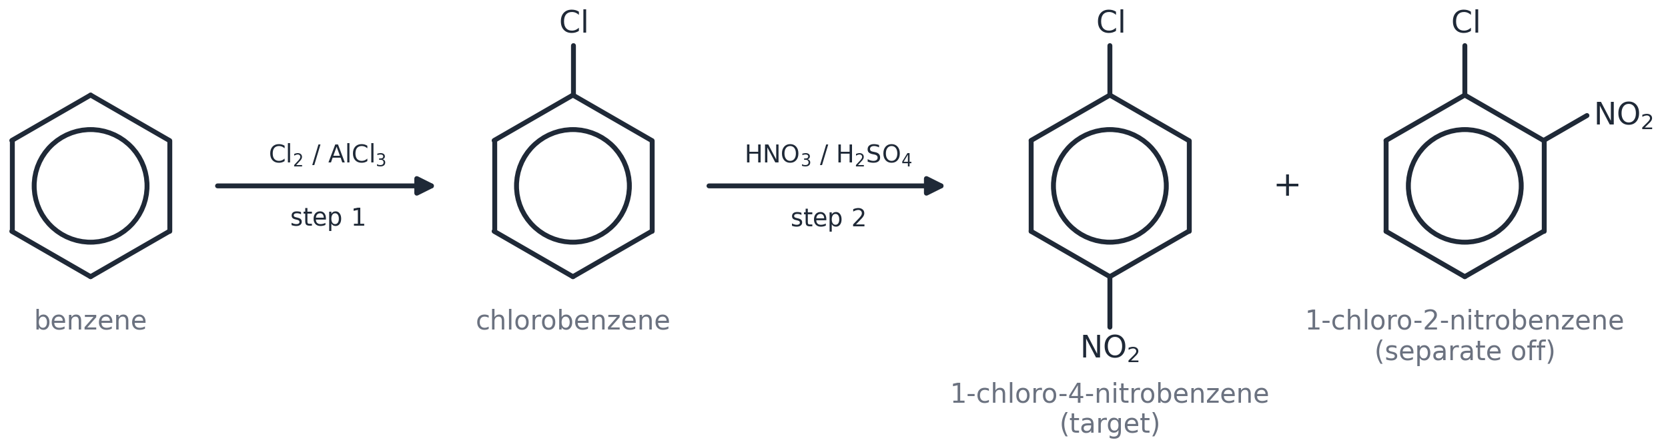

How to plan a two-step synthesis (3 steps)
1 | Step 1: Look at the target. Are the two groups 1,2 or 1,4 apart? → you need a 2,4-director on first. Are they 1,3 apart? → you need a 3-director on first.
2 | Step 2: Put that group on first (write the reagents and conditions).
3 | Step 3: Add the second group (reagents and conditions). Say if you get a mixture to separate.

Plan it
I DO — read this worked example
Target: 1-chloro-4-nitrobenzene (groups 1,4 apart). Cl is a 2,4-director → Cl FIRST (Cl₂/AlCl₃), THEN nitrate (conc. HNO₃/H₂SO₄, 50 °C).

WE DO — fill in the gaps
Target: 3-bromonitrobenzene (groups 1,3 apart). NO₂ is a 3-director → ______ FIRST (______________), THEN ______________ (Br₂/FeBr₃).

YOU DO — your turn
Target: 4-bromonitrobenzene. Which group first? Give the reagents for both steps.

Group on the ring | Gives or takes electrons? | Sends the new group to…
–OH | gives | 2 and 4
–NH₂ | gives | 2 and 4
–NO₂ | takes | 3

Watch out! Common mistakes
✗ People often write… | ✓ What you should write
OH sends the next group to 3. | OH → 2 and 4. NO₂ → 3.
The order of the steps does not matter. | Wrong order = wrong isomer!
Position 6 is different from position 2. | 2 and 6 are the SAME (mirror images) — always say 2.

Memory hook: Givers go 2,4. Takers go 3.

Check yourself
1. Where does OH send the next group? | 2 and 4
2. Where does NO₂ send the next group? | 3
3. To make 1-chloro-4-nitrobenzene, which group goes on first? | Cl (it is 2,4-directing)
Cover the green column with your hand. Say the answer. Then check.

Support pages
Mechanism recipe cards

Cut these out. They work for EVERY electrophilic substitution in this topic: just swap the electrophile.
Nitration (electrophile NO₂⁺)
MOVE 1: arrow — tail ON the circle, head TOUCHING the N of NO₂⁺ | MOVE 2: horseshoe (stops either side of the carbon with H and NO₂) + plus INSIDE; H and NO₂ on the SAME carbon
MOVE 3: arrow — tail on the MIDDLE of the C–H bond, head INTO the ring | MOVE 4: product + H⁺
Before: HNO₃ + H₂SO₄ → NO₂⁺ + HSO₄⁻ + H₂O. After: H⁺ + HSO₄⁻ → H₂SO₄
Bromination (electrophile Br⁺)
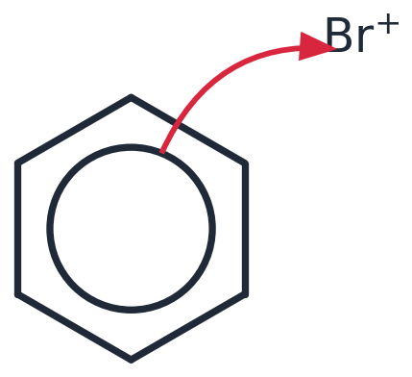  MOVE 1: arrow — tail ON the circle, head TOUCHING Br⁺ | 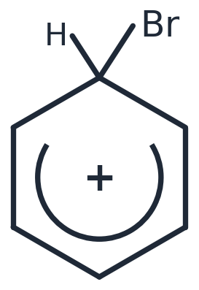  MOVE 2: horseshoe (stops either side of the carbon with H and Br) + plus INSIDE; H and Br on the SAME carbon
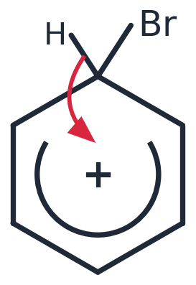  MOVE 3: arrow — tail on the MIDDLE of the C–H bond, head INTO the ring | 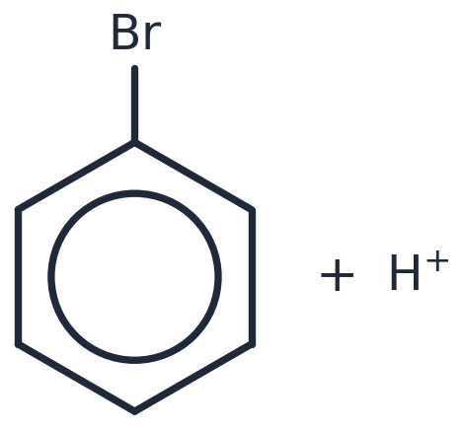  MOVE 4: bromobenzene + H⁺
Before: Br₂ + FeBr₃ → Br⁺ + FeBr₄⁻. After: H⁺ + FeBr₄⁻ → FeBr₃ + HBr
The three marks, in the examiner's words. Say them until you can say them in your sleep.
Mark | The examiner must see
1 · Curly arrow from the delocalised ring to N of NO₂⁺ | Tail ON the circle — that is where the electron pair is — next to the carbon being attacked. Head touching the N atom of NO₂⁺ — the atom that carries the + (never an O). An arrow that starts on the hexagon edge (a σ bond), ends on the wrong atom, or points the other way scores nothing.
2 · The intermediate, drawn exactly | Open the circle into a HORSESHOE that stops at the two carbons either side of the carbon holding the H and the NO₂ — it must not reach that carbon. Write + INSIDE the horseshoe (the charge is spread over the other five carbons; never on the carbon with the H, never on the H itself). Draw H AND NO₂ on the SAME carbon.
3 · Curly arrow from the C–H bond into the ring, and H⁺ leaves | Tail on the MIDDLE of the C–H bond (a bond is breaking — never on the H atom). Head pointing into the ring, towards the +, to re-form the circle. Products: nitrobenzene + H⁺.

Where does arrow 1 go for the other electrophiles? Br⁺: the Br. Cl⁺: the Cl. CH₃CO⁺: the C of the C=O (it carries the +). SO₃: the S (δ+). Always the atom with the positive charge.
Reaction | Electrophile | How it is made | Catalyst back
nitration | NO₂⁺ | HNO₃ + H₂SO₄ → NO₂⁺ + HSO₄⁻ + H₂O | H⁺ + HSO₄⁻ → H₂SO₄
bromination | Br⁺ | Br₂ + FeBr₃ → Br⁺ + FeBr₄⁻ | H⁺ + FeBr₄⁻ → FeBr₃ + HBr
chlorination | Cl⁺ | Cl₂ + AlCl₃ → Cl⁺ + AlCl₄⁻ | H⁺ + AlCl₄⁻ → AlCl₃ + HCl
alkylation | C₂H₅⁺ | C₂H₅Cl + AlCl₃ → C₂H₅⁺ + AlCl₄⁻ | H⁺ + AlCl₄⁻ → AlCl₃ + HCl
acylation | CH₃CO⁺ | CH₃COCl + AlCl₃ → CH₃CO⁺ + AlCl₄⁻ | H⁺ + AlCl₄⁻ → AlCl₃ + HCl

Support pages
Knowledge organiser

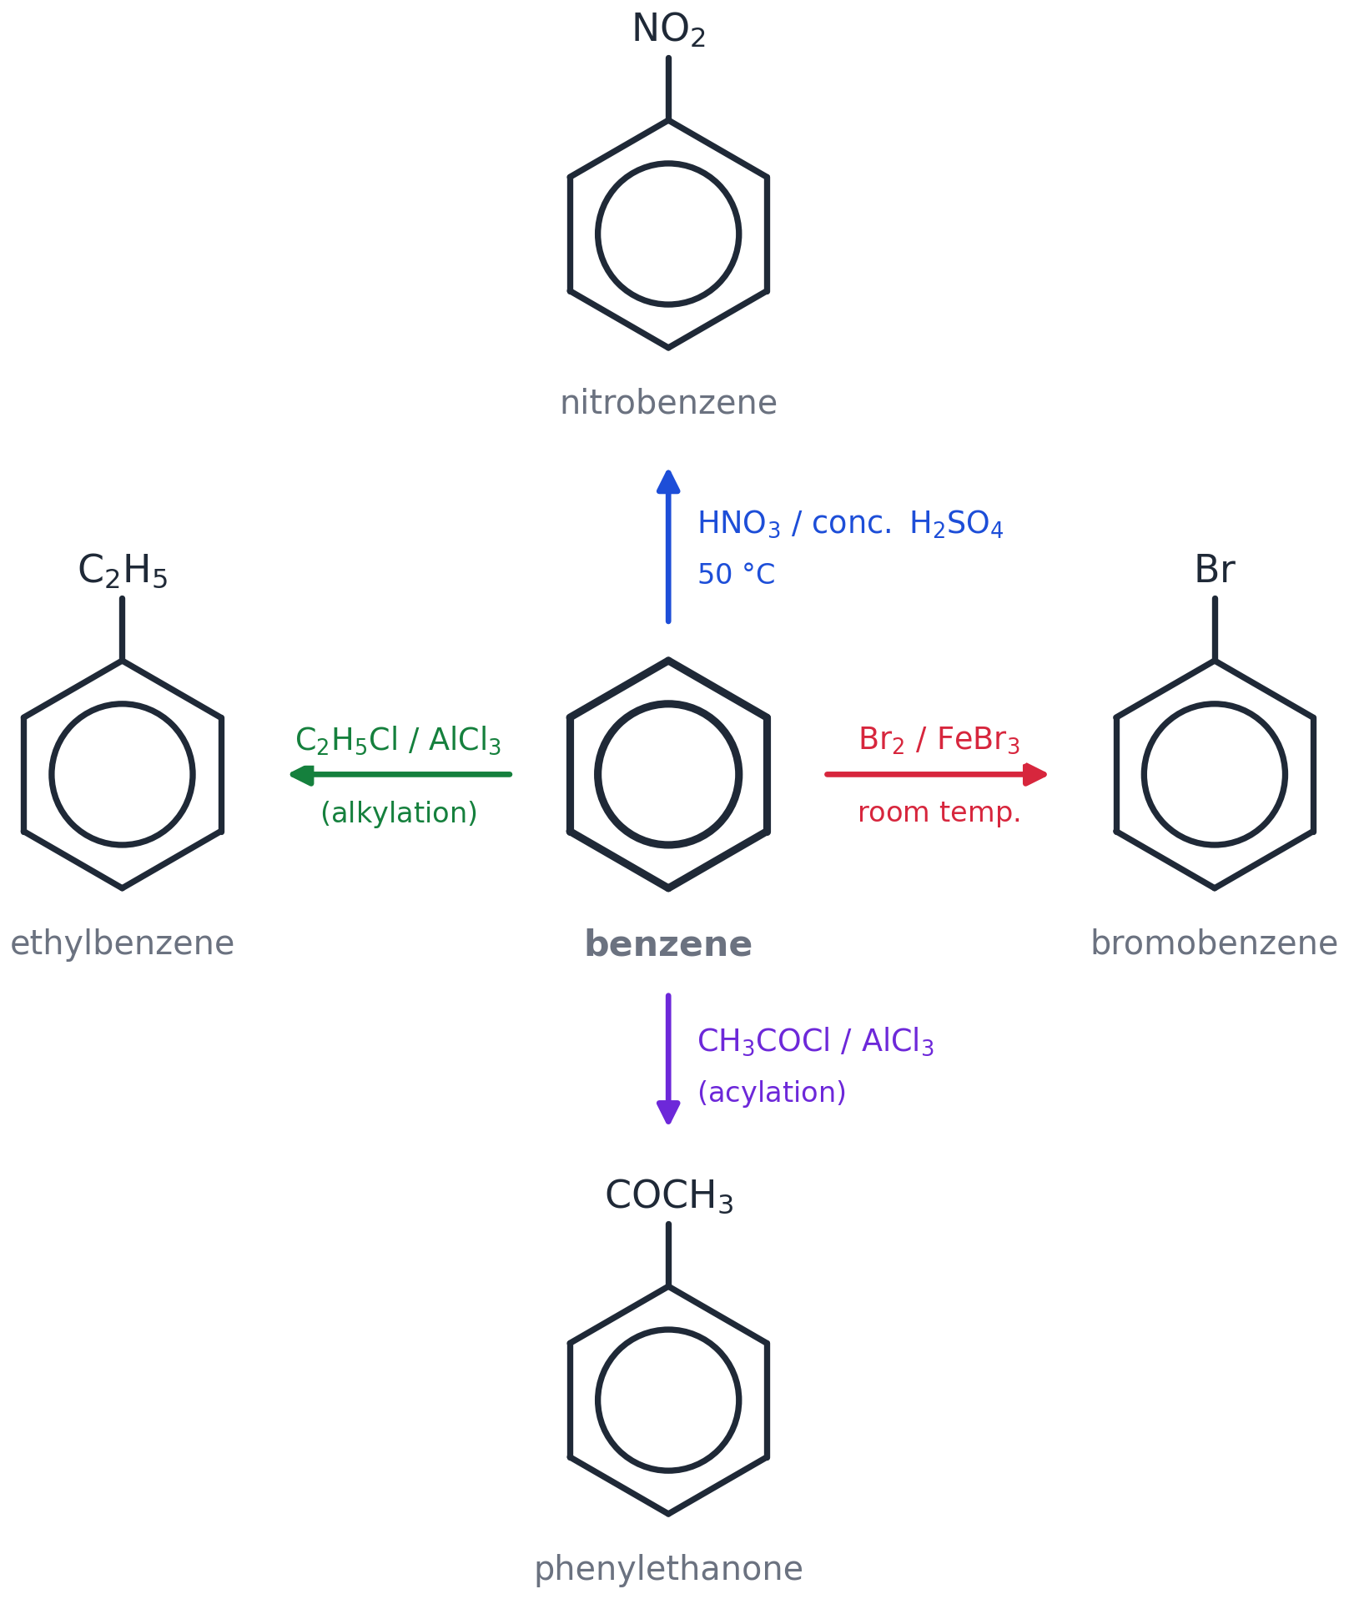
Benzene: four reactions, one mechanism.
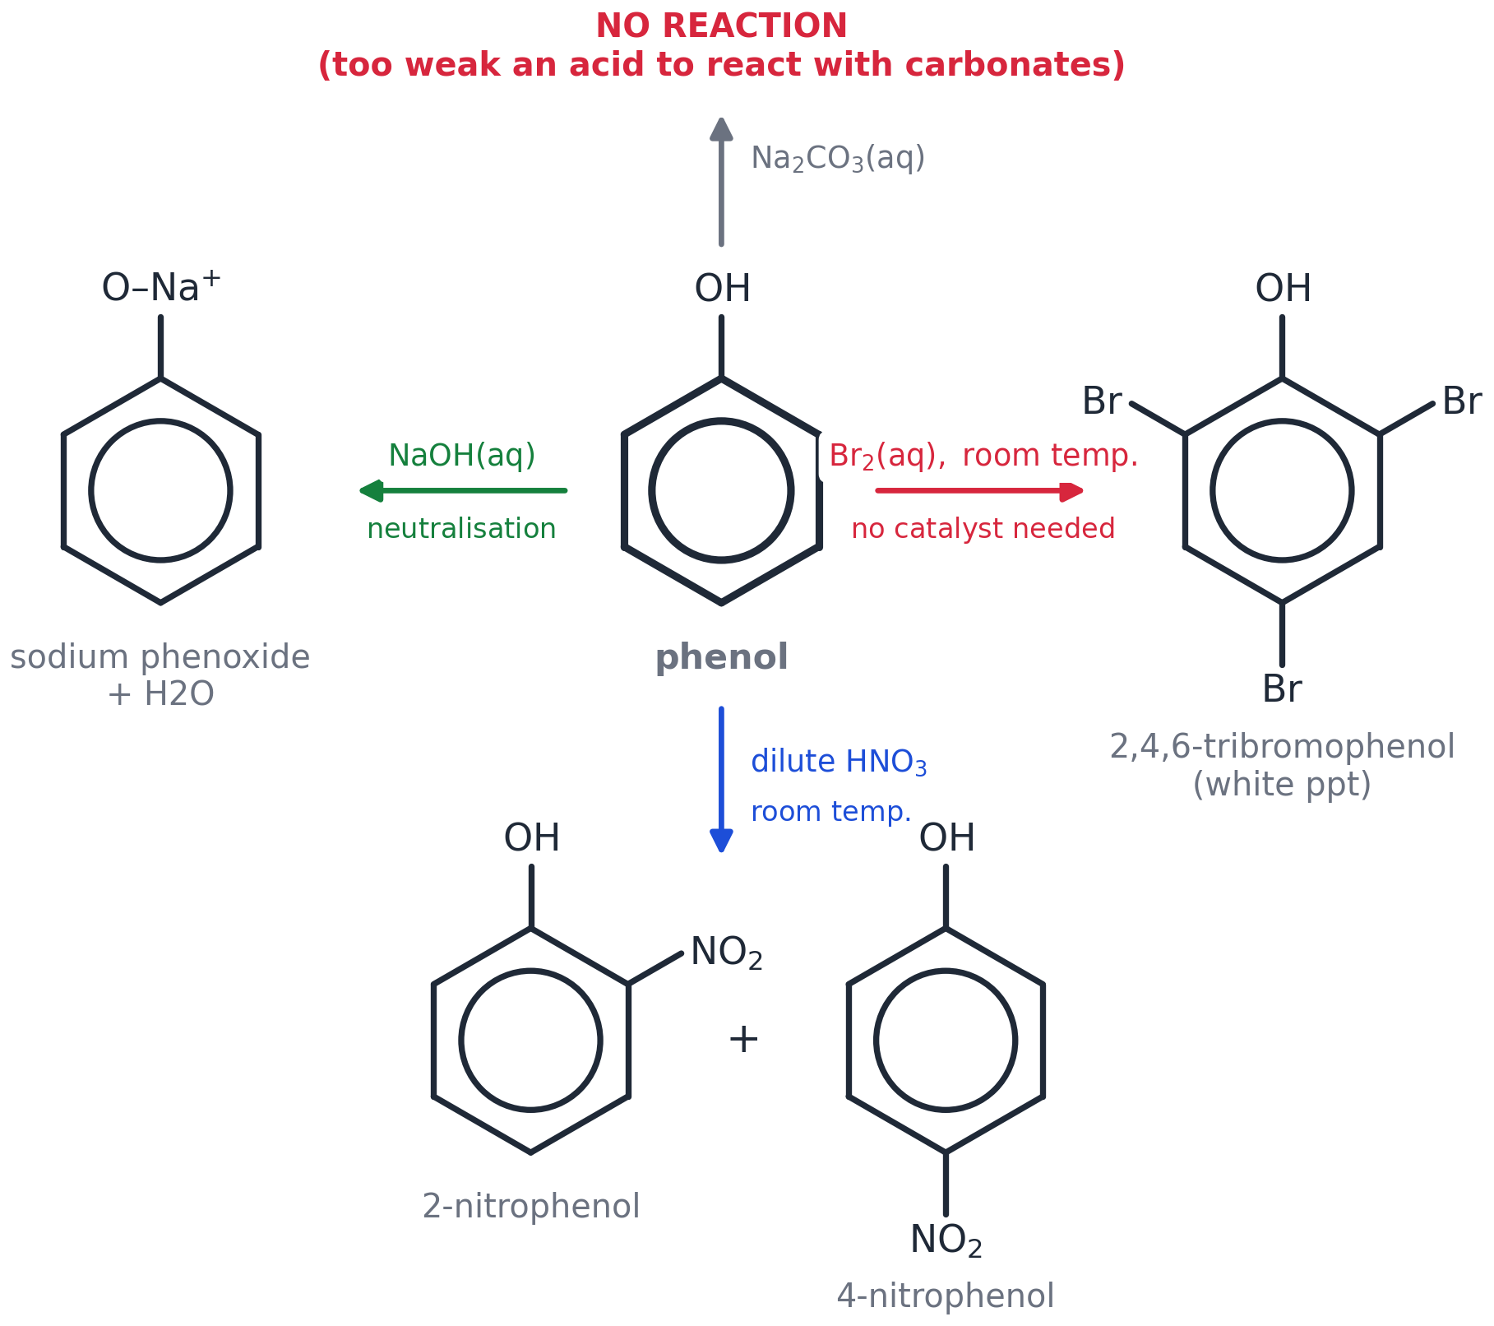
Phenol: weak acid, activated ring.
Reaction | Reagents | Conditions | Product
nitration | conc. HNO₃ + conc. H₂SO₄ | 50 °C, water bath | nitrobenzene + H₂O
bromination | Br₂ + FeBr₃ (halogen carrier) | room temperature | bromobenzene + HBr
chlorination | Cl₂ + AlCl₃ | room temperature | chlorobenzene + HCl
alkylation | C₂H₅Cl + AlCl₃ | warm | ethylbenzene + HCl
acylation | CH₃COCl + AlCl₃ | warm | phenylethanone + HCl
phenol + NaOH | NaOH(aq) | room temperature | sodium phenoxide + H₂O
phenol + Na₂CO₃ | — | — | NO REACTION
phenol + Br₂ | bromine water | room temp., no catalyst | 2,4,6-tribromophenol (white ppt) + 3HBr
phenol + HNO₃ | DILUTE nitric acid | room temperature | 2-nitrophenol + 4-nitrophenol

Number to remember | What it is
0.139 nm | every C–C bond in benzene (C–C 0.153, C=C 0.134)
152 kJ mol⁻¹ | how much more stable benzene is than Kekulé's structure
−208 kJ mol⁻¹ | enthalpy change of hydrogenation of benzene (expected −360)
50 °C | nitration temperature
2, 4 / 3 | where OH & NH₂ / NO₂ send the next group
120° | bond angle in benzene

Support pages
Writing frames for the 'explain' questions

Frame 1 — Why is benzene more stable than the Kekulé structure? (3 marks)
The Kekulé structure has three C=C bonds, so its enthalpy of hydrogenation should be 3 × (−120) = ______ kJ mol⁻¹.
The actual value for benzene is ______ kJ mol⁻¹.
Benzene releases ______ kJ mol⁻¹ LESS energy, so it is MORE ________, because the electrons are ____________.
Word bank: −360 • −208 • 152 • stable • delocalised

Frame 2 — Why does benzene not react with bromine, when an alkene does? (4 marks)
In an alkene the π electrons are __________, so the electron density is ______.
The alkene __________ Br₂, making Br δ+ the ____________.
In benzene the π electrons are ____________ over six carbons, so the electron density is ______.
Benzene cannot __________ Br₂, so no electrophile forms without a ______________.
Word bank: localised • high • polarises • electrophile • delocalised • lower • polarise • halogen carrier

Frame 3 — Why does phenol react more readily than benzene? (3 marks)
A ________ on the oxygen is in a ____________.
It is ____________ into the ring's π-system, so the electron density of the ring ____________.
The ring is more susceptible to attack: it can __________ Br₂ without a catalyst.
Word bank: lone pair • p-orbital • delocalised • increases • polarise

Frame 4 — Explain the role of the catalyst (2 marks)
______ is used up in step 1 to make the electrophile ______.
It is ____________ in the last step: ________________________.
Word bank: H₂SO₄ (or AlCl₃ / FeBr₃) • NO₂⁺ (or Br⁺ …) • regenerated • H⁺ + HSO₄⁻ → H₂SO₄

Frame 5 — Why must the steps be done in this order? (2 marks)
______ must go on first because it directs the second group to position ______.
If ______ went on first it would direct to position ______, giving the ______ isomer.
Word bank: Cl / the 2,4-director • 4 (and 2) • NO₂ • 3 • wrong

Support pages
Word mat

Word | What it means | Picture
benzene | C₆H₆ — a flat ring of six carbons with six delocalised electrons | 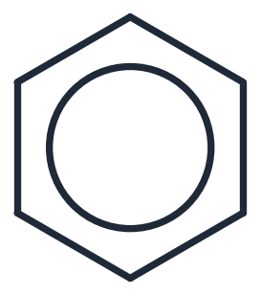
arene / aromatic | a compound that contains a benzene ring
delocalised | electrons shared over several atoms, not stuck in one bond
π-system | the ring of electron density above and below the benzene ring | 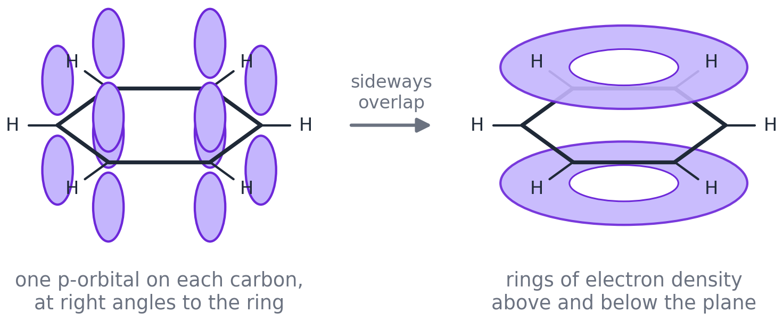
p-orbital | the orbital each carbon uses to make the π-system
Kekulé structure | benzene drawn with alternating double bonds | 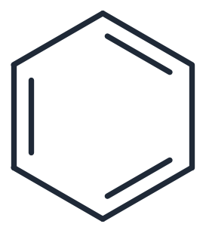
electrophile | a species that accepts a pair of electrons (E⁺)
electrophilic substitution | an electrophile swaps places with an H on the ring | 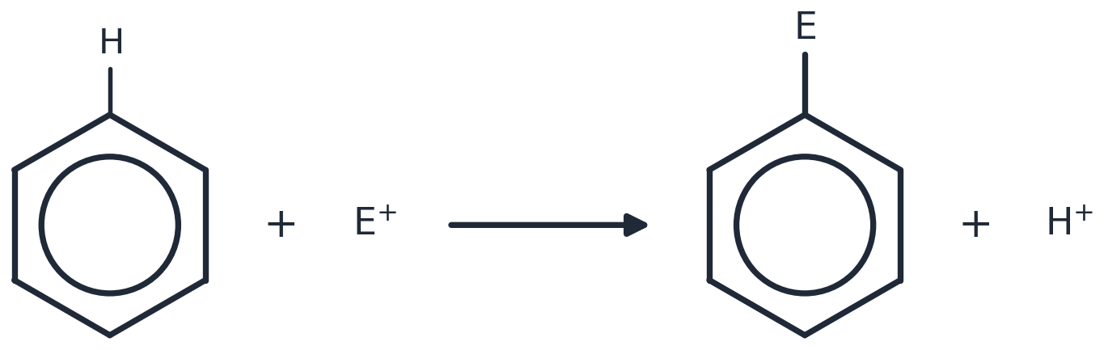
intermediate | the ring with a horseshoe and a + charge, halfway through the mechanism
curly arrow | shows a PAIR of electrons moving
catalyst | speeds up the reaction and is regenerated at the end
halogen carrier | the catalyst (FeBr₃, AlCl₃, Fe) that makes Br⁺ or Cl⁺
nitronium ion | NO₂⁺, the electrophile in nitration
Friedel–Crafts | alkylation or acylation: adds carbon to the ring using AlCl₃
acyl chloride | RCOCl — used in acylation to make a ketone
phenol | OH directly on the ring; a weak acid | 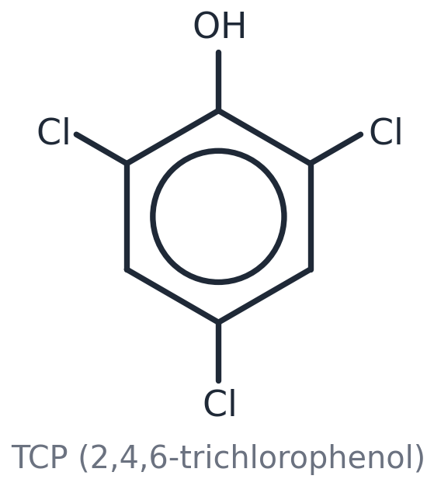
phenoxide ion | C₆H₅O⁻ — phenol after it loses H⁺
weak acid | only partly dissociates in water
precipitate | a solid that forms in a solution (phenol + Br₂ → white ppt)
directing group | a group on the ring that decides where the next group goes
activating | makes the ring MORE reactive (OH, NH₂)
deactivating | makes the ring LESS reactive (NO₂)
locant | the number that says which carbon a group is on
phenyl | the C₆H₅– group when the ring is the 'add-on'
hydrogenation | adding H₂ to a double bond

Support pages
My progress tracker

Colour each box: RED = not yet, AMBER = nearly, GREEN = I can do it. Do it again after revision.
I can… | Before | After lesson | After revision
draw benzene two ways and say which is Kekulé
give the three pieces of evidence for delocalisation
explain why benzene does not react with bromine water
name a ring with two groups (lowest numbers, alphabetical)
write the equation that makes NO₂⁺
draw the 4-move mechanism
say what a halogen carrier does and write its equations
give reagents and products for alkylation and acylation
say how phenol reacts with NaOH, Na₂CO₃, Br₂ and dilute HNO₃
explain why phenol is more reactive than benzene
say where OH, NH₂ and NO₂ send the next group
plan a two-step synthesis in the right order

