Beyond the Specification
Aromatic Chemistry
at university level
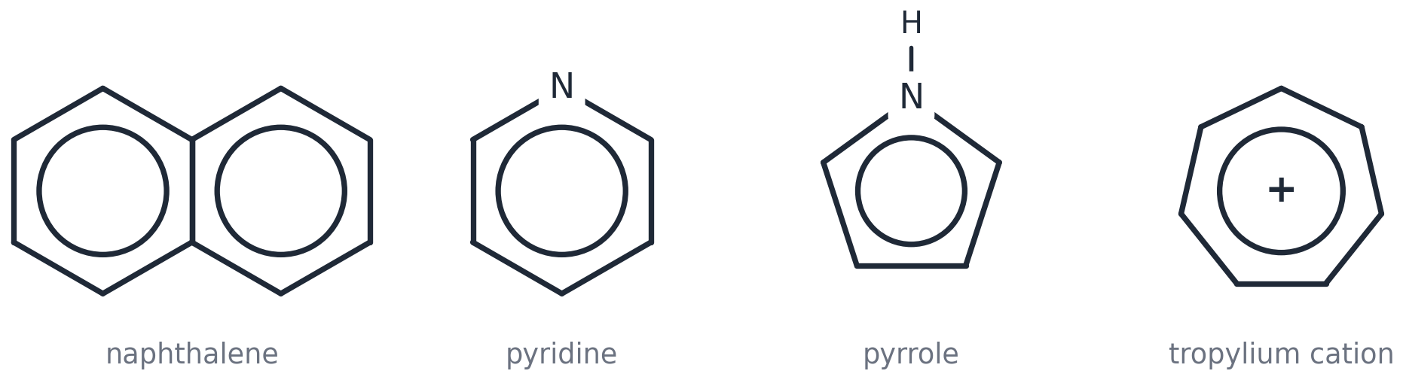

Who this is for
You can already do everything in OCR A 6.1.1. This pack takes the same ideas to the depth of a chemistry degree. Part A is first-year level; Part B is second-year level and beyond. Nothing here is needed for the exam — and all of it will make the exam questions feel easy.
How to use it
Read a section, then attempt its problems on paper before turning to the worked answers at the back. Every section ends with a short reading list; Section 18 is a full guide to reading beyond the course. Difficulty: ★ first-year ★★ second-year ★★★ open-ended / research level.

Contents
Part A — first-year undergraduate 21 problems ★
1. What makes a ring aromatic?
2. Resonance energy and the ring current
3. The Wheland intermediate and the energy profile
4. Directing effects — the real reason
5. Friedel–Crafts — the fine print
6. Phenol: acidity, the Kolbe–Schmitt reaction and aspirin
7. Nucleophilic aromatic substitution and benzyne

Part B — second-year undergraduate 42 problems ★★ / ★★★
8. Hückel molecular orbital theory — with numbers
9. Linear free-energy relationships: the Hammett equation
10. Electrophilic substitution at research depth
11. Regioselectivity, blocking groups and diazonium chemistry
12. Named reactions and rearrangements of aromatic compounds
13. Making aromatic bonds the modern way: SNAr in depth, benzyne, cross-coupling and directed metalation
14. Aromatic heterocycles
15. Spectroscopy of aromatic rings
16. Frontiers: what 'aromatic' means today

Challenge and reading
17. Challenge problems
18. Reading beyond the course

Worked answers all 72 problems, at the back

Part A
First-year undergraduate level
Everything a first-year chemistry undergraduate is expected to explain about aromatic compounds: what aromaticity is, why the mechanism has the shape it has, and why substituents direct where they do. Problems marked ★.
Sections
1. What makes a ring aromatic?
2. Resonance energy and the ring current
3. The Wheland intermediate and the energy profile
4. Directing effects — the real reason
5. Friedel–Crafts — the fine print
6. Phenol: acidity, the Kolbe–Schmitt reaction and aspirin
7. Nucleophilic aromatic substitution and benzyne

Section 1 PART A · FIRST-YEAR UNDERGRADUATE LEVEL
What makes a ring aromatic?
The A-level story says 'benzene is delocalised and stable'. First-year chemistry asks the sharper question: WHICH rings are aromatic, and why is aromaticity all-or-nothing?

Key facts
• A molecule (or ion) is aromatic if it is CYCLIC, PLANAR, FULLY CONJUGATED (a p-orbital on every ring atom) and has 4n + 2 π electrons (Hückel's rule, 1931).
• 4n π electrons in a planar conjugated ring is ANTIaromatic — much LESS stable than the open-chain equivalent (cyclobutadiene, cyclopentadienyl cation).
• A ring that escapes planarity is simply NON-aromatic (cyclooctatetraene, 8 π electrons, adopts a tub shape and behaves like a polyene).
• Lone pairs count only if they sit in a p-orbital that is part of the ring π-system (pyrrole: yes; pyridine: no — its lone pair is in an sp² orbital in the plane).
Aromatic systems that are not benzene: naphthalene (10 π), pyridine (6 π), pyrrole (6 π, N lone pair included), tropylium cation (6 π).
Why 4n + 2? Draw a regular polygon inscribed in a circle with one vertex at the bottom (a Frost circle). The vertices mark the energies of the π molecular orbitals. The lowest orbital is always single; the others come in degenerate pairs. Filling a closed shell (all bonding orbitals full) needs 2 + 4 + 4 + … = 4n + 2 electrons. With 4n electrons the last pair is spread singly over a degenerate pair — a diradical, which is what makes cyclobutadiene so unstable.
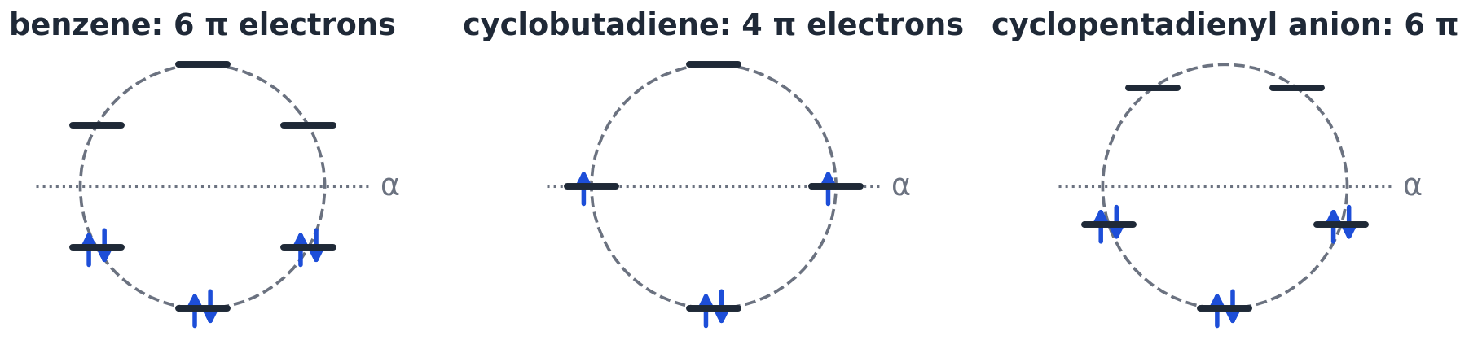
Frost circles for benzene (closed shell), cyclobutadiene (two unpaired electrons — antiaromatic) and the cyclopentadienyl anion (6 π, aromatic).
1.1 Classify each as aromatic, antiaromatic or non-aromatic, giving the π-electron count: (a) the cyclopropenyl cation, C₃H₃⁺; (b) cyclooctatetraene, C₈H₈; (c) the cyclooctatetraene dianion, C₈H₈²⁻ (which is planar); (d) [18]annulene (an 18-membered ring with 9 C=C bonds); (e) furan (a five-membered ring containing an O atom). ★

1.2 Cyclopentadiene, C₅H₆, has pKₐ ≈ 16 — about the same as water and 10²⁹ times more acidic than cyclopentane (pKₐ ≈ 45). Explain. ★

1.3 Draw the Frost circle for the cyclopropenyl system (a triangle, vertex down). Use it to explain why the cation (2 π) is aromatic but the anion (4 π) is antiaromatic. ★

Reading for this section
▸ Clayden, Greeves & Warren, Organic Chemistry (2nd ed., OUP), ch. 7 'Delocalization and conjugation' — the standard first-year treatment of aromaticity, with Frost circles
▸ E. Hückel, Z. Physik 1931, 70, 204 — the original 4n + 2 rule
▸ Master Organic Chemistry — 'Aromaticity' series (online) — worked examples of counting π electrons in ions and heterocycles

Section 2 PART A · FIRST-YEAR UNDERGRADUATE LEVEL
Resonance energy and the ring current
How big is the stabilisation, what exactly does a double-headed arrow mean, and how can NMR 'see' aromaticity?

Key facts
• Resonance energy of benzene from hydrogenation data: 360 − 208 = 152 kJ mol⁻¹. Other reference states give 150–210 kJ mol⁻¹ — the number depends on what you compare with, so quote the method.
• The two Kekulé structures are RESONANCE FORMS (↔), not molecules in equilibrium (⇌). Benzene is a single hybrid: bond order 1.5, all bonds 0.139 nm.
• In a magnetic field the delocalised π electrons circulate (a 'ring current'), inducing a field that DEshields hydrogens on the outside of the ring: benzene H at δ 7.3 ppm vs alkene H at 5–6 ppm (see NMR, 6.3.2).
• Hydrogens INSIDE a large aromatic ring are shielded: the six inner H of [18]annulene appear at δ −3 ppm.
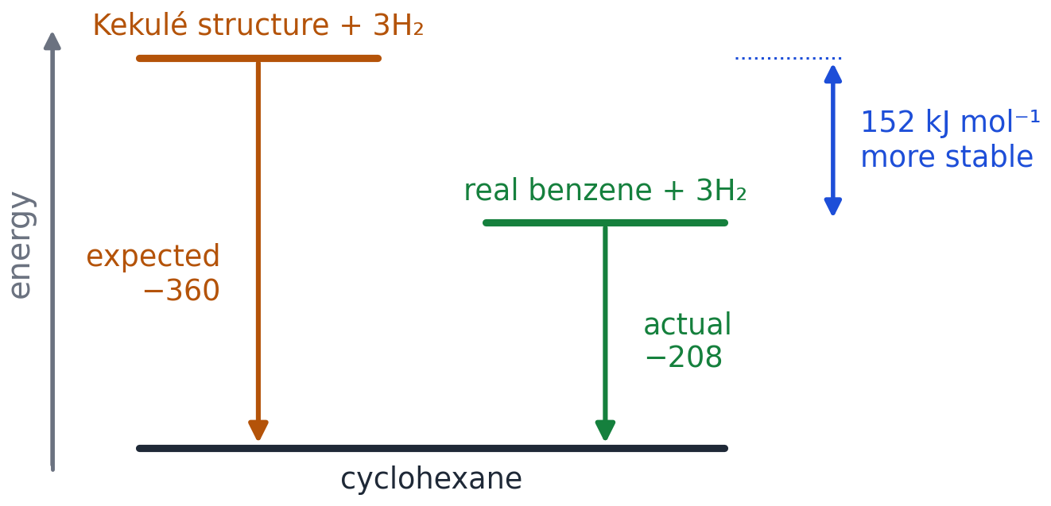
The A-level energy diagram — the 152 kJ mol⁻¹ is the resonance (delocalisation) energy.
2.1 A student writes 'benzene ⇌ (other Kekulé structure)'. Explain what is wrong with the arrow and what the correct symbol means. ★

2.2 The enthalpy change of hydrogenation of cyclooctatetraene is −410 kJ mol⁻¹, and that of cyclooctene is −96 kJ mol⁻¹. Calculate the 'resonance energy' of cyclooctatetraene and comment. ★

2.3 Predict the approximate ¹H chemical shifts of (a) the ring hydrogens of benzene, (b) the H atoms of cyclohexene's C=C, (c) the inner hydrogens of [18]annulene, and explain the differences. ★

Reading for this section
▸ Clayden ch. 13 (¹H NMR — the ring current) — why aromatic protons appear at 7–8 ppm
▸ Chemguide, 'Bonding in benzene' — a clear picture of the p-orbital overlap

Section 3 PART A · FIRST-YEAR UNDERGRADUATE LEVEL
The Wheland intermediate and the energy profile
The A-level mechanism draws one intermediate with a horseshoe. Here is what that horseshoe hides.

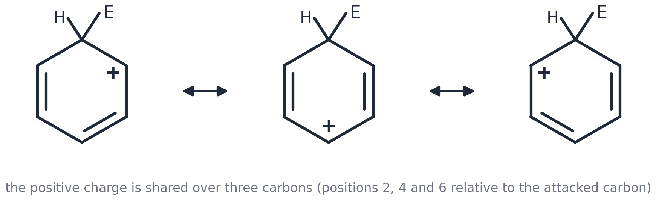
The three resonance forms of the Wheland intermediate (arenium ion, σ-complex). The positive charge is shared over C2, C4 and C6 relative to the attacked carbon.
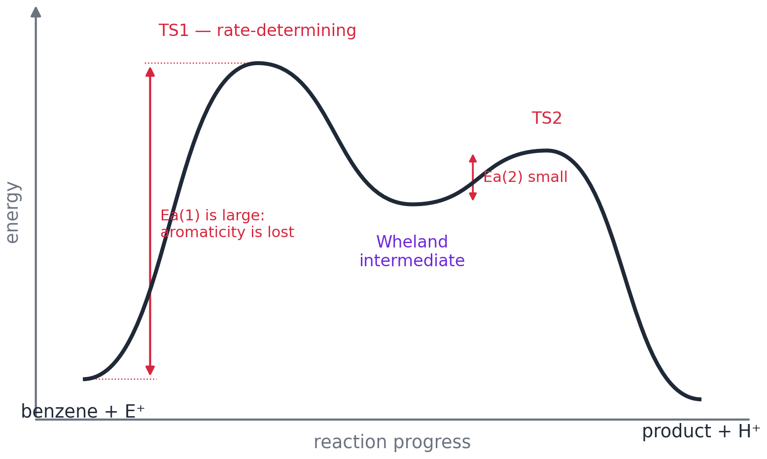
Energy profile for electrophilic aromatic substitution: two transition states, one intermediate.
Key facts
• Step 1 (attack) breaks aromaticity → large activation energy → RATE-DETERMINING.
• Step 2 (loss of H⁺) restores aromaticity → small activation energy → fast. This is why the intermediate loses H⁺ instead of gaining a nucleophile: substitution beats addition by ~150 kJ mol⁻¹.
• Evidence: nitration of C₆D₆ is as fast as C₆H₆ (no kinetic isotope effect, Melander 1950) — C–H bond breaking is not in the slow step.
• Hammond postulate: TS1 resembles the intermediate (they are close in energy), so anything that stabilises the intermediate speeds up the reaction — the key to directing effects in §4.
3.1 Draw the three resonance forms of the intermediate formed when Br⁺ attacks benzene. Mark the sp³ carbon. ★

3.2 Sulfonation, unlike nitration, DOES show a kinetic isotope effect (C₆D₆ reacts more slowly) and is reversible. Suggest what this tells you about the energy profile for sulfonation. ★

3.3 Use the energy profile to explain why the intermediate does not simply pick up HSO₄⁻ (or Br⁻) to give an addition product, as an alkene intermediate would. ★

Reading for this section
▸ Clayden ch. 21 'Electrophilic aromatic substitution' — the mechanism as chemists draw it, with the σ-complex
▸ G. W. Wheland, J. Am. Chem. Soc. 1942, 64, 900 — the paper that gave the intermediate its name

Section 4 PART A · FIRST-YEAR UNDERGRADUATE LEVEL
Directing effects — the real reason
The specification gives you a rule (OH/NH₂ → 2,4; NO₂ → 3). Here is the explanation a first-year undergraduate is expected to give.

Draw the intermediate for attack at each position and count the resonance forms. Attack ortho or para to an electron-donating group with a lone pair (–OH, –NH₂, –OCH₃, –Cl) gives an EXTRA form in which the heteroatom lone pair makes a C=O⁺ or C=N⁺ bond — every atom has a full octet, so this form is unusually stable. Attack meta cannot do this.
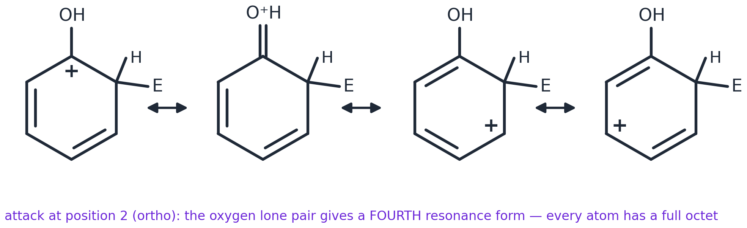
Attack at position 2 of phenol: four resonance forms, including the oxonium form on the right.
For an electron-withdrawing group such as –NO₂, ortho/para attack places the positive charge on the carbon bonded to the δ+ nitrogen (like charges adjacent — very unfavourable). Meta attack keeps the charge away from that carbon. So –NO₂ deactivates every position, but meta LEAST.
Group | Inductive effect | Mesomeric (resonance) effect | Overall | Directs to
–O⁻, –OH, –NH₂, –OCH₃ | −I (electronegative) | +M (strong): lone pair donation | activating | 2,4
–CH₃, alkyl | +I | weak + (hyperconjugation) | activating | 2,4
–Cl, –Br | −I (strong) | +M (weak): lone pair donation | deactivating | 2,4
–NO₂, –CN, –CHO, –COOH, –COOR, –SO₃H | −I | −M: withdraws by resonance | deactivating | 3

Partial rate factors compare ONE position of a substituted ring with ONE position of benzene. For the nitration of methylbenzene: ortho 42, meta 2.5, para 58 — the methyl group activates every position, but 2,4 far more. For chlorobenzene: ortho 0.030, meta 0.0009, para 0.14 — every position is deactivated, but 2,4 are deactivated least.
4.1 Use the chlorobenzene partial rate factors to predict the percentage of 2-, 3- and 4-chloronitrobenzene formed on nitration, and comment on the overall rate compared with benzene. ★

4.2 Draw the three resonance forms for attack of NO₂⁺ at the para position of nitrobenzene, and the three for attack at the meta position. Identify the form that makes para attack unfavourable. ★

4.3 4-Methylphenol is nitrated with dilute nitric acid. Predict the major product and explain your reasoning. ★

Reading for this section
▸ Clayden ch. 21, 'Electrophilic substitution on substituted benzenes' — resonance arguments for every class of substituent, with data
▸ Chemguide, 'Directing effects' — an accessible bridge from the A-level rule to the resonance explanation

Section 5 PART A · FIRST-YEAR UNDERGRADUATE LEVEL
Friedel–Crafts — the fine print
Alkylation and acylation look identical at A-level. In practice, alkylation is one of the least reliable reactions in organic synthesis and acylation one of the most reliable. Here is why.

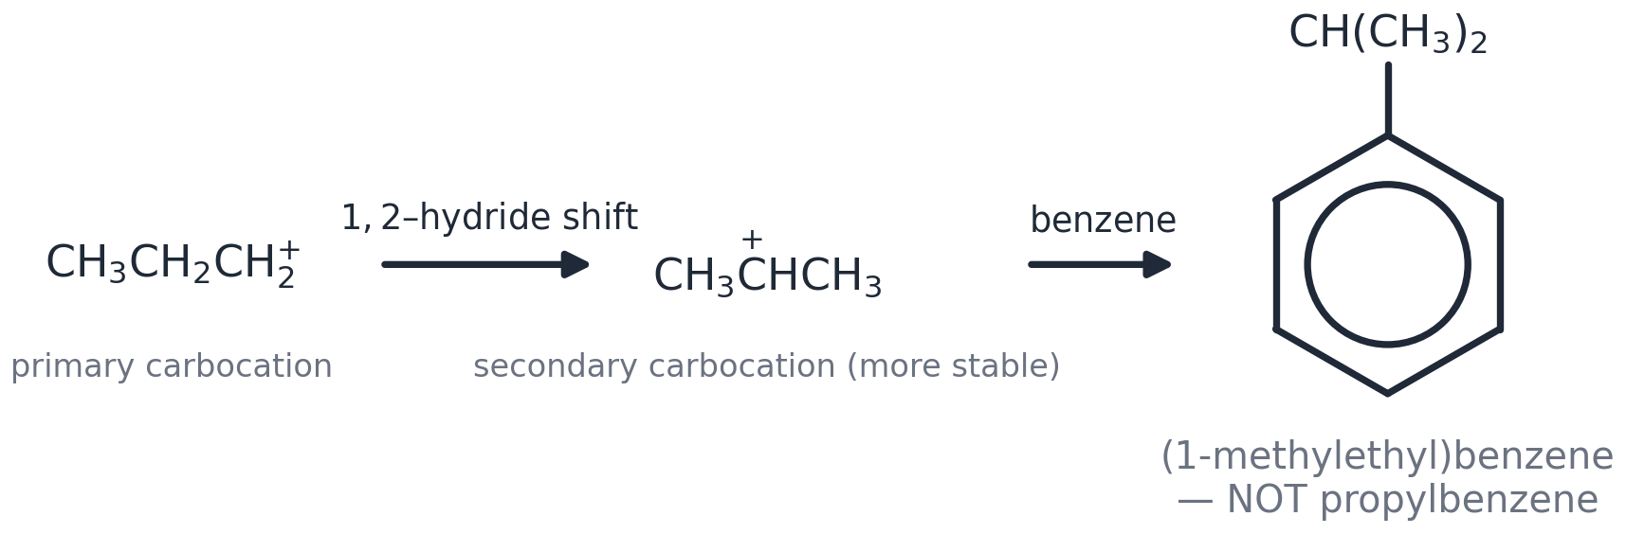
Carbocation rearrangement: a primary cation undergoes a 1,2-hydride shift before it attacks the ring.
Key facts
• Rearrangement: primary carbocations rearrange to secondary/tertiary by hydride or methyl shifts. Benzene + 1-chloropropane gives mostly (1-methylethyl)benzene; benzene + 1-chloro-2-methylpropane gives tert-butylbenzene.
• Polyalkylation: an alkyl group activates the ring, so the product competes for the electrophile — you get mixtures unless benzene is in large excess.
• Deactivated rings (–NO₂, –CN, –C=O, –SO₃H) do not undergo Friedel–Crafts reactions at all. –NH₂ and –OH complex with AlCl₃ and poison the catalyst.
• Acylation avoids all of this: the acylium ion (R–C≡O⁺ ↔ R–C⁺=O) is resonance-stabilised and does not rearrange; the ketone product is deactivated so the reaction stops after one substitution. Reducing the C=O to CH₂ (Clemmensen: Zn/Hg, HCl; Wolff–Kishner: N₂H₄, KOH, heat) gives clean, unrearranged alkylbenzenes.
5.1 Suggest a two-step synthesis of butylbenzene, C₆H₅CH₂CH₂CH₂CH₃, from benzene and explain why direct alkylation with 1-chlorobutane is a poor choice. ★

5.2 Draw the two resonance forms of the ethanoyl (acylium) cation and explain why it does not rearrange. ★

5.3 Explain why nitrobenzene is a good SOLVENT for Friedel–Crafts acylations but methoxybenzene is not. ★

Reading for this section
▸ Clayden ch. 21, 'Friedel–Crafts alkylation and acylation' — why chemists acylate then reduce
▸ G. A. Olah, Friedel–Crafts Chemistry (Wiley, 1973) — introduction — the definitive monograph; skim the historical introduction

Section 6 PART A · FIRST-YEAR UNDERGRADUATE LEVEL
Phenol: acidity, the Kolbe–Schmitt reaction and aspirin
Why is phenol an acid at all, why does a nitro group make it stronger, and how does phenol become aspirin?

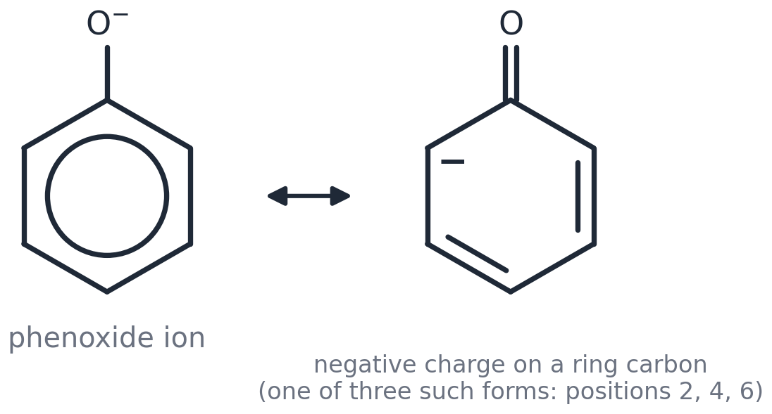
The phenoxide ion: the negative charge is delocalised onto the ring carbons (C2, C4 and C6).
Compound | pKₐ | Reason
ethanol | ≈ 16 | no delocalisation of the negative charge in the ethoxide ion
phenol | 10.0 | charge delocalised into the ring (resonance)
3-nitrophenol | 8.4 | –NO₂ withdraws inductively; meta position cannot delocalise the charge onto NO₂
4-nitrophenol | 7.2 | –NO₂ withdraws AND accepts the charge by resonance (para)
2,4,6-trinitrophenol (picric acid) | 0.4 | three –NO₂ groups: as strong as a mineral acid
ethanoic acid | 4.8 | charge shared equally by two equivalent oxygens

Kolbe–Schmitt reaction (1860): sodium phenoxide + CO₂ at 125 °C and 100 atm, then acid, gives 2-hydroxybenzoic acid (salicylic acid). The phenoxide's O⁻ activates the ring enough to attack the weak electrophile CO₂; the sodium ion holds CO₂ next to the ortho position. Salicylic acid + ethanoic anhydride (or ethanoyl chloride, 6.1.3) → aspirin.
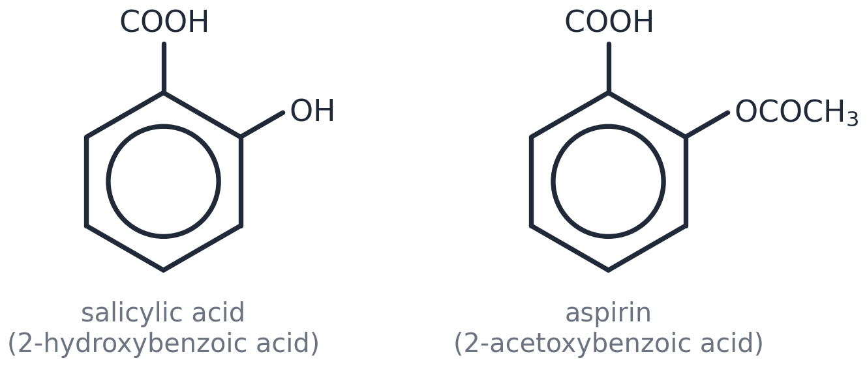
6.1 Rank in order of increasing acidity: phenol, 4-methylphenol, 4-nitrophenol, 3-nitrophenol, 2,4-dinitrophenol, cyclohexanol. Justify the position of 4-methylphenol. ★

6.2 Draw resonance forms to show why the negative charge of 4-nitrophenoxide can be delocalised onto the nitro group, but that of 3-nitrophenoxide cannot. ★

6.3 Explain why the Kolbe–Schmitt reaction is carried out on sodium phenoxide rather than phenol, and why the product is the 2-isomer rather than the 4-isomer. ★

Reading for this section
▸ Clayden ch. 8 'Acidity, basicity and pKₐ' — phenol's acidity in the context of every other organic acid
▸ J. Emsley, Molecules at an Exhibition (OUP) — the aspirin entry — short, readable history of salicylic acid and aspirin

Section 7 PART A · FIRST-YEAR UNDERGRADUATE LEVEL
Nucleophilic aromatic substitution and benzyne
At A-level the ring is always the nucleophile. Under the right conditions the ring can be ATTACKED BY nucleophiles — by two completely different mechanisms.

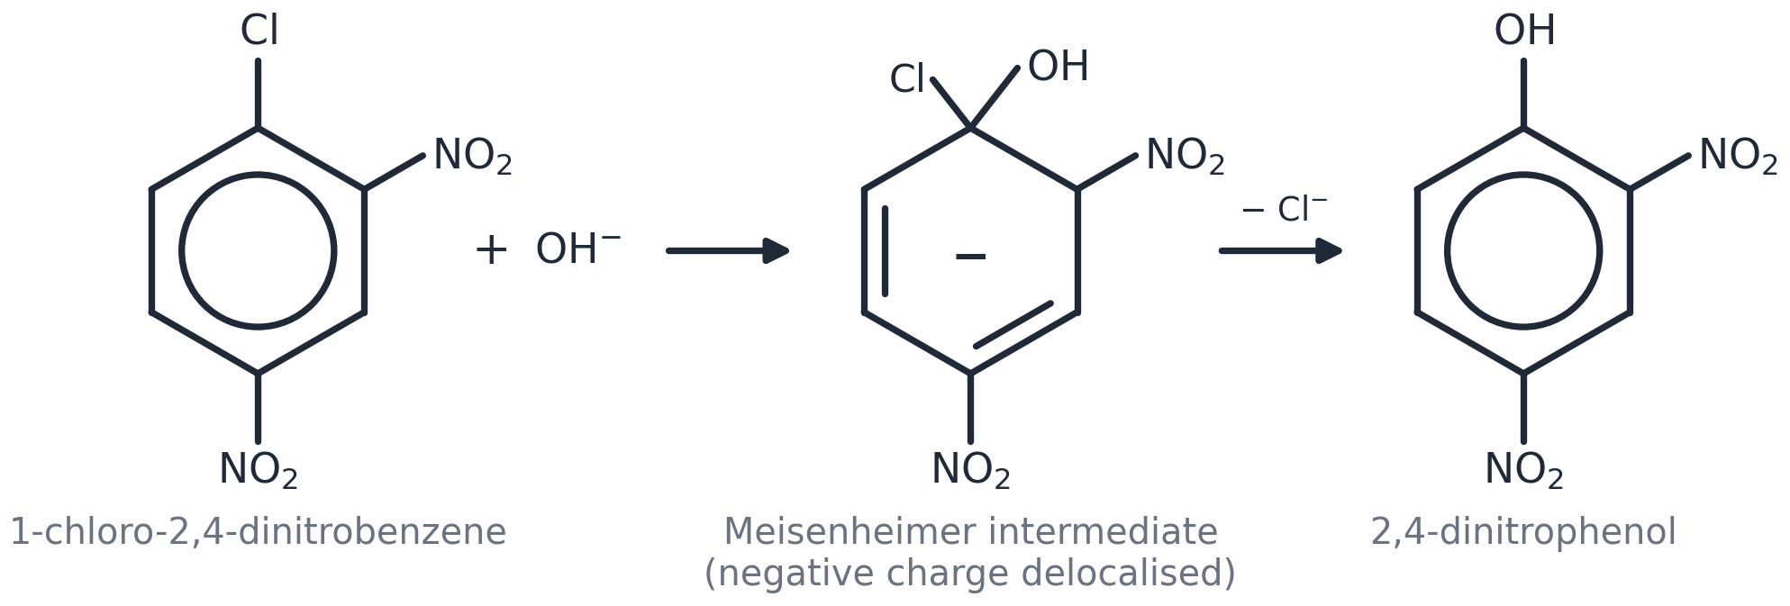
SNAr (addition–elimination): hydroxide adds to the carbon bearing chlorine; the negative charge is delocalised onto the nitro groups in the Meisenheimer intermediate; chloride then leaves.
Key facts
• SNAr needs (1) a good leaving group on the ring and (2) strong electron-withdrawing groups ORTHO or PARA to it, to stabilise the negative charge of the Meisenheimer intermediate. 2,4-Dinitrochlorobenzene reacts with warm NaOH; chlorobenzene itself needs 350 °C and 300 atm (the old Dow process for phenol).
• Benzyne (elimination–addition): a very strong base (NaNH₂ in liquid NH₃) removes H⁺ ortho to the halogen, chloride leaves, and the resulting 'triple bond' in the ring (benzyne) is attacked by the nucleophile at EITHER end.
• Evidence (Roberts, 1953): chlorobenzene labelled with ¹⁴C at C1 gave phenylamine with the label split 50 : 50 between C1 and C2 — impossible for a direct substitution.
7.1 Explain why 4-nitrochlorobenzene reacts with NaOH(aq) at 130 °C to give 4-nitrophenol, but chlorobenzene does not react under these conditions. Draw the key intermediate. ★

7.2 Predict the product(s) when 1-chloro-4-methylbenzene is treated with NaNH₂ in liquid ammonia, and explain using the benzyne mechanism. ★

7.3 Draw the three resonance forms of the Meisenheimer intermediate formed from 2,4-dinitrochlorobenzene and OH⁻, including one with the charge on a nitro oxygen. ★

Reading for this section
▸ Clayden ch. 22 'Nucleophilic aromatic substitution' — SNAr, benzyne and the labelling evidence
▸ J. D. Roberts et al., J. Am. Chem. Soc. 1953, 75, 3290 — the ¹⁴C experiment that discovered benzyne — short and readable

Part B
Second-year undergraduate level
The tools used in second-year courses and beyond: Hückel MO calculations, Hammett linear free-energy relationships, kinetics and isotope effects, synthesis with blocking and directing groups, heterocycles, spectroscopy and modern definitions of aromaticity. Problems marked ★★ (★★★ = open-ended).
Sections
8. Hückel molecular orbital theory — with numbers
9. Linear free-energy relationships: the Hammett equation
10. Electrophilic substitution at research depth
11. Regioselectivity, blocking groups and diazonium chemistry
12. Named reactions and rearrangements of aromatic compounds
13. Making aromatic bonds the modern way: SNAr in depth, benzyne, cross-coupling and directed metalation
14. Aromatic heterocycles
15. Spectroscopy of aromatic rings
16. Frontiers: what 'aromatic' means today

Section 8 PART B · SECOND-YEAR UNDERGRADUATE LEVEL
Hückel molecular orbital theory — with numbers
Frost circles are a picture; HMO theory is the calculation behind them. Second-year chemists compute π energies, delocalisation energies and HOMO–LUMO gaps by hand.

Key facts
• Hückel approximation: each carbon contributes one p-orbital; Coulomb integral α (energy of an electron in an isolated p-orbital) and resonance integral β (interaction between adjacent p-orbitals; β < 0). Non-adjacent interactions and overlap are set to zero.
• For a monocyclic conjugated ring of n atoms the π orbital energies are Eₖ = α + 2β cos(2πk/n), k = 0, ±1, ±2, … — this IS the Frost circle: the cosine puts the levels on a circle of radius 2|β|.
• Benzene: E = α + 2β (k = 0), α + β (k = ±1, degenerate), α − β (k = ±2), α − 2β (k = 3). Six electrons fill the three bonding orbitals: Eπ = 2(α + 2β) + 4(α + β) = 6α + 8β.
• Three isolated C=C bonds (ethene: 2α + 2β each) give 6α + 6β, so the DELOCALISATION ENERGY of benzene is 2β. Fitting to the hydrogenation data (152 kJ mol⁻¹) gives β ≈ −76 kJ mol⁻¹; spectroscopic estimates of β are larger (≈ −250 kJ mol⁻¹) — β is a parameter of a model, not a constant of nature.
• HOMO–LUMO gap: benzene 2|β| (absorbs in the UV). As conjugation extends the gap shrinks: naphthalene 1.24|β|, anthracene 0.83|β|, tetracene 0.59|β| (orange), pentacene 0.44|β| (blue-violet). Colour appears when the gap falls into the visible.
n (ring size) | Orbital energies (α + xβ), x = | Electrons (species) | Eπ | Reference | Delocalisation energy
3 | +2, −1, −1 | 2 (C₃H₃⁺) | 2α + 4β | one ethene: 2α + 2β | 2β (aromatic)
4 | +2, 0, 0, −2 | 4 (C₄H₄) | 4α + 4β | two ethenes: 4α + 4β | 0 — and a diradical
5 | +2, +0.618 (×2), −1.618 (×2) | 6 (C₅H₅⁻) | 6α + 6.47β | 2 ethenes + lone pair: 6α + 4β | 2.47β
6 | +2, +1 (×2), −1 (×2), −2 | 6 (benzene) | 6α + 8β | 3 ethenes: 6α + 6β | 2β
7 | +2, +1.25 (×2), −0.45 (×2), −1.80 (×2) | 6 (C₇H₇⁺) | 6α + 8.99β | 3 ethenes: 6α + 6β | 2.99β

8.1 Cyclobutadiene: write down the four Hückel energies, fill in 4 electrons (Hund's rule) and calculate the delocalisation energy relative to two ethene molecules. What does the result predict about its structure? ★★

8.2 Use Eₖ = α + 2β cos(2πk/8) to write down the orbital energies of planar cyclooctatetraene, then explain why (a) neutral C₈H₈ is a tub, (b) the dianion C₈H₈²⁻ is planar and aromatic. ★★

8.3 The HOMO energies of the linear acenes (α + xβ) are: naphthalene x = 0.618, anthracene 0.414, tetracene 0.295, pentacene 0.220 (the LUMO is symmetric at α − xβ). Calculate each HOMO–LUMO gap in units of |β|, then, using β ≈ −250 kJ mol⁻¹ (spectroscopic), estimate the wavelength absorbed by anthracene and comment on the colours of the series. ★★

8.4 Explain in one paragraph what HMO theory leaves out, and why it nevertheless predicts aromaticity correctly. ★★

Reading for this section
▸ I. Fleming, Molecular Orbitals and Organic Chemical Reactions (Student ed., Wiley), ch. 1–2 — HMO theory done properly, with worked energies
▸ P. Atkins & J. de Paula, Physical Chemistry — 'Hückel approximation' section — the secular determinant for benzene, if you want to see where Eₖ comes from
▸ Clayden ch. 7 (Hückel's rule) and ch. 4 (MOs) — the qualitative bridge

Section 9 PART B · SECOND-YEAR UNDERGRADUATE LEVEL
Linear free-energy relationships: the Hammett equation
How chemists quantify 'electron-withdrawing' and 'electron-donating' — and use one number to predict thousands of rate constants.

Key facts
• Hammett (1937): log(k/k₀) = ρσ (or log(K/K₀) = ρσ). σ measures the SUBSTITUENT (defined from the ionisation of substituted benzoic acids in water at 25 °C, ρ = 1); ρ measures the REACTION's sensitivity to substituents.
• σ > 0: electron-withdrawing (NO₂, CN, Cl). σ < 0: electron-donating (OCH₃, NH₂, CH₃). σₘ ≠ σₚ because resonance donation/withdrawal reaches the para position but not the meta position.
• ρ > 0: negative charge builds up in the transition state (helped by EWGs) — e.g. alkaline ester hydrolysis, ρ = +2.5. ρ < 0: positive charge builds up — electrophilic aromatic substitution: nitration ρ ≈ −6, Friedel–Crafts acetylation ≈ −9, bromination ≈ −12.
• For EAS, strong +M groups react far faster than ordinary σₚ predicts because the lone pair conjugates DIRECTLY with the developing positive charge. Brown & Okamoto's σ⁺ constants (from the solvolysis of cumyl chlorides) fix this: σₚ⁺(OCH₃) = −0.78, σₚ⁺(CH₃) = −0.31, σₚ⁺(NH₂) = −1.30.
• Selectivity relationship (Brown): Sf = log(pf / mf), where pf and mf are the para and meta partial rate factors. A more reactive electrophile is LESS selective (reactivity–selectivity principle): nitration of toluene Sf = log(58/2.5) = 1.37; bromination Sf = log(2420/5.5) = 2.64.
Substituent | σₘ | σₚ | σₚ⁺ | Comment
–NO₂ | +0.71 | +0.78 | +0.79 | −I and −M
–CN | +0.56 | +0.66 | +0.66 | −I and −M
–CF₃ | +0.43 | +0.54 | +0.61 | −I only
–Cl | +0.37 | +0.23 | +0.11 | −I > +M
–F | +0.34 | +0.06 | −0.07 | strong −I, +M nearly cancels at para
–H | 0 | 0 | 0 | reference
–CH₃ | −0.07 | −0.17 | −0.31 | +I, hyperconjugation
–OCH₃ | +0.12 | −0.27 | −0.78 | −I at meta; +M dominates at para
–OH | +0.12 | −0.37 | −0.92 | as OCH₃
–NH₂ | −0.16 | −0.66 | −1.30 | strongest +M

9.1 Benzoic acid has pKₐ 4.20. Use σₚ(NO₂) = 0.78 and ρ = 1.00 (by definition) to predict the pKₐ of 4-nitrobenzoic acid. Then predict the pKₐ of 4-methoxybenzoic acid and explain the direction of the change. ★★

9.2 The bromination of aromatic compounds by Br₂ in acetic acid has ρ = −12.1 (with σ⁺). Estimate how many times faster methoxybenzene reacts than benzene at the para position. Repeat for chlorobenzene (σₚ⁺ = +0.11). Comment on the size of ρ. ★★

9.3 Explain, with resonance structures, why σₚ(OCH₃) is negative but σₘ(OCH₃) is positive, and why a separate σ⁺ scale is needed for electrophilic substitution. ★★

9.4 Two nitration experiments give relative rates (per position) k/k₀ = 58 for para-CH₃ (σ⁺ = −0.31) and 2.5 × 10⁻⁵ for para-NO₂ (σ⁺ = +0.79). Determine ρ from each point and comment on whether nitration obeys a single Hammett line. ★★

9.5 Using the toluene partial rate factors for nitration (o 42, m 2.5, p 58) and bromination (o 600, m 5.5, p 2420): (a) calculate Sf for each; (b) state the reactivity–selectivity principle; (c) predict which electrophile gives the higher proportion of meta product and check with the numbers. ★★

Reading for this section
▸ E. V. Anslyn & D. A. Dougherty, Modern Physical Organic Chemistry (University Science Books), ch. 8 'Experiments related to thermodynamics and kinetics' — the Hammett section — the definitive modern account of LFERs
▸ L. P. Hammett, J. Am. Chem. Soc. 1937, 59, 96 — the original paper — remarkably readable
▸ H. C. Brown & Y. Okamoto, J. Am. Chem. Soc. 1958, 80, 4979 — the σ⁺ scale
▸ C. Hansch, A. Leo & R. W. Taft, Chem. Rev. 1991, 91, 165 — the big table of σ values

Section 10 PART B · SECOND-YEAR UNDERGRADUATE LEVEL
Electrophilic substitution at research depth
Evidence for the nitronium ion, complexes you can isolate, reactions that go backwards, and what happens when the electrophile attacks a carbon that already has a substituent.

Key facts
• Evidence for NO₂⁺ (Ingold, Hughes, Gillespie, 1940s–50): Raman spectra of HNO₃/H₂SO₄ show a band at 1400 cm⁻¹ from the linear NO₂⁺ ion; freezing-point depression shows that each HNO₃ in H₂SO₄ gives FOUR particles (van 't Hoff factor i = 4): HNO₃ + 2H₂SO₄ → NO₂⁺ + H₃O⁺ + 2HSO₄⁻; and nitronium salts such as NO₂⁺BF₄⁻ (Olah, 1961) nitrate benzene cleanly in nitromethane with no acid at all.
• π-complex vs σ-complex: the electrophile first forms a loose π-complex with the whole ring, then the σ-complex (the Wheland intermediate). σ-Complexes can be isolated: heptamethylbenzenium tetrachloroaluminate (Doering, 1958) and many arenium ions in superacids at −80 °C (Olah) — their NMR spectra show the sp³ CH.
• Encounter control: with very reactive substrates (toluene, mesitylene, phenol) nitration by NO₂⁺ becomes as fast as the molecules can diffuse together, so their rates are all the same (the 'encounter pair', Ridd). Hammett plots flatten at the top.
• Kinetic isotope effects (kH/kD): nitration ≈ 1.0; bromination ≈ 1; sulfonation 1.6–2; iodination ≈ 4; azo coupling up to 6.5. A KIE appears whenever the second step (C–H cleavage) becomes partly rate-determining — weak or bulky electrophiles, reversible first step, base catalysis.
• Reversibility: sulfonation (steam/dilute acid removes –SO₃H) and Friedel–Crafts alkylation are reversible. Under thermodynamic control alkylation gives the most stable isomer: AlCl₃/HCl isomerises 1,2- and 1,4-dimethylbenzene to 1,3-dimethylbenzene (the meta isomer is the most stable because neither methyl group is crowded and the cation intermediate is best stabilised).
• Ipso substitution: attack at a carbon that already carries a substituent, which then leaves as a cation: ArSiMe₃ + E⁺ → ArE + Me₃Si⁺ (the β-silicon effect stabilises the intermediate), ArSO₃H → ArH (desulfonation), ArCMe₃ + H⁺ → ArH + Me₃C⁺ (de-tert-butylation).
10.1 Predict the van 't Hoff factor i for (a) HNO₃ dissolved in 100% H₂SO₄, (b) ethanol dissolved in 100% H₂SO₄ (which forms EtOSO₃H). Write the ionisation equations. Why was measurement (a) such strong evidence for NO₂⁺? ★★

10.2 Nitration of toluene, mesitylene (1,3,5-trimethylbenzene) and methoxybenzene by nitric acid in sulfolane all proceed at the same rate, even though their partial rate factors differ by orders of magnitude. Explain, and say what this implies about the position at which reaction occurs. ★★

10.3 Azo coupling of benzenediazonium ions with 2-naphthol-6,8-disulfonate shows kH/kD ≈ 6.5 and is catalysed by pyridine. Nitration of the same substrate shows kH/kD ≈ 1. Explain both observations with energy profiles. ★★

10.4 4-Methylphenyltrimethylsilane, 4-CH₃C₆H₄SiMe₃, reacts with Br₂ to give 4-bromotoluene. Draw the mechanism and explain why substitution occurs at the ipso carbon rather than ortho to the methyl group. ★★

10.5 Under kinetic control, methylation of toluene (CH₃Cl/AlCl₃, 0 °C) gives mainly 1,2- and 1,4-dimethylbenzene; on prolonged heating with AlCl₃/HCl the mixture becomes mostly 1,3-dimethylbenzene. Explain both results and draw the intermediate responsible for the isomerisation. ★★

Reading for this section
▸ R. Taylor, Electrophilic Aromatic Substitution (Wiley, 1990) — the monograph: everything measured up to 1990, with tables of partial rate factors
▸ G. A. Olah, Acc. Chem. Res. 1971, 4, 240 — σ- and π-complexes, with the NMR evidence
▸ J. H. Ridd, Chem. Soc. Rev. 1991, 20, 149 — encounter pairs and the fine mechanism of nitration
▸ Clayden ch. 21 & ch. 40 (kinetic vs thermodynamic control) — the thermodynamic isomerisation of alkylbenzenes

Section 11 PART B · SECOND-YEAR UNDERGRADUATE LEVEL
Regioselectivity, blocking groups and diazonium chemistry
Real syntheses have two or three substituents competing, steric effects, groups that must be protected — and diazonium salts, the Swiss-army knife of aromatic synthesis.

Key facts
• Two substituents: the stronger ACTIVATOR wins (NH₂/OH > OR > alkyl > halogen > EWG). If both direct to the same positions, sterics decide: the position between two meta groups is rarely attacked; ortho to a bulky group is disfavoured (tert-butylbenzene nitrates 16% ortho vs 58% for toluene).
• Protecting NH₂: phenylamine is oxidised by HNO₃ and protonated to the meta-directing –NH₃⁺. Acetylate first (ethanoic anhydride → acetanilide, –NHCOCH₃): still 2,4-directing but tamer and bulkier (mainly para); hydrolyse afterwards (aqueous acid, heat).
• Blocking with –SO₃H: sulfonate the para position (conc. H₂SO₄, reversible), do the chemistry ortho, then remove –SO₃H with dilute acid/steam.
• Diazonium salts: ArNH₂ + NaNO₂/HCl at 0–5 °C → ArN₂⁺Cl⁻ (nitrosation of the amine by NO⁺, then dehydration). Above 10 °C they lose N₂. They convert the amino group into almost anything: CuCl/CuBr/CuCN (Sandmeyer), KI (iodoarene), HBF₄ then heat (Balz–Schiemann → fluoroarene), warm water (phenol), H₃PO₂ (replaces N₂ by H — 'deamination'), and phenols/amines under mild conditions give azo dyes (the diazonium ion is the electrophile).
• Nitro → amino: Sn/conc. HCl or H₂/Pd or Fe/HCl. Partial reduction of a dinitro compound with Na₂S or NH₄SH reduces just one nitro group.
• Paracetamol: phenol → (dilute HNO₃) 4-nitrophenol, separated from the 2-isomer by steam distillation (the 2-isomer is volatile because its OH is intramolecularly hydrogen-bonded) → (H₂/Pd) 4-aminophenol → (ethanoic anhydride) paracetamol; the more nucleophilic NH₂ is acetylated selectively.
11.1 Devise a synthesis of 4-bromophenylamine from benzene. Explain why direct bromination of phenylamine is unsuitable. ★★

11.2 1,3,5-Tribromobenzene cannot be made by direct bromination of benzene (which gives the 1,2,4-isomer). Devise a route from benzene. ★★

11.3 Devise a synthesis of 3-bromophenol from benzene. (Direct bromination of phenol gives the 2- and 4-isomers.) ★★

11.4 Predict the major mono-nitration product of (a) 4-methylnitrobenzene, (b) 3-methylphenol, (c) 4-tert-butyltoluene, (d) 4-methylacetanilide. Justify each. ★★

11.5 Draw the mechanism for the formation of benzenediazonium chloride from phenylamine, NaNO₂ and HCl, starting from the generation of the nitrosonium ion, NO⁺. ★★

Reading for this section
▸ Clayden ch. 21 (diazonium salts and the 'route to everything') and ch. 24 'Regioselectivity' — second-year regiochemistry and the diazonium toolkit
▸ S. Warren & P. Wyatt, Organic Synthesis: The Disconnection Approach (2nd ed., Wiley), ch. 3 'Aromatic compounds: order of events' — how to PLAN aromatic syntheses — retrosynthesis of exactly these problems
▸ Chemguide, 'Diazonium salts' — the reactions, with equations

Section 12 PART B · SECOND-YEAR UNDERGRADUATE LEVEL
Named reactions and rearrangements of aromatic compounds
Formylation, acylation of phenols, the industrial route to phenol, and a pericyclic rearrangement — the reactions on every second-year mechanism sheet.

Key facts
• Hock (cumene) process — the source of almost all the world's phenol: benzene + propene (H₃PO₄) → cumene; air oxidation (radical chain) → cumene hydroperoxide, PhC(CH₃)₂–O–OH; dilute acid → phenol + propanone. Key step: protonation of the O–OH, loss of water with a 1,2-shift of the PHENYL group from carbon to the electron-deficient oxygen (aryl migrates faster than methyl because the transition state is stabilised by the ring's π electrons), giving an oxocarbenium ion; water adds → hemiketal → collapses to phenol + acetone.
• Fries rearrangement: an aryl ester (phenyl ethanoate) + AlCl₃ gives hydroxyaryl ketones. Low temperature (kinetic) → mainly para; high temperature (thermodynamic) → ortho, because the ortho product forms a stable chelate with AlCl₃ (intramolecular H-bond after work-up).
• Vilsmeier–Haack formylation: DMF + POCl₃ → chloroiminium ion (Me₂N⁺=CHCl), a mild electrophile; attacks activated rings (phenols, anilines, pyrrole, indole) at the para/2-position; hydrolysis of the iminium product gives the aldehyde.
• Gattermann–Koch: CO + HCl + AlCl₃/CuCl → formyl cation HC≡O⁺ → benzaldehyde from benzene (unactivated rings, unlike Vilsmeier).
• Reimer–Tiemann: phenoxide + CHCl₃/NaOH → dichlorocarbene :CCl₂ (from CHCl₃ + OH⁻ → CCl₃⁻ → :CCl₂ + Cl⁻) attacks the ortho position of the phenoxide (an electrophile attacked by an electron-rich ring) → after hydrolysis 2-hydroxybenzaldehyde (salicylaldehyde).
• Claisen rearrangement: allyl phenyl ethers rearrange on heating (≈ 200 °C) to 2-allylphenols by a concerted [3,3]-sigmatropic shift through a six-membered cyclic transition state; no intermediates, no catalyst. The allyl group ends up attached by its OTHER end (C1 of the allyl unit bonds to the ring carbon).
12.1 Draw the full mechanism for the acid-catalysed conversion of cumene hydroperoxide into phenol and propanone (the Hock rearrangement). Explain why the phenyl group migrates rather than a methyl group. ★★

12.2 Phenyl ethanoate is treated with AlCl₃ at (a) 25 °C and (b) 160 °C. Predict the major product in each case and explain the temperature dependence. What A-level reaction is this related to? ★★

12.3 Write the mechanism for the Reimer–Tiemann formylation of phenol to 2-hydroxybenzaldehyde. Identify the electrophile and explain why the reaction is ortho-selective. ★★

12.4 Allyl phenyl ether labelled with deuterium at the CH₂ next to oxygen (Ph–O–CD₂–CH=CH₂) is heated to 200 °C. Draw the product, showing where the deuterium ends up, and explain what this tells you about the mechanism. ★★

12.5 Explain why the Vilsmeier–Haack reagent formylates phenol and N,N-dimethylaniline but not benzene, whereas the Gattermann–Koch reaction formylates benzene but is useless for phenol. ★★

Reading for this section
▸ Clayden ch. 21 (Vilsmeier, Gattermann–Koch), ch. 35 'Pericyclic reactions 2: sigmatropic and electrocyclic' (Claisen), ch. 36 (Hock/Baeyer–Villiger migrations) — the mechanisms in full
▸ J. J. Li, Name Reactions (Springer) — one-page mechanism cards for every named reaction here
▸ Chemguide / Wikipedia 'Cumene process' — the industrial context — 8 million tonnes of phenol a year

Section 13 PART B · SECOND-YEAR UNDERGRADUATE LEVEL
Making aromatic bonds the modern way: SNAr in depth, benzyne, cross-coupling and directed metalation
Friedel–Crafts is what the A-level teaches; palladium catalysis and organolithium chemistry are what a medicinal chemist actually uses.

Key facts
• SNAr leaving-group order is F > Cl ≈ Br > I — the REVERSE of SN2 — because the rate-determining step is the ADDITION of the nucleophile, not the loss of the leaving group: the most electronegative halogen makes the ipso carbon most electrophilic and stabilises the Meisenheimer intermediate best. 1-Fluoro-2,4-dinitrobenzene (Sanger's reagent, used to label N-terminal amino acids) reacts with amines hundreds of times faster than the chloro compound.
• Meisenheimer complexes can be isolated as salts (2,4,6-trinitroanisole + KOMe, 1902) and characterised by NMR: the sp³ carbon appears at ≈ 100 ppm.
• Benzyne regiochemistry: with a substituent, the nucleophile adds to the aryne carbon that places the resulting aryl anion CLOSER to an inductively withdrawing group. 3-Chloroanisole + NaNH₂ gives ONLY 3-methoxyphenylamine (the anion at C2, next to OMe, is stabilised). Benzynes are trapped by dienes: with furan a Diels–Alder adduct forms; with anthracene, triptycene. Mild precursors: 2-(trimethylsilyl)phenyl triflate + CsF (Kobayashi, 1983); anthranilic acid + isoamyl nitrite.
• Palladium cross-coupling (Suzuki–Miyaura: ArX + Ar'B(OH)₂; Buchwald–Hartwig: ArX + R₂NH; Heck; Sonogashira). The catalytic cycle: oxidative addition of Ar–X to Pd(0) → transmetalation (or amine coordination/deprotonation) → reductive elimination forming Ar–Ar' or Ar–N and regenerating Pd(0). Works on deactivated rings, tolerates most functional groups, gives single regioisomers — the reasons it replaced Friedel–Crafts for making biaryls in the pharmaceutical industry.
• Directed ortho-metalation (DoM, Snieckus): a 'directed metalation group' (OMe, CONEt₂, NHBoc, SO₂NR₂, oxazoline) coordinates n-BuLi (or s-BuLi/TMEDA) and delivers it to the ORTHO C–H, which is deprotonated to an aryllithium; quenching with an electrophile (CO₂, DMF, I₂, Me₃SiCl) puts the new group ortho ONLY — complementary to electrophilic substitution, which gives ortho/para mixtures.
13.1 Explain why 1-fluoro-2,4-dinitrobenzene undergoes SNAr with piperidine faster than the chloro analogue, even though F⁻ is a far worse leaving group than Cl⁻ in SN2 reactions. Sketch the energy profile. ★★

13.2 3-Chloroanisole with NaNH₂ in liquid ammonia gives exclusively 3-methoxyphenylamine, whereas 4-chloroanisole gives a mixture of 3- and 4-methoxyphenylamine. Explain both results. ★★

13.3 Propose a synthesis of 2-methoxybenzaldehyde from methoxybenzene using directed ortho-metalation, and explain why an electrophilic formylation (Vilsmeier) would not give this isomer. ★★

13.4 Draw the catalytic cycle for the Suzuki–Miyaura coupling of 4-bromoacetophenone with phenylboronic acid (Pd(PPh₃)₄, K₂CO₃), naming each step. Then explain why this reaction — rather than Friedel–Crafts — is used to make biaryls in drug synthesis. ★★

13.5 Benzyne generated from 2-(trimethylsilyl)phenyl triflate and CsF reacts with anthracene to give triptycene. Draw the reaction, classify it, and explain why it is fast even though the diene is aromatic. ★★

Reading for this section
▸ Clayden ch. 22 (SNAr and benzyne), ch. 40 'Organometallic chemistry' (cross-coupling) — the mechanisms with the evidence
▸ V. Snieckus, Chem. Rev. 1990, 90, 879 — directed ortho-metalation — the review that defined the field
▸ N. Miyaura & A. Suzuki, Chem. Rev. 1995, 95, 2457 — the Suzuki coupling (Nobel Prize 2010)
▸ Nobel Prize in Chemistry 2010 — popular science background (nobelprize.org) — a readable account of why palladium changed synthesis

Section 14 PART B · SECOND-YEAR UNDERGRADUATE LEVEL
Aromatic heterocycles
Half of all drugs contain an aromatic heterocycle. Their chemistry is benzene's chemistry with the electron count and the electronegativity of the heteroatom dialled in.

Key facts
• Pyridine: the N lone pair is in an sp² orbital in the plane — NOT part of the 6 π electrons — so pyridine is a base (pKₐH 5.2) and the ring is electron-POOR (N is more electronegative than C). Electrophilic substitution is very hard (nitration: KNO₃/H₂SO₄ at 300 °C, 6% yield, at C3) because under the acidic conditions the N is protonated, making a pyridinium ion. Attack at C2/C4 would put positive charge on N⁺ — hence C3. Nucleophiles attack C2/C4 (Chichibabin: NaNH₂, 100 °C → 2-aminopyridine, via addition then loss of hydride).
• Pyridine N-oxide (pyridine + H₂O₂/ethanoic acid): the N–O⁻ oxygen is a +M donor to C2/C4, so nitration (HNO₃/H₂SO₄, 90 °C) goes at C4; PCl₃ then removes the oxygen. This is the standard route to 4-substituted pyridines.
• Pyrrole: the N lone pair IS part of the 6 π electrons (4 from C=C + 2 from N), so pyrrole is essentially non-basic (pKₐH −4) and electron-RICH: electrophilic substitution is enormously faster than for benzene — comparable to phenylamine (bromine water instantly gives tetrabromopyrrole; mild Vilsmeier gives pyrrole-2-carbaldehyde). Attack at C2 because the intermediate has THREE resonance forms (charge on C3, C5 and N) vs TWO for C3 attack. Strong acids polymerise it.
• Furan and thiophene: like pyrrole, EAS at C2. Resonance energies (kJ mol⁻¹): benzene 152, thiophene ≈ 120, pyrrole ≈ 90, furan ≈ 67. Furan, the least aromatic, is a good Diels–Alder diene; thiophene is the most benzene-like and survives acid.
• Indole (benzene fused to pyrrole): electrophiles attack C3 (not C2) because the C3 intermediate keeps the benzene ring's sextet intact and is stabilised as an iminium ion by N; C2 attack would disrupt the benzene ring. Quinoline (benzene fused to pyridine): electrophiles attack the carbocyclic ring (C5/C8); nucleophiles attack C2/C4 of the pyridine ring.
14.1 Draw the resonance forms of the intermediate for electrophilic attack on pyrrole at C2 and at C3. Hence explain the observed 2-selectivity, and predict the product of pyrrole with Vilsmeier reagent. ★★

14.2 Nitration of pyridine gives 3-nitropyridine in 6% yield at 300 °C. Devise a two-step route to 4-nitropyridine from pyridine and explain why it works. ★★

14.3 Write the mechanism of the Chichibabin reaction (pyridine + NaNH₂ → 2-aminopyridine + H₂) and explain why hydride, normally a terrible leaving group, is lost. ★★

14.4 Predict the major product of (a) indole + Br₂ (1 equiv., DMF), (b) quinoline + HNO₃/H₂SO₄, (c) furan + maleic anhydride at room temperature, (d) thiophene + ethanoyl chloride/SnCl₄. Explain each. ★★

14.5 Histamine, nicotine and serotonin each contain an aromatic heterocycle. Identify the heterocycle in each and state, with reasoning, whether it is electron-rich or electron-poor and which ring nitrogen (if any) is basic. ★★

Reading for this section
▸ J. A. Joule & K. Mills, Heterocyclic Chemistry (5th ed., Wiley) — the standard second-year text
▸ Clayden ch. 29 'Aromatic heterocycles 1: reactions' and ch. 30 'Aromatic heterocycles 2: synthesis' — reactivity patterns explained with resonance
▸ T. L. Gilchrist, Heterocyclic Chemistry (3rd ed., Longman) — concise alternative

Section 15 PART B · SECOND-YEAR UNDERGRADUATE LEVEL
Spectroscopy of aromatic rings
Links to OCR 6.3.2 — but at the depth of a second-year structure-determination course: coupling constants, symmetry and the out-of-plane region.

Key facts
• ¹H NMR: aromatic H at 6.5–8.5 ppm (ring current). Electron-withdrawing groups deshield the ortho/para H (nitrobenzene ortho H at 8.2 ppm); donating groups shield them (methoxybenzene ortho H at 6.9 ppm). The meta H are barely affected — a direct picture of resonance donation/withdrawal.
• Coupling: ³J(ortho) = 7–9 Hz, ⁴J(meta) = 2–3 Hz, ⁵J(para) = 0–1 Hz. A 1,4-disubstituted ring with different substituents gives two 2H 'doublets' (an AA'BB' system) — the most recognisable pattern in the spectrum. A 1,2-disubstituted ring gives a complex 4H multiplet; 1,3-disubstitution gives an isolated H2 as a narrow triplet/singlet.
• ¹³C NMR: aromatic C at 110–160 ppm. Count environments to find the symmetry: benzene 1, toluene 5, 1,2-dimethylbenzene 4 (incl. CH₃), 1,3- 5, 1,4- 3. The ipso carbon of a substituent with +M shifts its ortho/para carbons upfield (methoxybenzene C2/C4 at 114/121 ppm).
• IR: C–H out-of-plane bends 680–900 cm⁻¹ reveal the substitution pattern: mono 690 + 750; 1,2- 750; 1,3- 690 + 780; 1,4- 830 cm⁻¹. Weak overtone 'fingers' at 1660–2000 cm⁻¹; ring C=C stretches 1450–1600 cm⁻¹.
• Mass spectra: aromatic molecular ions are intense (the ring stabilises the radical cation); the tropylium ion C₇H₇⁺ (m/z 91) dominates spectra of alkylbenzenes — benzyl cations rearrange to the aromatic 6 π tropylium ion.
15.1 An aromatic compound C₈H₁₀ shows three aromatic ¹³C signals and one aliphatic signal; its ¹H spectrum has a 4H singlet at 7.1 ppm and a 6H singlet at 2.3 ppm. Identify it and explain how the other C₈H₁₀ arene isomers would differ. ★★

15.2 The ¹H NMR spectrum of 4-nitrotoluene shows δ 8.13 (d, J = 8.5 Hz, 2H), 7.33 (d, J = 8.5 Hz, 2H), 2.45 (s, 3H). Assign every signal and explain the chemical shifts in terms of the substituents. ★★

15.3 The three dinitrobenzene isomers are hard to tell apart by mass spectrometry. Explain how ¹³C NMR and IR distinguish them, giving the number of ¹³C environments for each and the diagnostic IR bands. ★★

15.4 Predict the ¹H NMR spectrum of 2,4,6-tribromophenol (the product of the A-level bromination of phenol) and of 4-bromophenol, and explain how NMR proves that bromination went to positions 2, 4 and 6 rather than, say, 2, 3 and 4. ★★

Reading for this section
▸ Clayden ch. 13 '¹H NMR' and ch. 18 'Structure determination' — aromatic coupling patterns worked through
▸ D. H. Williams & I. Fleming, Spectroscopic Methods in Organic Chemistry (6th ed., McGraw-Hill) — the tables every research group keeps on the shelf
▸ SDBS spectral database (AIST, Japan — free online) — look up the real spectra of every compound in this pack

Section 16 PART B · SECOND-YEAR UNDERGRADUATE LEVEL
Frontiers: what 'aromatic' means today
Magnetic criteria, Möbius rings, polycyclic sextets and graphene — where the idea Kekulé started has ended up.

Key facts
• Magnetic criterion — NICS (nucleus-independent chemical shift, Schleyer 1996): compute the NMR shielding at the ring centre. Aromatic rings give negative NICS (benzene −9.7 ppm), antiaromatic rings positive (cyclobutadiene +27.6), non-aromatic ≈ 0 (tub cyclooctatetraene). NICS turned aromaticity from a chemist's judgement into a number.
• Möbius aromaticity (Heilbronner 1964, prediction; Herges 2003, first synthesis): give a ring one half-twist so the p-orbital array has a phase inversion, and the rules swap — 4n π electrons become aromatic, 4n + 2 antiaromatic.
• Clar's rule (1972): for a polycyclic aromatic hydrocarbon, the dominant structure is the one with the largest number of DISJOINT aromatic sextets (drawn as circles). Anthracene has ONE sextet (three ways to place it); phenanthrene has TWO. Phenanthrene is more stable than anthracene by ≈ 25 kJ mol⁻¹, and anthracene reacts at C9/C10 by addition (bromine, Diels–Alder) because doing so converts one sextet into two.
• Kekulé structure counting: naphthalene 3, anthracene 4, phenanthrene 5. In naphthalene the C1–C2 bond is double in 2 of 3 structures (0.137 nm) while C2–C3 is double in only 1 (0.142 nm) — resonance theory predicts the measured bond alternation.
• Graphene is an 'infinite' polycyclic aromatic; nanographenes with hundreds of rings are now synthesised by cyclodehydrogenation of polyphenylenes (Müllen), with properties tuned by the edge structure — Clar's rule still predicts which edges are reactive.
• Antiaromatic intermediates: the cyclopentadienyl CATION (4 π) is so destabilised that it is a triplet ground state and has never been isolated as a simple salt; the parent cyclobutadiene dianion has resisted isolation too. These are the exceptions that make the rule.
16.1 Anthracene and phenanthrene are both C₁₄H₁₀. Use Clar's rule to explain (a) why anthracene is the less stable isomer, and (b) why anthracene readily undergoes bromine ADDITION across C9–C10 whereas phenanthrene undergoes substitution. ★★★

16.2 Draw the three Kekulé structures of naphthalene. Use them to predict the order of bond lengths C1–C2, C2–C3 and C4a–C8a (the central bond), and compare with the experimental values 0.137, 0.142 and 0.142 nm. ★★★

16.3 Sketch how a Möbius [4n]annulene can be aromatic. What experimental observations would you use to decide whether a newly made twisted annulene is aromatic? ★★★

16.4 The Hammett plot for a reaction is a straight line for meta substituents but shows strongly negative deviations for para +M substituents. A colleague proposes that this proves a cationic intermediate. Evaluate the claim and design one further experiment. ★★★

Reading for this section
▸ P. v. R. Schleyer et al., J. Am. Chem. Soc. 1996, 118, 6317 — the NICS paper
▸ D. Ajami, O. Oeckler, A. Simon & R. Herges, Nature 2003, 426, 819 — the first Möbius aromatic hydrocarbon
▸ E. Clar, The Aromatic Sextet (Wiley, 1972) — short, visual, and still the best way to think about polycyclic aromatics
▸ R. Hoffmann, 'Aromaticity' (essay in Foundations of Chemistry / American Scientist columns) — what the word means, by a Nobel laureate who writes beautifully
▸ A. Narita, X.-Y. Wang, X. Feng & K. Müllen, Chem. Soc. Rev. 2015, 44, 6616 — nanographenes — Clar's rule on a 100-ring scale

Section 17 MIXED LEVEL — COMBINES PARTS A AND B
Challenge problems
Mixed problems that combine ideas from both parts. ★ Year 1, ★★ Year 2, ★★★ open-ended. Worked answers at the back.

C1 Naphthalene is nitrated almost exclusively at C1 (the 'α' position) rather than C2. Draw the resonance forms of the intermediates for attack at C1 and at C2, and explain the selectivity. ★★

C2 Design a synthesis of 4-nitrobenzoic acid from benzene in three steps. (You may use: CH₃Cl/AlCl₃; HNO₃/H₂SO₄; KMnO₄/H⁺, reflux, which oxidises an alkyl side chain to –COOH.) ★

C3 Azulene, C₁₀H₈, is an isomer of naphthalene made of a five-membered ring fused to a seven-membered ring. It is deep blue and has a dipole moment of 1.08 D, whereas naphthalene has none. Explain the dipole, and suggest why azulene is coloured while naphthalene is not. ★★

C4 Sulfonation is reversible: heating an arenesulfonic acid with dilute H₂SO₄ removes the –SO₃H group. Use this to design a synthesis of 2-bromophenol from phenol that avoids the 2,4,6-tribromo product. ★★

C5 Explain why pyrrole undergoes electrophilic substitution far FASTER than benzene (comparable to phenol) and mainly at C2, whereas pyridine reacts far more SLOWLY than benzene (comparable to nitrobenzene) and at C3. ★★

C6 Ibuprofen is made industrially (the BHC process, 1992) in three steps from isobutylbenzene: (1) Friedel–Crafts acylation with ethanoic anhydride/HF; (2) catalytic hydrogenation of the ketone to the secondary alcohol; (3) palladium-catalysed carbonylation (CO) of the alcohol to the carboxylic acid. Draw the intermediates, explain the regiochemistry of step 1, and explain why this route won a Green Chemistry award compared with the older six-step Boots synthesis. ★★

C7 Explain why 2,4,6-trinitrotoluene (TNT) is (a) far less reactive towards further electrophilic substitution than toluene, (b) readily attacked by nucleophiles at the methyl group (its CH₃ has pKₐ ≈ 15, whereas toluene's is ≈ 41), and (c) capable of exploding — relate all three to the electronic effect of the nitro groups. ★★

C8 Compound X, C₈H₉NO₂, gives an orange precipitate with 2,4-dinitrophenylhydrazine, reacts with bromine water without a catalyst, has a ¹H NMR spectrum with two 2H doublets (J = 8.5 Hz) at 7.8 and 6.9 ppm, a 3H singlet at 2.5 ppm and a broad 2H singlet at 4.2 ppm (exchanges with D₂O), and an IR spectrum with bands at 3450, 3350 and 1660 cm⁻¹. Deduce its structure, explaining every piece of evidence. Then propose a synthesis from benzene, explaining why the two 'obvious' two-step routes (nitrate then acylate; acylate then nitrate) both fail. ★★★

C9 'Aromaticity is not an observable.' Discuss this statement with reference to at least three different experimental or computational criteria, giving one case where the criteria disagree. ★★★

Section 18 FOR EVERYONE
Reading beyond the course
Where to go next, arranged from an evening's reading to a first-year textbook to the primary literature.

Books to read for pleasure
Book | Why
Simon Garfield, Mauve (2000) | William Perkin, aged 18, tries to make quinine from coal-tar aniline and instead invents the synthetic dye industry — the birth of aromatic chemistry as an industry
Penny Le Couteur & Jay Burreson, Napoleon's Buttons (2003) | chapters on dyes, nitro compounds and phenol — how these molecules changed history
Alan Rocke, Image and Reality: Kekulé, Kopp, and the Scientific Imagination (2010) | the real story of the benzene ring — and of the 'dream'
Philip Ball, Bright Earth: The Invention of Colour (2001) | aromatic dyes and pigments from mauve to modern
John Emsley, Molecules at an Exhibition (1998) | short readable essays; look for aspirin, TNT, phenol, paracetamol
Oliver Sacks, Uncle Tungsten (2001) | not about aromatics, but the best account ever written of falling in love with chemistry

Textbooks — first year
Book | Chapters for this topic
J. Clayden, N. Greeves & S. Warren, Organic Chemistry, 2nd ed. (OUP, 2012) | 7 (conjugation & aromaticity), 21 (electrophilic aromatic substitution), 22 (nucleophilic aromatic substitution), 24 (regioselectivity), 29–30 (heterocycles), 40 (organometallics/cross-coupling). The book to buy.
I. Fleming, Molecular Orbitals and Organic Chemical Reactions, Student ed. (Wiley, 2009) | 1–2 (Hückel MOs), 4 (aromaticity in MO terms)
P. Sykes, A Guidebook to Mechanism in Organic Chemistry, 6th ed. (Longman) | ch. 6 (electrophilic aromatic substitution) — compact and classic
S. Warren & P. Wyatt, Organic Synthesis: The Disconnection Approach, 2nd ed. (Wiley, 2008) | ch. 3 — planning aromatic syntheses

Textbooks — second year and beyond
Book | Chapters for this topic
E. V. Anslyn & D. A. Dougherty, Modern Physical Organic Chemistry (University Science Books, 2006) | 8 (Hammett/LFERs), 2 (aromaticity criteria), 7 (isotope effects)
F. A. Carey & R. J. Sundberg, Advanced Organic Chemistry Part A, 5th ed. (Springer, 2007) | 9 'Aromaticity'; Part B ch. 11 'Aromatic substitution reactions'
J. A. Joule & K. Mills, Heterocyclic Chemistry, 5th ed. (Wiley, 2010) | the whole book — start with pyridine and pyrrole
M. B. Smith, March's Advanced Organic Chemistry, 8th ed. (Wiley, 2020) | 2 (aromaticity), 11 (aromatic electrophilic substitution), 13 (aromatic nucleophilic substitution)
R. Taylor, Electrophilic Aromatic Substitution (Wiley, 1990) | the data monograph
E. Clar, The Aromatic Sextet (Wiley, 1972) | polycyclic aromatics, beautifully illustrated

Primary literature — the papers that made the subject
Paper | What it did
A. Kekulé, Bull. Soc. Chim. Fr. 1865, 3, 98; Ann. 1866, 137, 129 | the ring structure of benzene
K. Lonsdale, Proc. R. Soc. A 1929, 123, 494 | X-ray structure of hexamethylbenzene: flat, regular hexagon
E. Hückel, Z. Physik 1931, 70, 204 | the 4n + 2 rule from MO theory
L. P. Hammett, J. Am. Chem. Soc. 1937, 59, 96 | the Hammett equation
G. W. Wheland, J. Am. Chem. Soc. 1942, 64, 900 | the σ-complex intermediate
R. J. Gillespie, E. D. Hughes & C. K. Ingold, J. Chem. Soc. 1950, 2552 (and the Ingold series) | the nitronium ion — cryoscopy and spectroscopy
L. Melander, Arkiv Kemi 1950, 2, 211 | no isotope effect in nitration
J. D. Roberts et al., J. Am. Chem. Soc. 1953, 75, 3290 | benzyne discovered by ¹⁴C labelling
H. C. Brown & Y. Okamoto, J. Am. Chem. Soc. 1958, 80, 4979 | σ⁺ constants
G. A. Olah, Acc. Chem. Res. 1971, 4, 240 | σ- and π-complexes observed directly
V. Snieckus, Chem. Rev. 1990, 90, 879 | directed ortho-metalation
N. Miyaura & A. Suzuki, Chem. Rev. 1995, 95, 2457 | palladium cross-coupling
P. v. R. Schleyer et al., J. Am. Chem. Soc. 1996, 118, 6317 | NICS: a magnetic measure of aromaticity
D. Ajami et al., Nature 2003, 426, 819 | Möbius aromaticity realised

Online
Resource | Use it for
MIT OpenCourseWare 5.12 / 5.13 Organic Chemistry I & II (video lectures + problem sets) | a complete first-year course, free
Master Organic Chemistry (masterorganicchemistry.com) — aromaticity and EAS series | clear articles with worked examples
Chemistry LibreTexts — 'Aromaticity', 'Electrophilic aromatic substitution' | textbook-style reference with problems
SDBS spectral database (sdbs.db.aist.go.jp) | real NMR/IR/MS of every compound in this pack
Royal Society of Chemistry, Education in Chemistry — 'Kekulé's dream' and 'Perkin's mauve' features | history, well told
Reaction mechanism practice: 'Organic Chemistry Practice Problems' at Michigan State (Reusch) | hundreds of graded problems with answers

How to read a research paper (a two-minute guide)
Read the title and abstract; then look at the figures and schemes before the text — chemists communicate in structures. Ask three questions: what did they make or measure, what is the evidence, and what would have to be true for the conclusion to be wrong? Do not read the experimental section unless you intend to repeat the work. If a paper is behind a paywall, the authors will almost always send a copy if you email them politely — and a school library can usually obtain it.

Worked answers
Check your reasoning, not just your final answer. If you disagree with an answer here, argue it out with your teacher — that is what chemists do.
Section 1 — What makes a ring aromatic?
1.1 ★ Classify each as aromatic, antiaromatic or non-aromatic, giving the π-electron count: (a) the cyclopropenyl cation, C₃H₃⁺; (b) cyc…
(a) 2 π (n = 0) → aromatic — the smallest aromatic ring. (b) 8 π = 4n → would be antiaromatic if planar, so it puckers into a tub: non-aromatic, alkene-like. (c) 10 π (n = 2), planar → aromatic — adding two electrons makes it flatten! (d) 18 π (n = 4), planar → aromatic. (e) 6 π (two C=C + one O lone pair in a p-orbital) → aromatic (the other O lone pair is in the plane).
1.2 ★ Cyclopentadiene, C₅H₆, has pKₐ ≈ 16 — about the same as water and 10²⁹ times more acidic than cyclopentane (pKₐ ≈ 45). Explain.
Removing H⁺ from the CH₂ gives the cyclopentadienyl anion: planar, fully conjugated, 6 π electrons (4 from the C=C bonds + 2 from the new lone pair) → aromatic. The enormous stabilisation of the conjugate base pulls the equilibrium far to the right. Cyclopentane's anion has no such stabilisation.
1.3 ★ Draw the Frost circle for the cyclopropenyl system (a triangle, vertex down). Use it to explain why the cation (2 π) is aromatic b…
Triangle vertex-down: one bonding orbital at the bottom, a degenerate pair of antibonding orbitals above the centre line. Cation: 2 electrons fill the bonding orbital — closed shell, aromatic. Anion: 4 electrons — the extra two go one each into the degenerate antibonding pair → open-shell diradical, antiaromatic (it is unknown as a free species).
Section 2 — Resonance energy and the ring current
2.1 ★ A student writes 'benzene ⇌ (other Kekulé structure)'. Explain what is wrong with the arrow and what the correct symbol means.
⇌ implies two distinct species interconverting. The Kekulé structures are not real molecules; they are two inadequate drawings of ONE structure. The correct symbol is the double-headed resonance arrow ↔, meaning 'the true structure is a weighted average (hybrid) of these'.
2.2 ★ The enthalpy change of hydrogenation of cyclooctatetraene is −410 kJ mol⁻¹, and that of cyclooctene is −96 kJ mol⁻¹. Calculate the…
Expected for four isolated C=C: 4 × (−96) = −384 kJ mol⁻¹. Actual −410 is MORE exothermic — a 'resonance energy' of about −26 kJ mol⁻¹, i.e. slightly DEstabilised. Consistent with a non-planar, non-aromatic tub (some strain), nothing like benzene's +152.
2.3 ★ Predict the approximate ¹H chemical shifts of (a) the ring hydrogens of benzene, (b) the H atoms of cyclohexene's C=C, (c) the inn…
(a) ≈ 7.3 ppm: outside the ring, the induced field of the ring current adds to the applied field → deshielded. (b) 5–6 ppm: a localised π bond deshields less. (c) ≈ −3 ppm: inside the ring the induced field opposes the applied field → strongly shielded, upfield of TMS.
Section 3 — The Wheland intermediate and the energy profile
3.1 ★ Draw the three resonance forms of the intermediate formed when Br⁺ attacks benzene. Mark the sp³ carbon.
Ring with H and Br on the same (sp³) carbon; positive charge on the ortho carbon with C=C at the two other positions; then the para form; then the other ortho form. The sp³ carbon is never charged and carries no double bond.
3.2 ★ Sulfonation, unlike nitration, DOES show a kinetic isotope effect (C₆D₆ reacts more slowly) and is reversible. Suggest what this t…
For sulfonation the two transition states are of similar height (SO₃ is a weaker electrophile and the intermediate can revert to reactants), so the C–H (C–D) breaking step is partly rate-determining → isotope effect; the shallow well means the reaction is reversible (heating benzenesulfonic acid with dilute acid regenerates benzene).
3.3 ★ Use the energy profile to explain why the intermediate does not simply pick up HSO₄⁻ (or Br⁻) to give an addition product, as an a…
Loss of H⁺ regenerates the aromatic ring, releasing the resonance energy (~150 kJ mol⁻¹): a very favourable, low-barrier step. Addition of a nucleophile would give a non-aromatic cyclohexadiene, far higher in energy; the alkene carbocation has no aromaticity to regain, so addition is its only option.
Section 4 — Directing effects — the real reason
4.1 ★ Use the chlorobenzene partial rate factors to predict the percentage of 2-, 3- and 4-chloronitrobenzene formed on nitration, and c…
Weight by number of equivalent positions: ortho 2 × 0.030 = 0.060; meta 2 × 0.0009 = 0.0018; para 0.14. Total 0.2018. 2-: 30%; 3-: 0.9%; 4-: 69%. Overall relative rate = 0.2018/6 ≈ 0.034 of benzene — about 30 times slower (deactivated) yet almost entirely ortho/para (experiment: 30 : 1 : 69).
4.2 ★ Draw the three resonance forms for attack of NO₂⁺ at the para position of nitrobenzene, and the three for attack at the meta posit…
Para attack: one of the three forms puts the positive charge on the carbon bearing –NO₂, adjacent to the δ+ N (electrostatic repulsion; no octet-complete stabilisation) — this form contributes little, so the intermediate is less stabilised. Meta attack: the charge sits at positions 2, 4 and 6 relative to the attacked carbon, never on the C–NO₂ carbon — three 'normal' forms.
4.3 ★ 4-Methylphenol is nitrated with dilute nitric acid. Predict the major product and explain your reasoning.
Both groups direct to 2,4 relative to themselves; –OH is a far stronger activator (+M with a lone pair) than –CH₃, so the incoming NO₂ goes ortho to OH: 4-methyl-2-nitrophenol (positions 2 and 6 relative to OH are equivalent). The position para to OH is blocked by CH₃.
Section 5 — Friedel–Crafts — the fine print
5.1 ★ Suggest a two-step synthesis of butylbenzene, C₆H₅CH₂CH₂CH₂CH₃, from benzene and explain why direct alkylation with 1-chlorobutane…
Step 1: benzene + CH₃CH₂CH₂COCl / AlCl₃ → 1-phenylbutan-1-one (acylation; no rearrangement, mono-substitution). Step 2: Clemmensen reduction (Zn(Hg), conc. HCl, heat) or Wolff–Kishner (N₂H₄, KOH, ethane-1,2-diol, 200 °C) → butylbenzene. Direct alkylation: the primary butyl cation rearranges (hydride shift) to the secondary cation, giving mostly (1-methylpropyl)benzene, plus polyalkylation.
5.2 ★ Draw the two resonance forms of the ethanoyl (acylium) cation and explain why it does not rearrange.
CH₃–C≡O⁺ ↔ CH₃–C⁺=O. The positive charge is delocalised onto oxygen (every atom keeps an octet in the first form), so the cation is far more stable than an alkyl cation and has no driving force to rearrange.
5.3 ★ Explain why nitrobenzene is a good SOLVENT for Friedel–Crafts acylations but methoxybenzene is not.
Nitrobenzene is so strongly deactivated by –NO₂ that it does not react with acylium ions, yet it dissolves AlCl₃ and the AlCl₃–acyl chloride complex. Methoxybenzene is activated (–OCH₃, +M) and would itself be acylated (at the para position) faster than benzene.
Section 6 — Phenol: acidity, the Kolbe–Schmitt reaction and aspirin
6.1 ★ Rank in order of increasing acidity: phenol, 4-methylphenol, 4-nitrophenol, 3-nitrophenol, 2,4-dinitrophenol, cyclohexanol. Justif…
cyclohexanol (≈ 18) < 4-methylphenol (10.3) < phenol (10.0) < 3-nitrophenol (8.4) < 4-nitrophenol (7.2) < 2,4-dinitrophenol (4.1). 4-Methylphenol is slightly WEAKER than phenol: –CH₃ is electron-donating (+I), which destabilises the negative charge of the phenoxide.
6.2 ★ Draw resonance forms to show why the negative charge of 4-nitrophenoxide can be delocalised onto the nitro group, but that of 3-ni…
In 4-nitrophenoxide the form with the charge on C4 can push electrons into the C–N bond, placing the negative charge on a nitro oxygen (an extra, very stable form). From C3 no such 'push' reaches the nitro group; only the inductive effect operates — hence pKₐ 8.4 vs 7.2.
6.3 ★ Explain why the Kolbe–Schmitt reaction is carried out on sodium phenoxide rather than phenol, and why the product is the 2-isomer…
O⁻ donates far more electron density than OH (a full negative charge, +M), activating the ring enough to attack CO₂, a weak electrophile. The sodium ion coordinates both the phenoxide oxygen and CO₂, delivering the electrophile to the adjacent (ortho) carbon (with potassium phenoxide at higher temperature the 4-isomer dominates — thermodynamic control).
Section 7 — Nucleophilic aromatic substitution and benzyne
7.1 ★ Explain why 4-nitrochlorobenzene reacts with NaOH(aq) at 130 °C to give 4-nitrophenol, but chlorobenzene does not react under thes…
Addition of OH⁻ to the carbon bearing Cl gives a Meisenheimer intermediate; with a para –NO₂ the negative charge is delocalised onto the nitro oxygens (draw the form with C=N⁺(O⁻)O⁻), lowering the activation energy. Chlorobenzene has no such stabilisation, so the intermediate is far too high in energy.
7.2 ★ Predict the product(s) when 1-chloro-4-methylbenzene is treated with NaNH₂ in liquid ammonia, and explain using the benzyne mechan…
Elimination of HCl gives 4-methylbenzyne (triple bond between C1 and C2). NH₂⁻ can add to either end, giving (after protonation) a roughly 1 : 1 mixture of 4-methylphenylamine and 3-methylphenylamine — a tell-tale 'cine-substitution' product that a direct substitution could never give.
7.3 ★ Draw the three resonance forms of the Meisenheimer intermediate formed from 2,4-dinitrochlorobenzene and OH⁻, including one with t…
Forms with the negative charge at C2 (ortho), C4 (para) and C6 (ortho) relative to the attacked carbon; from C2 or C4 the charge can be pushed onto the adjacent nitro group (N=O → N–O⁻), giving the extra, most stable forms.
Section 8 — Hückel molecular orbital theory — with numbers
8.1 ★★ Cyclobutadiene: write down the four Hückel energies, fill in 4 electrons (Hund's rule) and calculate the delocalisation energy rel…
E = α + 2β, α, α, α − 2β. Two electrons fill α + 2β; the next two go singly into the degenerate non-bonding pair at α. Eπ = 2(α + 2β) + 2α = 4α + 4β. Reference (two ethenes) = 4α + 4β → delocalisation energy ZERO, plus an open-shell diradical. Real cyclobutadiene distorts to a rectangle (two localised C=C, a Jahn–Teller distortion) — antiaromatic, isolable only in an argon matrix at 8 K.
8.2 ★★ Use Eₖ = α + 2β cos(2πk/8) to write down the orbital energies of planar cyclooctatetraene, then explain why (a) neutral C₈H₈ is a…
cos(2πk/8) for k = 0, ±1, ±2, ±3, 4 gives x = +2, +1.414 (×2), 0 (×2), −1.414 (×2), −2. (a) 8 electrons: 2 + 4 in the bonding set, then 2 singly in the degenerate non-bonding pair at α — no stabilisation over four ethenes (8α + 8β vs 2(α+2β)+4(α+1.414β)+2α = 8α + 9.66β … strictly a small gain, but the open-shell diradical is avoided by puckering into a tub with four localised C=C). (b) Two more electrons fill the non-bonding pair completely: closed shell, 10 π electrons (4n + 2), Eπ = 10α + 9.66β vs reference (4 ethenes + lone pair) 10α + 8β → 1.66β of delocalisation energy — the dianion flattens to gain it.
8.3 ★★ The HOMO energies of the linear acenes (α + xβ) are: naphthalene x = 0.618, anthracene 0.414, tetracene 0.295, pentacene 0.220 (th…
Gaps: 1.236, 0.828, 0.590, 0.440 |β|. Anthracene: 0.828 × 250 = 207 kJ mol⁻¹ per mole of photons → E = 207 000/6.022 × 10²³ = 3.44 × 10⁻¹⁹ J → λ = hc/E = (6.626 × 10⁻³⁴ × 3.00 × 10⁸)/3.44 × 10⁻¹⁹ = 578 nm (crude: HMO overestimates; the real absorption edge is 375 nm). The trend is right: naphthalene and anthracene absorb in the UV (colourless), tetracene absorbs blue light (appears orange), pentacene absorbs yellow-green (appears blue-violet). Longer acenes are also increasingly reactive — small gaps mean easy oxidation.
8.4 ★★ Explain in one paragraph what HMO theory leaves out, and why it nevertheless predicts aromaticity correctly.
It ignores σ electrons entirely, treats all C–C π interactions as identical (no bond-length dependence), neglects electron–electron repulsion explicitly, neglects overlap (S = 0) and non-neighbour interactions. It works for aromaticity because the 4n + 2 pattern is a consequence of topology (the ring's cyclic symmetry fixes the degeneracy pattern), which these approximations do not disturb — the energies are wrong in detail but the closed-shell/open-shell distinction is robust.
Section 9 — Linear free-energy relationships: the Hammett equation
9.1 ★★ Benzoic acid has pKₐ 4.20. Use σₚ(NO₂) = 0.78 and ρ = 1.00 (by definition) to predict the pKₐ of 4-nitrobenzoic acid. Then predict…
log(K/K₀) = ρσ = 0.78 → K/K₀ = 6.0 → pKₐ = 4.20 − 0.78 = 3.42 (experimental 3.44). 4-Methoxy: σₚ = −0.27 → pKₐ = 4.47 (experimental 4.47): the +M donation destabilises the carboxylate anion, so the acid is weaker.
9.2 ★★ The bromination of aromatic compounds by Br₂ in acetic acid has ρ = −12.1 (with σ⁺). Estimate how many times faster methoxybenzene…
Methoxybenzene: log(k/k₀) = −12.1 × (−0.78) = +9.4 → about 3 × 10⁹ times faster (experiment: ≈ 10⁹). Chlorobenzene: −12.1 × 0.11 = −1.33 → about 21 times slower. |ρ| = 12 is huge: the transition state carries almost a full positive charge on the ring (late, Wheland-like TS — consistent with the Hammond postulate), so the reaction is extremely sensitive to substituents.
9.3 ★★ Explain, with resonance structures, why σₚ(OCH₃) is negative but σₘ(OCH₃) is positive, and why a separate σ⁺ scale is needed for e…
Meta: only the inductive effect of the electronegative oxygen reaches the reaction site → withdrawing (σₘ = +0.12). Para: the lone pair donates by resonance, placing negative charge on the para carbon (draw the form with C=O⁺CH₃ and C⁻ at para) → donating overall (σₚ = −0.27). In benzoic acid ionisation (the σ reference reaction) the carboxylate charge is insulated from the ring, so resonance donation contributes only modestly. In EAS a positive charge develops ON the ring, conjugated directly with the OCH₃ lone pair, so the donation is far more effective — the standard σ underestimates it; σ⁺ (defined from a reaction that itself builds a benzylic cation) captures the 'through-resonance'.
9.4 ★★ Two nitration experiments give relative rates (per position) k/k₀ = 58 for para-CH₃ (σ⁺ = −0.31) and 2.5 × 10⁻⁵ for para-NO₂ (σ⁺ =…
CH₃: ρ = log(58)/(−0.31) = 1.763/(−0.31) = −5.7. NO₂: ρ = log(2.5 × 10⁻⁵)/0.79 = (−4.60)/0.79 = −5.8. Consistent: ρ ≈ −6, a single line — encouraging, though very reactive substrates deviate because nitration becomes encounter-controlled (see §10).
9.5 ★★ Using the toluene partial rate factors for nitration (o 42, m 2.5, p 58) and bromination (o 600, m 5.5, p 2420): (a) calculate Sf…
(a) Nitration Sf = log(58/2.5) = 1.37; bromination Sf = log(2420/5.5) = 2.64. (b) The more reactive (less stable) electrophile has an earlier, more reactant-like transition state and discriminates less between positions/substrates. (c) NO₂⁺ is the more reactive electrophile → lower selectivity → more meta: nitration gives 2 × 2.5/(2 × 42 + 2 × 2.5 + 58) = 3.4% meta; bromination gives 11/(1200 + 11 + 2420) = 0.3% meta. ✓
Section 10 — Electrophilic substitution at research depth
10.1 ★★ Predict the van 't Hoff factor i for (a) HNO₃ dissolved in 100% H₂SO₄, (b) ethanol dissolved in 100% H₂SO₄ (which forms EtOSO₃H).…
(a) HNO₃ + 2H₂SO₄ → NO₂⁺ + H₃O⁺ + 2HSO₄⁻: four particles, i = 4 (observed 4). (b) EtOH + 2H₂SO₄ → EtOSO₃H + H₃O⁺ + HSO₄⁻: three particles, i = 3. Only a scheme in which nitric acid loses water to give NO₂⁺ produces four particles; simple protonation (H₂NO₃⁺ + HSO₄⁻) would give i = 2.
10.2 ★★ Nitration of toluene, mesitylene (1,3,5-trimethylbenzene) and methoxybenzene by nitric acid in sulfolane all proceed at the same r…
The rate-determining step has become the formation of an encounter pair between NO₂⁺ and the arene (diffusion-controlled); every collision leads to product, so the rate no longer depends on ring reactivity. Regioselectivity is still decided AFTER encounter, in the collapse of the encounter pair/π-complex to the σ-complex, so isomer ratios still reflect the directing effects even though overall rates do not.
10.3 ★★ Azo coupling of benzenediazonium ions with 2-naphthol-6,8-disulfonate shows kH/kD ≈ 6.5 and is catalysed by pyridine. Nitration of…
The diazonium ion is a weak, bulky electrophile; the σ-complex it forms is crowded (peri-interaction) and reverts to reactants readily, so loss of the proton (step 2) is partly rate-determining → large primary KIE. Pyridine, a base, accelerates step 2 by removing the proton. NO₂⁺ is a small, powerful electrophile: step 1 is strongly exothermic and effectively irreversible, so C–H cleavage is after the rate-determining step → no KIE.
10.4 ★★ 4-Methylphenyltrimethylsilane, 4-CH₃C₆H₄SiMe₃, reacts with Br₂ to give 4-bromotoluene. Draw the mechanism and explain why substitu…
Br⁺ attacks the carbon bearing SiMe₃ (ipso). In the resulting σ-complex the C–Si bond is β to the cationic centre and is aligned with the empty p-orbital: hyperconjugation (σ(C–Si) → p) stabilises the intermediate strongly (the β-silicon effect, ~ 150 kJ mol⁻¹ for a full cation). Loss of Me₃Si⁺ (captured by Br⁻ to give Me₃SiBr) regenerates the aromatic ring. The silyl group thus acts as a 'placeholder' that dictates regiochemistry — ipso-desilylation is a standard way to install a group at a defined position.
10.5 ★★ Under kinetic control, methylation of toluene (CH₃Cl/AlCl₃, 0 °C) gives mainly 1,2- and 1,4-dimethylbenzene; on prolonged heating…
Kinetic: CH₃ is 2,4-directing → ortho/para products. Thermodynamic: Friedel–Crafts alkylation is reversible; protonation of the ring (the σ-complex, an arenium ion) allows methyl groups to migrate by 1,2-shifts. The 1,3-isomer is the thermodynamic sink because its protonated form (charge at C2, C4, C6 of the arenium ion) has BOTH methyl groups on charge-bearing carbons — the most stabilised arenium ion — and there is no steric clash between the methyls.
Section 11 — Regioselectivity, blocking groups and diazonium chemistry
11.1 ★★ Devise a synthesis of 4-bromophenylamine from benzene. Explain why direct bromination of phenylamine is unsuitable.
Benzene → nitrobenzene (conc. HNO₃/H₂SO₄, 50 °C) → phenylamine (Sn/conc. HCl, then NaOH) → acetanilide (ethanoic anhydride) → 4-bromoacetanilide (Br₂ in ethanoic acid; the acetamido group is 2,4-directing, mainly para for steric reasons) → 4-bromophenylamine (hydrolyse: aqueous HCl, reflux, then NaOH). Direct bromination: phenylamine is so activated that bromine water gives 2,4,6-tribromophenylamine instantly, and the amine is prone to oxidation.
11.2 ★★ 1,3,5-Tribromobenzene cannot be made by direct bromination of benzene (which gives the 1,2,4-isomer). Devise a route from benzene.
Benzene → nitrobenzene → phenylamine (as above) → 2,4,6-tribromophenylamine (excess Br₂(aq), room temperature — NH₂ directs to all three 2,4,6 positions) → diazotise (NaNO₂/HCl, 0–5 °C; or H₂SO₄/NaNO₂ in ethanol) → treat with H₃PO₂ (hypophosphorous acid) to replace N₂⁺ by H → 1,3,5-tribromobenzene. The amino group is used purely as a removable director.
11.3 ★★ Devise a synthesis of 3-bromophenol from benzene. (Direct bromination of phenol gives the 2- and 4-isomers.)
Benzene → nitrobenzene → 3-bromonitrobenzene (Br₂/FeBr₃; NO₂ is 3-directing) → 3-bromophenylamine (Sn/HCl) → diazonium salt (NaNO₂/HCl, 0–5 °C) → 3-bromophenol (warm the diazonium solution in water; N₂ is lost and water attacks the aryl cation). The nitro group is used as a meta director and then converted, via NH₂ and N₂⁺, into OH.
11.4 ★★ Predict the major mono-nitration product of (a) 4-methylnitrobenzene, (b) 3-methylphenol, (c) 4-tert-butyltoluene, (d) 4-methylace…
(a) CH₃ (2,4-director, activating) and NO₂ (3-director) both point to the positions ortho to CH₃ (= meta to NO₂): 2,4-dinitromethylbenzene… i.e. 4-methyl-1,3-dinitrobenzene (the new NO₂ at C2 relative to CH₃). (b) OH dominates and directs to C2, C4 and C6; C2 (between the two groups) is hindered, so nitration goes at C4 and C6, giving mainly 3-methyl-4-nitrophenol and 5-methyl-2-nitrophenol. (c) Both alkyl groups direct ortho to themselves; sterics favour ortho to the smaller methyl: 4-tert-butyl-2-nitrotoluene (4-tert-butyl-1-methyl-2-nitrobenzene). (d) NHCOCH₃ is the stronger activator: nitration ortho to it (para is blocked by CH₃): 4-methyl-2-nitroacetanilide.
11.5 ★★ Draw the mechanism for the formation of benzenediazonium chloride from phenylamine, NaNO₂ and HCl, starting from the generation of…
NaNO₂ + HCl → HNO₂; HNO₂ + H⁺ → H₂O–NO⁺ → NO⁺ + H₂O. The amine nitrogen attacks NO⁺ (N-nitrosation) → Ar–NH₂⁺–N=O → loses H⁺ → N-nitrosamine Ar–NH–N=O → tautomerises to the diazohydroxide Ar–N=N–OH → protonation of OH and loss of water → Ar–N≡N⁺ (diazonium ion). Kept below 10 °C because Ar–N₂⁺ loses N₂ to give the very reactive aryl cation.
Section 12 — Named reactions and rearrangements of aromatic compounds
12.1 ★★ Draw the full mechanism for the acid-catalysed conversion of cumene hydroperoxide into phenol and propanone (the Hock rearrangemen…
1. Protonation of the outer oxygen: PhC(CH₃)₂–O–OH₂⁺. 2. Loss of H₂O concerted with migration of Ph from C to O (the C–Ph bond electrons move to O as the O–O bond breaks): gives the oxocarbenium ion (CH₃)₂C=O⁺–Ph. 3. Water adds to the carbocationic carbon → protonated hemiketal (CH₃)₂C(OH)(O⁺H–Ph) → loses H⁺. 4. The hemiketal fragments: protonation of the phenoxy oxygen, expulsion of phenol, giving protonated acetone → acetone. Phenyl migrates because in the transition state the migrating group bridges C and O with a partial positive charge that the aromatic π system delocalises (a phenonium-like bridged TS); a methyl group has no such stabilisation. The same migratory-aptitude argument applies in the Baeyer–Villiger oxidation, where tertiary alkyl and aryl groups migrate far more readily than methyl.
12.2 ★★ Phenyl ethanoate is treated with AlCl₃ at (a) 25 °C and (b) 160 °C. Predict the major product in each case and explain the tempera…
The acyl group migrates from O to the ring (an intramolecular Friedel–Crafts acylation: AlCl₃ generates the acylium ion, which attacks the ring of the phenoxide–AlCl₃ complex). (a) Kinetic control → 4-hydroxyphenylethanone (para: less hindered, faster). (b) Thermodynamic control → 2-hydroxyphenylethanone (ortho: the product is stabilised by chelation of AlCl₃ between the carbonyl O and the phenoxide O, and after work-up by an intramolecular hydrogen bond; the reversible reaction funnels to it). Related A-level reaction: Friedel–Crafts acylation (6.1.1 d iii).
12.3 ★★ Write the mechanism for the Reimer–Tiemann formylation of phenol to 2-hydroxybenzaldehyde. Identify the electrophile and explain w…
OH⁻ deprotonates CHCl₃ → CCl₃⁻ → :CCl₂ + Cl⁻ (α-elimination). Phenol is deprotonated to phenoxide (much more nucleophilic). The phenoxide's ortho carbon attacks the empty p-orbital of the carbene (the electrophile), giving a dienone with a –CCl₂⁻ carbanion → protonation → 2-(dichloromethyl)phenol after rearomatisation → hydrolysis of the gem-dichloride (2 × SN with OH⁻/loss of HCl) → aldehyde. Ortho-selectivity: the carbene coordinates to the phenoxide oxygen/its counter-ion and is delivered to the adjacent carbon (and the ortho anion intermediate is stabilised by the oxygen).
12.4 ★★ Allyl phenyl ether labelled with deuterium at the CH₂ next to oxygen (Ph–O–CD₂–CH=CH₂) is heated to 200 °C. Draw the product, show…
Product: 2-allylphenol with the label at the terminal CH₂: 2-(CH₂–CH=CD₂)C₆H₄OH — the ring carbon bonds to what was the far end of the allyl group (C3), and the CD₂ becomes the terminal =CD₂. This 'allyl inversion' is the signature of a concerted [3,3]-sigmatropic (Claisen) rearrangement through a cyclic six-membered transition state: the O–C1 bond breaks as the ring-C–C3 bond forms. A dissociative (allyl cation/radical) mechanism would scramble the label between both ends.
12.5 ★★ Explain why the Vilsmeier–Haack reagent formylates phenol and N,N-dimethylaniline but not benzene, whereas the Gattermann–Koch rea…
The chloroiminium ion is a weak, resonance-stabilised electrophile — it needs a strongly activated ring (+M substituent). HC≡O⁺ (from CO + HCl + AlCl₃) is a powerful electrophile that attacks unactivated benzene; but phenol complexes AlCl₃ through its oxygen (deactivating the ring and consuming the catalyst) and CO/HCl gives side reactions with the OH, so Gattermann–Koch fails for phenols (the Reimer–Tiemann or Vilsmeier methods are used instead).
Section 13 — Making aromatic bonds the modern way: SNAr in depth, benzyne, cross-coupling and directed metalation
13.1 ★★ Explain why 1-fluoro-2,4-dinitrobenzene undergoes SNAr with piperidine faster than the chloro analogue, even though F⁻ is a far wo…
In SNAr the first step (addition to form the Meisenheimer intermediate) is rate-determining; C–X cleavage happens afterwards, in a fast step. Fluorine's strong −I effect makes the ipso carbon more electrophilic and lowers the energy of the anionic intermediate and of TS1. In SN2 the C–X bond breaks IN the rate-determining step, so the strong C–F bond makes F a poor leaving group. Profile: two-step, first barrier highest; F lowers the first barrier relative to Cl.
13.2 ★★ 3-Chloroanisole with NaNH₂ in liquid ammonia gives exclusively 3-methoxyphenylamine, whereas 4-chloroanisole gives a mixture of 3-…
3-Chloroanisole: the base removes the most acidic proton, H2 (between Cl and the inductively withdrawing OMe), giving 2,3-benzyne. NH₂⁻ adds to C3 rather than C2 because the resulting carbanion at C2 is adjacent to OMe (−I stabilisation); protonation gives the 3-amino product only. 4-Chloroanisole: the only possible benzyne is 3,4-; the anions at C3 and at C4 are both remote from OMe and differ little in stability, so addition at both ends gives a 1 : 1 mixture (cine substitution).
13.3 ★★ Propose a synthesis of 2-methoxybenzaldehyde from methoxybenzene using directed ortho-metalation, and explain why an electrophilic…
Methoxybenzene + n-BuLi (or s-BuLi/TMEDA, THF, 0 °C): the OMe oxygen coordinates lithium and directs deprotonation ortho → 2-lithioanisole; quench with DMF, then aqueous acid work-up (hydrolysis of the hemiaminal alkoxide) → 2-methoxybenzaldehyde. Vilsmeier formylation of anisole is an electrophilic substitution and goes para (sterically favoured; the ortho isomer is a minor product) — DoM inverts the usual regiochemistry.
13.4 ★★ Draw the catalytic cycle for the Suzuki–Miyaura coupling of 4-bromoacetophenone with phenylboronic acid (Pd(PPh₃)₄, K₂CO₃), naming…
Pd(0)L₂ + ArBr → oxidative addition → Ar–Pd(II)(Br)L₂; base converts Ar'B(OH)₂ into the boronate Ar'B(OH)₃⁻; transmetalation exchanges Br for Ar' → Ar–Pd(II)(Ar')L₂; reductive elimination forms Ar–Ar' (4-phenylacetophenone) and regenerates Pd(0). Advantages over Friedel–Crafts: works on deactivated (electron-poor) rings such as acetophenone, gives one defined isomer (the C–C bond forms exactly where the halogen was), tolerates ketones, esters, amines and heterocycles, needs only ~1 mol% catalyst, no rearrangements or polysubstitution.
13.5 ★★ Benzyne generated from 2-(trimethylsilyl)phenyl triflate and CsF reacts with anthracene to give triptycene. Draw the reaction, cla…
Fluoride attacks silicon; the aryl anion expels triflate to give benzyne. Benzyne is a superb dienophile (the strained 'triple bond' in the ring has a very low-lying LUMO). Anthracene's central ring (C9/C10) acts as the diene: a Diels–Alder [4+2] cycloaddition converts the three fused rings (only one Clar sextet) into two isolated benzene rings PLUS the new benzene ring of benzyne — three aromatic sextets, so aromaticity is gained, not lost. The product is the rigid, propeller-shaped triptycene.
Section 14 — Aromatic heterocycles
14.1 ★★ Draw the resonance forms of the intermediate for electrophilic attack on pyrrole at C2 and at C3. Hence explain the observed 2-sel…
C2 attack: positive charge delocalised over C3, C5 and N (three forms; the N form has every atom with an octet — an iminium ion). C3 attack: charge over C2 and N only (two forms). More delocalisation → lower-energy intermediate/TS (Hammond) → C2. Vilsmeier: pyrrole-2-carbaldehyde after hydrolysis.
14.2 ★★ Nitration of pyridine gives 3-nitropyridine in 6% yield at 300 °C. Devise a two-step route to 4-nitropyridine from pyridine and ex…
1. Pyridine + H₂O₂ in ethanoic acid (peracetic acid) → pyridine N-oxide. 2. HNO₃/H₂SO₄ at ≈ 90 °C → 4-nitropyridine N-oxide (the N–O⁻ lone pair donates by resonance to C4, making the ring electron-rich at that position even when the oxygen is protonated). 3. PCl₃ (or PPh₃) deoxygenates → 4-nitropyridine. The N-oxide turns a deactivated, 3-directing ring into an activated, 4-directing one — and the oxygen can be removed afterwards.
14.3 ★★ Write the mechanism of the Chichibabin reaction (pyridine + NaNH₂ → 2-aminopyridine + H₂) and explain why hydride, normally a terr…
NH₂⁻ adds to C2 (the position where the resulting anion is delocalised onto the electronegative N: an amide-like anion). The dihydropyridine anion then loses H⁻ from C2 to re-aromatise; the hydride is trapped by the N–H of the 2-aminopyridine/ammonia (or by a sodium ion at the surface) to give H₂ — the driving force is the recovery of aromaticity, and the hydride is delivered to a proton, so it is never a free H⁻ in solution.
14.4 ★★ Predict the major product of (a) indole + Br₂ (1 equiv., DMF), (b) quinoline + HNO₃/H₂SO₄, (c) furan + maleic anhydride at room te…
(a) 3-bromoindole — C3 attack keeps the benzene sextet and gives an iminium-stabilised intermediate. (b) A mixture of 5- and 8-nitroquinoline — the protonated pyridine ring is strongly deactivated, so the electrophile attacks the benzene ring at the positions that keep the pyridinium ring's aromaticity in the intermediate. (c) The Diels–Alder adduct (7-oxanorbornene anhydride) — furan is a weakly aromatic diene. (d) 2-Ethanoylthiophene — thiophene undergoes Friedel–Crafts acylation at C2 with a mild Lewis acid (AlCl₃ would polymerise it).
14.5 ★★ Histamine, nicotine and serotonin each contain an aromatic heterocycle. Identify the heterocycle in each and state, with reasoning…
Histamine: imidazole — one pyrrole-type N (lone pair in the π system, non-basic) and one pyridine-type N (lone pair in the plane, basic, pKₐH ≈ 7 — which is why histidine buffers physiological pH); moderately electron-rich. Nicotine: pyridine (electron-poor; ring N weakly basic, pKₐH 3.1) plus a saturated pyrrolidine (the strongly basic N, pKₐH 8.0). Serotonin: indole — electron-rich, N non-basic (its lone pair is part of the aromatic system); the basic centre is the side-chain primary amine.
Section 15 — Spectroscopy of aromatic rings
15.1 ★★ An aromatic compound C₈H₁₀ shows three aromatic ¹³C signals and one aliphatic signal; its ¹H spectrum has a 4H singlet at 7.1 ppm…
1,4-Dimethylbenzene: symmetry makes all four ring H equivalent (singlet) and gives only three carbon environments (CH₃, ipso C, CH). Ethylbenzene: 5 aromatic H as a multiplet, CH₂ quartet at 2.6, CH₃ triplet at 1.2 (6 ¹³C signals). 1,2-Dimethylbenzene: 4 ring H as a symmetric multiplet, 4 ¹³C environments. 1,3-Dimethylbenzene: 4 ring H in a 1 : 1 : 2 pattern (H2 singlet-like, H5 triplet, H4/H6 doublet), 5 ¹³C environments.
15.2 ★★ The ¹H NMR spectrum of 4-nitrotoluene shows δ 8.13 (d, J = 8.5 Hz, 2H), 7.33 (d, J = 8.5 Hz, 2H), 2.45 (s, 3H). Assign every signa…
8.13 ppm: H3/H5, ortho to NO₂ — deshielded by the −M/−I nitro group (resonance withdrawal puts δ+ on the ortho carbons) and by the C=O-like anisotropy of NO₂. 7.33 ppm: H2/H6, ortho to CH₃ and meta to NO₂ — near normal aromatic shift, slightly shielded by the +I methyl. J = 8.5 Hz is the ortho coupling H2–H3; each pair appears as a doublet because H2/H6 are equivalent by symmetry (AA'BB' simplified to two doublets). 2.45: ArCH₃ (deshielded relative to toluene's 2.35 by the para NO₂).
15.3 ★★ The three dinitrobenzene isomers are hard to tell apart by mass spectrometry. Explain how ¹³C NMR and IR distinguish them, giving…
¹³C environments: 1,2-dinitrobenzene 3 (C1/2, C3/6, C4/5); 1,3- 4 (C1/3, C2, C4/6, C5); 1,4- 2 (C1/4, C2/3/5/6). IR out-of-plane C–H bends: 1,2- ≈ 750 cm⁻¹ (four adjacent H); 1,3- ≈ 690 + 780 cm⁻¹ (plus the isolated H2 band near 880); 1,4- ≈ 830 cm⁻¹ (two adjacent H). ¹H NMR also: 1,4- gives a 4H singlet; 1,3- gives a very deshielded H2 (≈ 9.1 ppm, between two nitro groups).
15.4 ★★ Predict the ¹H NMR spectrum of 2,4,6-tribromophenol (the product of the A-level bromination of phenol) and of 4-bromophenol, and e…
2,4,6-Tribromophenol: one aromatic signal, a 2H singlet at ≈ 7.6 ppm (H3/H5 are equivalent and have no ortho neighbours, so no coupling) plus a broad OH at ≈ 5.8 ppm. 2,3,4-Tribromophenol would give two mutually coupled 1H doublets (J ≈ 9 Hz, H5 and H6). 4-Bromophenol: two 2H doublets (7.3 and 6.7 ppm, J ≈ 8.8 Hz) — the AA'BB' pattern of a 1,4-ring — plus OH. The singlet/no-coupling pattern is unique to the symmetric 2,4,6-isomer.
Section 16 — Frontiers: what 'aromatic' means today
16.1 ★★★ Anthracene and phenanthrene are both C₁₄H₁₀. Use Clar's rule to explain (a) why anthracene is the less stable isomer, and (b) why…
(a) Anthracene: only one sextet can be placed (in any one ring; the other two rings share the remaining 4 electrons as localised double bonds) — one sextet. Phenanthrene: sextets in both terminal rings simultaneously, with an isolated C9=C10 double bond — two sextets → more resonance stabilisation (≈ 25 kJ mol⁻¹ by heats of formation). (b) Adding Br₂ across C9–C10 of anthracene converts the middle ring into two sp³ carbons and leaves TWO independent benzene rings — one sextet becomes two, so the addition costs very little aromaticity. In phenanthrene addition at C9–C10 leaves the same two sextets (a biphenyl), gaining nothing, so the ring prefers substitution to keep 14 π electrons; its C9=C10 bond is nevertheless the most alkene-like bond in the molecule (it is a double bond in 4 of the 5 Kekulé structures).
16.2 ★★★ Draw the three Kekulé structures of naphthalene. Use them to predict the order of bond lengths C1–C2, C2–C3 and C4a–C8a (the centr…
Number the ring C1–C2–C3–C4–C4a–C5–C6–C7–C8–C8a (C4a–C8a is the shared central bond). The three Kekulé structures are: (i) C1=C2, C3=C4, C5=C6, C7=C8, C4a=C8a; (ii) C1=C2, C3=C4, C4a=C5, C6=C7, C8=C8a; (iii) C2=C3, C4=C4a, C8a=C1, C5=C6, C7=C8. C1–C2 is double in two of the three, so its Pauling bond order is 1 + 2/3 = 1.67 (shortest, 0.137 nm ✓); C2–C3 is double in only one (1.33, 0.142 nm ✓); the central bond is double in only one (1.33, 0.142 nm ✓). Simple resonance counting reproduces the real bond alternation — something the 'circle in a hexagon' picture cannot do.
16.3 ★★★ Sketch how a Möbius [4n]annulene can be aromatic. What experimental observations would you use to decide whether a newly made twis…
A half-twist in the p-orbital array introduces one phase inversion; the Hückel pattern of one non-degenerate lowest orbital plus degenerate pairs becomes all-degenerate pairs, so closed shells occur at 4n electrons. Tests: (1) ¹H NMR ring current — outer H deshielded, inner H shielded (diatropic) for aromatic; the reverse (paratropic) for antiaromatic; (2) bond-length equalisation by X-ray crystallography; (3) computed NICS (negative for aromatic); (4) chemical behaviour — substitution rather than addition; (5) a thermodynamic stabilisation relative to a reference (harder to define for a twisted ring). Herges' 2003 molecule was diagnosed mainly by crystallography and NMR.
16.4 ★★★ The Hammett plot for a reaction is a straight line for meta substituents but shows strongly negative deviations for para +M substi…
Downward deviation for para donors means these substituents accelerate MORE than ordinary σₚ predicts, i.e. their lone pairs conjugate directly with a developing positive charge — evidence for cationic character in the TS (σ⁺ would linearise the plot). It does not by itself prove a discrete cationic INTERMEDIATE (a concerted process with a polarised TS gives the same signature). Further experiments: measure a kinetic isotope effect or attempt to trap the intermediate; look for common-ion rate depression (a genuine cation returns to reactants when its counter-ion is added); or check whether the Hammett plot is curved when refit with σ⁺ (a break indicates a change in rate-determining step).
Section 17 — Challenge problems
C1 ★★ Naphthalene is nitrated almost exclusively at C1 (the 'α' position) rather than C2. Draw the resonance forms of the intermediates…
Attack at C1: 7 resonance forms, 4 of which keep one intact benzene ring (aromatic sextet preserved). Attack at C2: 6 forms, only 2 of which keep an intact benzene ring. The C1 intermediate is more stabilised → lower Ea (Hammond) → faster. (Sulfonation at 160 °C gives the 2-isomer instead: reversible, thermodynamic control — the 1-sulfonic acid suffers a peri-interaction with H8.)
C2 ★ Design a synthesis of 4-nitrobenzoic acid from benzene in three steps. (You may use: CH₃Cl/AlCl₃; HNO₃/H₂SO₄; KMnO₄/H⁺, reflux, wh…
1. Benzene + CH₃Cl/AlCl₃ → methylbenzene (Friedel–Crafts alkylation; CH₃ is 2,4-directing). 2. Conc. HNO₃/H₂SO₄, 50 °C → 4-nitromethylbenzene (separate from the 2-isomer). 3. KMnO₄/H⁺, reflux → 4-nitrobenzoic acid. Nitrating first would put NO₂ meta to the later group; Friedel–Crafts on nitrobenzene fails anyway.
C3 ★★ Azulene, C₁₀H₈, is an isomer of naphthalene made of a five-membered ring fused to a seven-membered ring. It is deep blue and has a…
Azulene can be drawn as a cyclopentadienyl anion (6 π) fused to a tropylium cation (6 π): moving one electron from the seven-membered ring to the five-membered ring makes BOTH rings aromatic. This charge-separated form contributes significantly, giving a permanent dipole (five-membered ring δ−). Colour: azulene is a NON-alternant hydrocarbon — its HOMO and LUMO are localised on different rings, so the HOMO–LUMO gap is much smaller than in naphthalene (an alternant hydrocarbon of the same size) and the S₀ → S₁ absorption falls at ≈ 580 nm (orange light absorbed → blue seen).
C4 ★★ Sulfonation is reversible: heating an arenesulfonic acid with dilute H₂SO₄ removes the –SO₃H group. Use this to design a synthesis…
1. Phenol + conc. H₂SO₄ → 4-hydroxybenzenesulfonic acid (para-sulfonation blocks position 4 and deactivates the ring). 2. Br₂ (one equivalent) → 3-bromo-4-hydroxybenzenesulfonic acid (Br goes ortho to OH). 3. Dilute H₂SO₄, steam → desulfonation → 2-bromophenol. The –SO₃H is a removable 'blocking group'.
C5 ★★ Explain why pyrrole undergoes electrophilic substitution far FASTER than benzene (comparable to phenol) and mainly at C2, whereas…
Pyrrole: the N lone pair is part of the 6 π system and is donated into the ring (+M, strongly activating). Attack at C2 gives an intermediate with three resonance forms (charge on N possible), attack at C3 only two → C2 favoured. Pyridine: the electronegative N withdraws electron density (−I); worse, under acidic conditions N is protonated, making the ring strongly deactivated. Attack at C2/C4 puts positive charge on the electronegative N (very unfavourable); C3 avoids this.
C6 ★★ Ibuprofen is made industrially (the BHC process, 1992) in three steps from isobutylbenzene: (1) Friedel–Crafts acylation with etha…
Step 1 gives 4-isobutylacetophenone: the isobutyl group is 2,4-directing and bulky, so the acylium ion attacks para (HF is both catalyst and solvent, and is recycled). Step 2: H₂/Raney Ni (or Pd) → 1-(4-isobutylphenyl)ethanol. Step 3: CO, Pd catalyst, H⁺ → the benzylic cation/alkyl-Pd inserts CO → 2-(4-isobutylphenyl)propanoic acid (ibuprofen, racemic). Green credentials: 3 steps instead of 6, atom economy ≈ 77% vs 40% (the Boots route used a chloroacetate ester, hydroxylamine and several stoichiometric reagents whose atoms all ended up as waste), catalytic rather than stoichiometric reagents, HF recovered and reused, and the only by-product of step 1 (ethanoic acid) is recovered.
C7 ★★ Explain why 2,4,6-trinitrotoluene (TNT) is (a) far less reactive towards further electrophilic substitution than toluene, (b) read…
(a) Each –NO₂ is strongly −I and −M, so the ring's electron density is drastically reduced; attack by any electrophile is hopeless. (b) The same withdrawal stabilises the benzylic carbanion formed on deprotonating CH₃: the negative charge is delocalised into all three nitro groups (draw the forms with C=C and N=O → N–O⁻), giving a pKₐ in the range of alcohols — TNT forms deep-red 'Meisenheimer-like' anions with bases. (c) The molecule carries its own oxidant: the nitro oxygens oxidise the carbon skeleton to CO, CO₂, N₂ and H₂O in a reaction that is hugely exothermic and produces a large volume of hot gas; the C–NO₂ bonds are weak (≈ 250 kJ mol⁻¹) so initiation is easy. All three properties follow from the nitro group being a powerful electron sink.
C8 ★★★ Compound X, C₈H₉NO₂, gives an orange precipitate with 2,4-dinitrophenylhydrazine, reacts with bromine water without a catalyst, ha…
Degrees of unsaturation: (2×8+2+1−9)/2 = 5 → benzene ring (4) + one C=O (1). DNPH positive → aldehyde/ketone; IR 1660 (conjugated C=O) with no aldehyde C–H → aryl ketone; 3450/3350 doublet → primary NH₂; broad 2H singlet exchanging with D₂O → NH₂. Two 2H doublets → 1,4-disubstituted ring; 2.5 ppm singlet → COCH₃. Reacts with Br₂ without catalyst → strongly activated ring (NH₂). X = 4-aminophenylethanone (4-aminoacetophenone). Obvious route 1 — benzene → nitrobenzene → Friedel–Crafts acetylation → reduce: fails, because Friedel–Crafts reactions do not work on the strongly deactivated nitrobenzene ring. Obvious route 2 — benzene → phenylethanone (CH₃COCl/AlCl₃) → nitrate → reduce: fails, because COCH₃ is 3-directing, so nitration gives the 3-nitro (wrong) isomer. Working route: benzene → nitrobenzene (conc. HNO₃/H₂SO₄, 50 °C) → phenylamine (Sn/conc. HCl, then NaOH) → acetanilide (ethanoic anhydride; the NH₂ must be protected because free amines complex AlCl₃ and are oxidised) → Friedel–Crafts acetylation para to –NHCOCH₃ (CH₃COCl/AlCl₃) → hydrolyse the amide (aqueous HCl, heat, then NaOH) → 4-aminoacetophenone. Five steps: the directing effects, not the bond-forming reactions, dictate the order.
C9 ★★★ 'Aromaticity is not an observable.' Discuss this statement with reference to at least three different experimental or computationa…
Aromaticity is a model-dependent concept: it is inferred from energetic criteria (resonance/aromatic stabilisation energy — but the number depends on the reference compound chosen), structural criteria (bond-length equalisation — but strain or substituents can equalise bonds without delocalisation), magnetic criteria (ring currents in NMR, magnetic susceptibility exaltation, NICS — but NICS is a computed quantity at a fictitious point, and σ-electron contributions contaminate it) and reactivity criteria (substitution over addition — but kinetics also depend on the electrophile). Disagreements: cyclooctatetraene dianion is aromatic by all criteria, but [16]annulene is 'antiaromatic' magnetically (paratropic) while being only slightly destabilised energetically; borazine, B₃N₃H₆, has equal bond lengths and a planar 6 π ring but a tiny ring current and alkene-like reactivity — 'aromatic' by structure, 'non-aromatic' by magnetism and chemistry. Conclusion: no single measurement defines it; chemists use a cluster of criteria and accept that 'how aromatic' is a question with several answers.

